



SD02.05

TRAFFIC MANAGEMENT GATEWAY Specification

Smart Metering Programme

Version:3.0

This document (and all dates referred to herein) is a preliminary draft for review and discussion purposes only and has been prepared on the basis of the current Industry Codes and Arrangements, SEC Subsidiary Documents and Relevant Documents. It may be updated, replaced or obsoleted in due course. Other documents may supersede this document

ALL RIGHTS RESERVED

This is an unpublished work. No part of this document may be copied, photocopied, reproduced, translated,   
or reduced to any electronic or machine-readable form without the prior permission of Virgin Media O2 Limited

|  |  |
| --- | --- |
| Document Author: | Asif Maruf |
| Owner while current: | Chris Dollimore |
| Retention period: |  |

VERSION

|  |  |  |  |
| --- | --- | --- | --- |
| Version | Date | Changed by | Changes |
| 0.1 | 20/09/23 | Asif Maruf | Initial draft |
| 0.2 | 13/10/23 | Asif Maruf | Updated following internal view |
| 0.3 | 28/11/23 | Asif Maruf | Updated following Networks team review |
| 0.4 | 1/12/23 | Chris Dollimore | Review for Draft version to be released. |
| 0.5 | 14/12/23 | Asif Maruf | Updated in line with DCC feedback:   * Section 1.6, 2.6, 2.7.2.2.1 and 2.12 – removed ambiguity in relation to the use of the pub/sub model between Telefónica and the DSP. An API based interface will be used. * Section 6.2: Clarified zonal redundancy approach. Microsoft Azure provides the ability to shut down services running in a specific zone which can be leveraged as part of BCDR testing.   Section 8.1.2 updated to clarify postcode proximity check process. |
| 0.6 | 14/3/24 | Asif Maruf | Updates following DCC feedback |
| 0.7 | 16/4/24 | Asif Maruf | Updates following feedback from Service Management and the DCC. |
| 1.0 | 10/4/24 | Chris Dollimore | Approved for release to DCC. |
| 1.1 | 30/5/24 | Asif Maruf | Updates following further comments from the DCC |
| 2.0 | 17/6/24 | Chris Dollimore | Approved for release to DCC. |
| 2.1 | 05/7/24 | Asif Maruf | Updates following further comments from the DCC |
| 3.0 | 17/7/2024 | Chris Dollimore | Approved for release to DCC. |

RELATED DOCUMENTS

|  |  |  |
| --- | --- | --- |
| ID | Name | Version |
|  | DS.0833 SD4.4.15WAN Provider SMWAN Interface Specification | 0-4 |
|  | DS.0093 SD 4.4.4 IS - CSP Management | 70-2 |
|  | DS.0088 SD 4.7.2 IS – Service Management | 50-1 |
|  | CSP_TEF_SD01_04_Application_Architecture_Specification | 12-0 |
|  | CSP_TEF_SD01_05 Technical_Architecture | 08-0 |
|  | CSP_TEF_SD01_03_Telefónica_Solution_Blueprint | 06-7 |
|  | CSP_TEF_SD02_06_Device_Manager | 0-1 |

APPROVERS

|  |  |  |  |
| --- | --- | --- | --- |
| Name | Role | Approved | Date |
| TBD | DCC_L Solution Architect |  |  |
| Chris Dollimore | Telefónica Managing Architect | 2.0 | 17/06/2024 |
| Cameron Moore | Telefónica Head of Service |  |  |
| Claire Rushforth | Telefónica Head of Service Acceptance |  |  |
| Sarah Beasley | Telefónica Operations Manager |  |  |
| Andrew Cornelius | Telefónica Build and Support Lead |  |  |

DISTRIBUTION IN ADDITION TO APPROVERS *(individual and role)*

|  |  |  |  |
| --- | --- | --- | --- |
| Name | Role | Internal/External | Reviewed |
| Chris Dollimore | Telefónica Managing Architect | Internal | 2.0 |

Contents

1. INTRODUCTION 9

1.1 PROJECT BACKGROUND 9

1.2 PURPOSE OF DOCUMENT 10

1.3 SUMMARY 10

1.4 SCOPE 12

1.4.1 IN SCOPE 12

1.4.2 OUT OF SCOPE 13

1.5 DOCUMENT STRUCTURE 13

1.6 ASSUMPTIONS 14

1.7 GLOSSARY 15

1.8 AUTHORISED REQUEST FOR CHANGE 17

2. THE ARCHITECTURE SPECIFICATION 18

2.1 ARCHITECTURE PRINCIPLES 18

2.1.1 DESIGN CRITERIA 18

2.1.2 STATELESS SERVICES 19

2.1.3 MICROSERVICE PATTERNS 19

2.1.4 DEVOPS (CI/CD PIPELINES) 19

2.1.5 CLOUD INFRASTRUCTURE AS CODE (IAC) 19

2.2 HIGH LEVEL ARCHITECTURE 20

2.3 REFERENCE ARCHITECTURE 24

2.4 DETAILED APPLICATION ARCHITECTURE 26

2.5 CLOUD SERVICES 26

2.6 THE TRAFFIC MANAGEMENT GATEWAY 28

2.7 TRAFFIC MANAGEMENT GATEWAY ARCHITECTURE COMPONENTS 30

2.7.1 TRAFFIC MANAGEMENT GATEWAY INTEGRATION APPROACH 31

2.7.1.1 HAPROXY / API MANAGEMENT 31

2.7.1.2 EVENT HUBS 32

2.7.2 COMMUNICATION HUB DATA SENDER 33

2.7.2.1 SR REQUEST API 35

2.7.2.1.1 FUNCTIONAL 35

2.7.2.1.2 INTERFACES 35

2.7.2.2 CANONICAL MAPPER 35

2.7.2.2.1 FUNCTIONAL 35

2.7.2.2.2 INTERFACES 35

2.7.2.3 COMMAND HANDLER 35

2.7.2.3.1 FUNCTIONAL 35

2.7.2.3.2 INTERFACES 36

2.7.2.4 CELL BANDWIDTH SERVICE 36

2.7.2.4.1 FUNCTIONAL 36

2.7.2.4.2 INTERFACES 36

2.7.2.5 IP DATA SERVICE 37

2.7.2.5.1 FUNCTIONAL 37

2.7.2.5.2 INTERFACES 37

2.7.2.6 SENDER SERVICES 37

2.7.2.6.1 FUNCTIONAL 37

2.7.2.6.2 INTERFACES 37

2.7.3 COMMUNICATION HUB DATA RECEIVER 37

2.7.3.1 IPV6/UDP RECEIVER SERVICES (OFFLOADER) 39

2.7.3.1.1 FUNCTIONAL 39

2.7.3.1.2 INTERFACES 39

2.7.3.2 GBCS DECODER 40

2.7.3.2.1 FUNCTIONAL 40

2.7.3.2.2 INTERFACES 40

2.7.3.3 EVENT TYPE PARSER 40

2.7.3.3.1 FUNCTIONAL 40

2.7.3.3.2 INTERFACES 40

2.7.3.4 IP DATA SERVICE 41

2.7.3.4.1 FUNCTIONAL 41

2.7.3.4.2 INTERFACES 41

2.7.3.5 WAN-GW FORMAT MAPPER 41

2.7.3.5.1 FUNCTIONAL 41

2.7.3.5.2 INTERFACES 41

2.7.3.6 WAN-GW NOTIFIER 41

2.7.3.6.1 FUNCTIONAL 41

2.7.3.6.2 INTERFACES 42

2.7.3.7 COMMUNICATION HUB STATUS SERVICE (CHSS) 42

2.7.3.7.1 FUNCTIONAL 42

2.7.3.7.2 INTERFACES 42

2.7.3.8 CELL SITE SERVICE (CSS) 42

2.7.3.8.1 FUNCTIONAL 42

2.7.3.8.2 INTERFACES 42

2.7.3.9 STRATEGIC DATA AND REPORTING (SDR) 42

2.7.3.9.1 FUNCTIONAL 42

2.7.3.9.2 INTERFACES 43

2.7.4 DASHBOARD 43

2.8 ACK AND RETRY POLICY 46

2.8.1 ACKNOWLEDGEMENTS 46

2.8.1.1 SERVICE REQUESTS AND METER ALERTS 46

2.8.1.2 DEVICE MANAGER COMMANDS 46

2.8.2 RETRIES 47

2.8.2.1 SR AND METER ALERTS 47

2.8.2.2 DEVICE MANAGER COMMANDS 48

2.8.2.2.1 RETRIES TO THE CH 48

2.8.2.2.2 RETRIES FROM THE CH 49

2.8.3 USE CASES 49

2.8.3.1 SR REQUESTS AND RESPONSE – GBCS COMMANDS 49

2.8.3.2 SR REQUESTS AND RESPONSE – GBT COMMANDS 51

2.8.3.3 METER ALERTS 53

2.8.3.4 AUTONOMOUS EVENT PROCESSING WITH DEVICE MANAGER 54

2.8.3.5 DEVICE MANAGER COMMAND AND RESPONSE 55

2.8.3.6 FIRMWARE DOWNLOAD COMMAND 58

2.8.3.7 PUSH TIME SYNC (PTS) AND FORCED TIME SYNC (FTS) 59

2.8.3.8 BIRTH EVENT AND FORCED TIME SYNC (FTS) 60

2.8.3.9 UTILISING AZURE PLATFORM SERVICES FOR RETRIES 62

2.9 CELL BANDWIDTH MANAGEMENT 62

2.9.1 CELL BANDWIDTH DATA GROUPS 65

2.9.1.1 STATIC DATA 65

2.9.1.2 DYNAMIC DATA 65

2.9.2 COMMUNICATION HUBS UNAVAILABLE STATUS 66

2.10 GENERAL BLOCK TRANSFER PROCESSING 67

2.10.1 GBT MESSAGE FROM DSP TO DEVICE 68

2.10.2 GBT MESSAGE FROM THE DEVICE TO DSP 68

2.11 CHATTY METERS 69

2.12 TECHNICAL IMPACT 70

2.13 TRANSITION TO END STATE ARCHITECTURE 71

2.14 DEVICE MANAGER 71

2.15 DATA ARCHITECTURE 71

2.16 SUPPORTING SERVICES 71

3. ARCHITECTURE ROADMAP 72

4. AUTOSCALING 72

5. HOSTING 72

5.1 TRAFFIC MANAGEMENT GATEWAY 73

5.2 SECURITY 74

5.3 OSS PLATFORMS 74

6. DISASTER RECOVERY AND HA 75

6.1 HA OFFERED BY THE AZURE PLATFORM 75

6.2 HA OFFERED BY SERVICES ON THE AZURE PLATFORM 75

6.3 APPROACH TO RESILIENCE 77

6.4 RETRIES TO THE CH FROM THE TRAFFIC MANAGEMENT GATEWAY 78

6.5 STORE AND FORWARD 78

6.6 API PROCESSING 79

6.7 RESILIENCE BASED TESTING 79

6.8 DEPLOYMENT 79

6.9 MONITOR 79

6.10 AZURE CLOUD INTERCONNECT 79

7. ENVIRONMENTS 81

7.1 STRATEGY 82

7.2 ON CLOUD 84

7.2.1 THE AZURE PLATFORM AND SERVICES 84

7.2.2 DESIGN PHASE CONSIDERATIONS 84

7.2.3 DATABASE DESIGN CONSIDERATIONS 85

7.2.4 IMPLEMENTATION CONSIDERATIONS 85

8. DCC PARTIES 87

8.1.1 (DSP) DCC SM WAN GATEWAY 87

8.1.2 POWER OUTAGE HOTSPOT IDENTIFICATION AND NOTIFICATION SERVICE 87

8.2 DCC DATA SYSTEMS INTERFACES 88

9. SECURITY 92

9.1 OVERVIEW 92

9.2 INTEGRATION 95

10. MONITORING 96

11. DESIGN QUESTIONS 97

12. RAID 98

12.1 RISKS 98

12.2 ISSUES 98

12.3 DEPENDENCIES 98

13. APPENDIX A 99

13.1 TOSHIBA 99

13.2 WNC 99

13.2.1 TRANSFER GBT MESSAGE TO ESME 100

13.2.1.1 STATUS HANDLING FOR ESME 100

13.2.1.2 TRANSFER OF DATA 101

13.2.2 TRANSFER GBT MESSAGE TO GSME 101

13.2.2.1 STATUS HANDLING FOR GSME 102

1. INTRODUCTION

## PROJECT BACKGROUND

In 2013, The Department for Energy and Climate Change, DECC now Department for Energy Security and Net Zero (DESNZ) and Ofgem had mandated Energy Suppliers to roll out up to 53 million Smart Meters to 30 million premises in GB to support EU carbon reduction targets. The Smart Metering Implementation Programme (SMIP) implemented the changes to Energy Suppliers, the implementation of the DCC and the rollout of meters across GB. The smart meters currently rolled out across 8m premises provide:

* New information, services, tariffs and automated smart appliances to drive customer energy saving behaviour (“demand response”);
* Measurement of micro generation ‘feed-in’;
* Elimination of estimated bills and manual meter reading;
* Easier switching between suppliers and tariffs;

Data and Communications Company (DCC) set up by DESNZ act as a central nationwide body and contract the services of Data Service Providers (DSP) and Communications Service Providers (CSP) to provide smart metering functionality to end users.

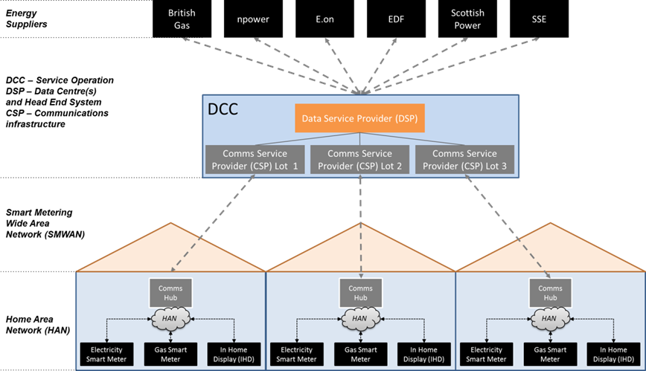

1. : DCC organisation overview

The DCC Licensee (DCC-L) oversees contracting and managing the services of the DSP and CSPs. Through a recent procurement process, DESNZ have selected the following organisations to make up the DCC:

* The DCC Licensee is Capita;
* The DSP is CGI;
* The CSP for the northern region is Arqiva;
* The provider of the Smart Metering Key Infrastructure (SMKI) is BT;
* The CSP for the central and southern regions is Telefónica.

The DSP provides a data service that integrates metering data to and from Energy suppliers (with properties across all the different regional lots), while the CSP(s) provides the communications network for the programme and the Communications hub within each home.

Telefónica’s role as a CSP provides:

* Logistics service to ensure the timely and safe delivery of Communication Hubs to DCC Users.
* The provision of managed communications service that provides an access network between the customer premise and the DCC. This network fulfils the CSP’s obligations to service 99.25% of customer premises;
* The provision of communications modules that act as a hub within the communications infrastructure and that must be able to support Home Area Network (HAN) and Wide Area Network (WAN) interfaces;
* Device manager service that provides management capability for Communication Hubs.
* The deployment of both Communications Hubs (CH) and the communications infrastructure started in Q4 2015. It is currently in its 8th year, with a current install base of approximately 9 million Communication Hubs, expected to reach approximately 13 million hubs by 2026.
* The duration of the contract between the DESNZ and the CSP is 15 years with a potential 5 year extension option.

Both Telefónica and the DCC intend to extend and future-proof DCC Services relating to smart metering including the adoption of their respective Cloud framework. The key strategic drivers are:

* Protecting against technology obsolescence and ensuring service continuity.
* Leveraging developments in technologies and making them available to DCC Users
* Delivering high levels of security, resilience and service quality.
* Improving delivery of in-life change, giving lower costs, speedier change, and greater accuracy.
* Continuing to achieve value for money and supporting the delivery of benefits to Great Britain’s energy consumers and the wider energy industry.
* Maintaining a competitive environment for services to the DCC
* Managing the sunsetting of Telefónica’s 3G radio network

## PURPOSE OF DOCUMENT

This document focuses on the Traffic Management Gateway which will need to be introduced to Telefónica’s architecture landscape to meet its and DCC’s future business goals and strategic drivers.

This document will describe the Traffic Management Gateway architecture and design, including the interactions that will be used to continue to fulfil the DCC CSP requirements for the existing service.

## SUMMARY

With the introduction of the Traffic Management Gateway, the application and system landscape across Telefónica will be used / developed as follows:

* For network connectivity, the existing radio access network will continue to be used. For cellular core systems, the dedicated instances of existing systems will be used, supporting IPv6 transport and integration into the Traffic Management Gateway service through the on-premise hosted Service Edge to support service user requests and provisioning via the Device Manager service;
* The Traffic Management Gateway will be provisioned to control traffic with the communication hubs to support service user and device manager requests. The Traffic Management Gateway services will also integrate with a public cloud security service to perform communications hub message security operations.
* The introduction of the Traffic Management Gateway allows Telefónica to monitor and manage Smart Metering traffic allowing the following savings / benefits across Telefónica and the DCC:
  + Insights (through Telefónica’s Strategic Data and Reporting service) into network usage, resulting in further service improvements.
  + Intelligent traffic monitoring per cell with overload risk identification and throttling to improve bandwidth utilisation and remove possibility that DSP overloads a single site based on excessive retries or SR requests.
  + Cell status service to manage the dynamic status of the cell site including general success for Communication Hub communication and cell bandwidth utilisation which will also be used to inform future cell dimensioning.
  + The Traffic Management Gateway will also utilise the Communication Hub status service that provides a dynamic view of the Communication Hub. This service is described in the Device Manager specification.
  + Mitigates incoming message loss in the event of DSP service downtime.
  + Manage Device Manager issued commands to the CH and send Communication Hub events to the appropriate Device Manager and SDR services
  + Allows DNO specific views of the outage maps
  + Facilitate the migration of the Device Manager services from SM2M DMM to Microsoft Azure
* To enable a robust service wrap, the existing Helix SaaS ITSM capability will be used. The Traffic Management Gateway service modelling will be aligned to Telefónica’s wider Cloud monitoring strategy. The Communication Hub CI and asset data is currently held in CMDB, but will be migrated to the Communication Hub Status Service (CHSS) as described in SD01_04 and SD02_06.
* Operational management of hubs will be performed leveraging Cloud based capabilities including logging, monitoring, analytics and integration into the existing operational monitoring systems (refer to section 10);

The Traffic Management Gateway will be delivered under CR5220 TMG Phase 1.

* Telefónica will be sunsetting their 3G radio network in 2025 and the Traffic Management Gateway will allow Telefónica to:

* Optimise processing of service requests from the DSP and issue responses and meter alerts.
* Manage firmware requests issued through the CSP management gateway based on cell site bandwidth utilisation.
* Provide more in-depth analysis of the power outage alerts to facilitate a per site check for potential outages not received over the IPv6/UDP connection

It should be noted that the Device Manager is out of scope of this document other than to describe its support for the Traffic Management Gateway service. For a detailed view of the Device Manager, please refer to CSP_TEF_SD02_06_Device_Manager.

## SCOPE

* + 1. IN SCOPE

The scope of this document is as follows:

* A detailed architecture view of the Traffic Management Gateway;
* The high-level functionality and interconnections required to support the gateway. These applications will be split across the following capabilities:
  + Traffic Management Gateway and internal interactions;
  + The Service Edge;
  + Integrations with external systems;
  + BCDR;
  + Autoscaling;
  + Security
  + Operational Support Systems including Service Management systems;
* All interfaces and high-level data flows required to support the interactions with the Traffic Management Gateway, including to and from external participants;
* High level of how the Traffic Management Gateway supports the transition of the Device Manager services required to manage the Communication Hubs;
* High level view of shared infrastructure required to support smart metering. These systems include:
  + Firewalls (on-premise);
  + Web application firewalls;
  + Intrusion prevention system (IPS);
  + Anti-Virus.

For clarity, this design will describe the architecture of the Traffic Management Gateway in the context of the End State Architecture (ESA) as described in section 2.2. However, the transition to the end state must be considered and is described in section 2.13. It should be noted the ESA is a logical destination and has not been fully underpinned by Business Cases to support all transition activities, however TMG and the associated capabilities for the basis of a cloud Device Manager that can be extended.

During the migration, the Traffic Management Gateway capability will ensure it continues to support legacy Device Manager system behaviour e.g., managing retries aligned to existing functionality. However, the transition will consider the end state as priority with the support of the legacy platform as an exception. As the Device Manager services hosted on the legacy platform are migrated to the end state in a phased manner, the transition architecture will ensure any capability of the Traffic Management Gateway to support the service on the legacy platform will be decommissioned with minimum effort.

For example, the Traffic Management Gateway will publish command signing requests to the Azure Device Manager. The consuming service is an API microservice that invokes the legacy device manager platform. As the message signing capability is transitioned to Azure, no change is required in the Traffic Management Gateway. The Device Manager consumer will only differ.

* + 1. OUT OF SCOPE

The following is out of scope of this document:

* The solution blueprint required to support the delivery of the smart metering services (see the smart metering Solution Blueprint);
* The technical architecture specification required to support the delivery of the smart metering services (see the smart metering Technical Architecture Specification);
* The application architecture specification required to support the delivery of the smart metering services (see the smart metering Application Architecture Specification);
* The device manager specification (see the smart metering Device Manager Specification). A high-level view of the device manager will be provided to describe its interaction with the Traffic Management Gateway;
* Specifics around data residency and ownership (see the Data Residency and Ownership Matrix);
* Projects required to deliver the Traffic Management Gateway services;
* Detailed timelines for delivery of the Traffic Management Gateway services;
* Detailed application architecture;
* Detailed security architecture;
* Detailed device manager architecture;
* Detailed network design;
* Detailed design of interfaces;
* Detailed design of data migrations;
* Volumes of business transactions;
* Shared infrastructure required to support smart metering. These systems include:
  + Patch management;
  + DCC IPsec VPN;
  + RSA Secure ID;
  + LAN Routers;
  + LAN Switches;
  + SMTP infrastructure;
* Systems to support People and Organisation such as Active Directory and Okta;

## DOCUMENT STRUCTURE

In the remainder of the document, the Traffic Management Gateway architecture is presented in detail as outlined in section 2. The remainder of the document will comprise sections as follows:

* Section 2: Telefónica’s End State Architecture and Traffic Management Gateway Services - This section will describe how the smart metering traffic management gateway functionality will be allocated across distinct services, and the interfaces required supporting the service. For each capability, the applications, associated functionality and logical data flows will be presented. A set of diagrams will be used to illustrate interactions with other services and applications (these diagrams are purely logical and do not represent how the interfaces should be implemented);
* Section 3: Telefónica’s Architecture Roadmap – this section will describe smart metering’s journey to enhance the service for the DCC.
* Section 4: Autoscaling – This section details the significant improvements in overall performance flexibility and autoscaling as a result of placing the Traffic Management Gateway components in a cloud environment.
* Section 5: Hosting Strategy – this section will describe Telefónica’s hosting approach to take advantage of cloud capabilities to serves as a platform for an agile flexible service. Through the use of Cloud services, Telefónica’s will provide on demand elasticity but still remain compliant when it comes to Telefónica’s security obligations. Telefónica will align to the DCC’s Cloud Policy
* Section 6: Disaster Recovery and HA – This section will describe how Telefónica intends to use Microsoft Azure as the cloud hosting platform for the Traffic Management Gateway to ensure it meets its Performance measure, SLA, RTO and RPO requirements;
* Section 7: Environments – This section details the environment strategy to support development, Test and Production of the Traffic Management Gateway services.
* Section 8: DCC Parties – This section details the impacts of integrating with the DCC parties as a result of placing the Traffic Management Gateway components in a cloud environment.
* Section 9: Security – This section will describe the security controls that will be implemented to ensure the Traffic Management Gateway meets our security contractual obligations.
* Section 10: Monitoring – This section will describe how Telefónica intends to monitor the Traffic Management Gateway and integrate with the BMC Helix platform.
* Section 11: Design Questions – This section captures any design question and their outcome.
* Section 12: Risks, Issues and Dependencies - This section will include Risk, Issues and Dependencies items that relate to this process but are not managed through this document. The list will be reflective of the date the document was written. Assumptions are captured in section 1.6, to provide context for the rest of the document. For the most up to date list of RAID items, see the SMIP Programme RAID log.
* Section 13: Appendix A – This section will describe the Communication Hub functionality upon receipt of a General Block Transfer (GBT) message. This behaviour is consistent with the current SMWAN solution. No changes will be made to the Communication Hub to support the Traffic Management Gateway.

## ASSUMPTIONS

The following assumptions have been made in the development of the Telefónica CSP Device. Confirmed assumptions can be treated as design decisions.

| No. | System | Description | Owner | Status |
| --- | --- | --- | --- | --- |
| 1 | DSP | Telefónica assumes that the interface between the Traffic Management Gateway and the DSP will be aligned to SD4.4.15. However, further discussions are required with the DCC to understand whether a publish and subscribe model can be adopted. | Asif Maruf | Closed. The integration between Telefónica and the DSP will be API based. The publish and subscribe model to support integration between the two parties will not be adopted. |

1. Assumptions

## GLOSSARY

|  |  |
| --- | --- |
| Term | Definition |
| AD | Active Directory – User directory for managing access to systems. |
| AV | Anti-Virus – Capability installed on systems to detect and quarantine malicious programs. |
| CIA | Change Impact Assessment – Process through which programme change is assessed and impacted. |
| CMDB | Configuration Management Database – Telefónica asset tracking database for all items that require service management. |
| CSP | Communications Service Provider – Telefónica’s role within the DCC |
| CSR | Credential Signing Request – A request from an endpoint that includes the publicly shared component of the credential, to be signed by a 3rd party to prove the identity of the endpoint. |
| DCC | Data Communications Company – Organisation formed to provide Data Communications for smart metering |
| DCCKI | Data Communications Company Key Infrastructure – Key infrastructure used to authenticate communications between DCC Service Providers and Service Users |
| DCC-L | Data Communications Company Licensee – Organisation formed to oversee the DCC responsibilities. Capita is the DCC-L. |
| DLP | Data Loss Prevention – Capability Installed throughout the Telefónica solution to track and prevent sensitive data types from leaving Telefónica boundaries. |
| DM | Device Manager |
| DSP | Data Services Provider |
| ERP | Enterprise Resource Planning – Component that is responsible for managing the core business processes for Telefónica relating to Purchase Orders to vendors and income. |
| IMEI | International Mobile Equipment Identifier – ID given to all GSM mobile devices, including Communications Hubs |
| IMSI | International Mobile Subscription Identifier – ID given to all GSM SIM cards. |
| IAC | Infrastructure as Code |
| IPS | Intrusion Prevention System – Capability deployed within Telefónica’s solution to identify and block unusual behaviour. |
| ITSM | IT Service Management – Suite of tools for managing change, incidents and problems. |
| MSISDN | Mobile Subscriber ISDN number. The telephone number allocated to a SIM. As this solution does not use publically routable MSISDNs, these are referred to as pseudo MSISDNs in this document. |
| NMC | Network Management Centre |
| OI | Operational Intelligence – Correlation engine used as part of the Operational Management capability. |
| PKI | Public Key Infrastructure – Set of processes and tools to distribute and manage digital certificates, used to prove identity and maintain confidentiality between systems and smart metering devices |
| RFC | Request for Change |
| SDR | Strategic Data and Reporting |
| SoC | Security operations Centre |
| SIEM | Security Incident and Event Monitoring |
| SIM | Subscriber Identity Module – Hardware component within a device that stores credentials for accessing a Cellular network |
| SLM | Service Level Management |
| SMKI | Smart Metering Key Infrastructure – Key infrastructure used to authenticate communications between Smart Metering devices within the home and DCC Service Providers and Service Users |
| SM WAN | Smart Metering Wide Area Network – the network between a Communications Hub and the Telefónica services |
| SRM | Service Request Management |
| TCO | Total Cost of Ownership |
| TMG | Traffic Management Gateway |
| VPN | Virtual Private Network |

1. Glossary

## AUTHORISED REQUEST FOR CHANGE

This document includes the following change requests. This document serves as a reference for the solution as it is expected to be deployed. As a result, the document assumes that all the changes requests listed below have been approved and will be progressed.

DCC CRs:

|  |  |
| --- | --- |
| DCC-L CR ID | Description |
|  | [Placeholder] |

1. Request for Change

Telefónica internal CRs.

|  |  |
| --- | --- |
| Telefónica CR ID | Description |
|  | [Placeholder] |

1. Internal CRs

This document specifically does not include the following change requests at this point in time. These items have not been approved and either result in design changes to this document or require further discussion with other DCC parties to confirm the scope and impact:

|  |  |  |
| --- | --- | --- |
| Telefónica CR ID | DCC-L CR ID | Description |
|  |  | [Placeholder] |

1. DCC CRs

1. THE ARCHITECTURE SPECIFICATION

This section of the document covers the services that will be used to provide the Traffic Management Gateway service, from the perspective of the internal Telefónica services and external systems that connect into Telefónica services.

## ARCHITECTURE PRINCIPLES

The architecture will adopt a “defence in depth” strategy to build in security provisions at all levels. This is to ensure that technologies adopted have already been operated in an environment with appropriate technical and process security controls in place.

* DCCs Traffic Management Gateway requirements align with Telefónica’s and DCC Cloud First strategy
* Traffic Management Gateway will provide key DCC benefits (described in later in subsequent sections)
* The architecture will facilitate the compliance of regulatory authority requirements
* Simplification and re-use will be required over the development of duplicate services
* The architecture will adopt open standard integration solutions
* All software to support the Traffic Management Gateway will be cloud-native
* Single source of data, data driven services and logical separation of application from data
* Simplicity, standards and configuration Out of the Box are required over customisation
* Use of FaaS, CaaS, PaaS will allow the Traffic Management Gateway solution to adjust to load automatically and self-heal.
* The platform will support the development and hosting of services that are loosely coupled with no cross-function dependencies
* The platform will automatically scale on demand. Telefónica’s cloud solution will not scale indefinitely due to OPEX related implications, and a root cause analysis of volumes that far exceed expected limits will be undertaken.
* The platform supports the management of planned and unplanned failure scenarios e.g. transaction failures through the event driven architecture
* The solution will be highly resilient with zonal redundancy offered out of the box that meets the RTO and RPO requirements and in some cases surpasses them (please refer to section 6)
* The solution will leverage out of box analytics capabilities e.g., data mining, stream analytics and machine learning
* The solution will support automated builds of environments
* Development will be managed through an automated pipeline-based approach i.e., DevOps, Continuous Delivery (CD), Continuous Integration (CI) and a deployment strategy tailored for the programme
* Ensure higher composite SLAs by creating independent fallback paths e.g., in case of DB failure, the application will continue be available as messages are queued.
  + 1. DESIGN CRITERIA

Telefónica will continue to meet his obligations as described in the Schedules. These requirements are captured in the Requirements Traceability Matrix (RTM) – SD07.

* + 1. STATELESS SERVICES

The solution will be designed based on statelessness services by separating them from their state data wherever possible resulting in reduced resource consumption leading to handling more requests in a reliable way.

* + 1. MICROSERVICE PATTERNS

Telefónica will adopt the use of industry proven patterns to support the design and build of the microservices supporting the Traffic Management Gateway. Examples include (but not limited to) the task, deferred task patterns, event sequencing, saga, event sourcing and circuit breaker. The use of the industry proven patterns promotes:

* Easier Monitoring
* Scalability
* Flexibility
* Independence and autonomy
* Decentralised governance
* Resilience
* Failure isolation
* CI / CD

The use of specific patterns and their detailed design will be covered in lower-level technical design.

* + 1. DEVOPS (CI/CD PIPELINES)

The solution will be deployed using DevOps principles – i.e. Continuous Integration & Continuous Delivery (CI/CD) pipelines. This approach ensures that changes are little and often, and all changes are expressed as repeatable, configurable, scripted tasks. The CI/CD pipeline will be used to deploy infrastructure, software packages and custom applications. This approach ensures that all deployment is scripted & automated, such that it is repeatable, and that testing is carried out as part of the integration process.

* + 1. CLOUD INFRASTRUCTURE AS CODE (IAC)

In order to allow the solution to be re-configured quickly, infrastructure will be defined in executable software. Software defined infrastructure conveys a number of significant advantages, including:

* Configurations can be managed in the same way as other code artefacts, e.g. in a Source Code Control System. The configuration is thus version managed and can be modified, branched, and rolled back enabling a rapid and robust development process and integrated with the overall DevOps approach.
* The configuration is repeatable since the same configuration definition can be deployed multiple times to create multiple instances of the infrastructure (such as for other development / test environments). Each instance is assured to be identical as it is built from the same definition.
* The infrastructure can be rapidly rebuilt in case of failure or misconfiguration maintaining maximum availability.
* There is no possibility of manual deployment errors, or of undocumented knowledge of the infrastructure as it is fully defined in code and automatically deployed.

This includes software definition of Networks, Virtual machines, Package installation and Platform as a Service (PaaS) services.

## HIGH LEVEL ARCHITECTURE

The figure below highlights the high-level end state architecture for the Smart Metering service. It shows the capabilities that will be deployed or enhanced, along with the underlying services that provide those capabilities.

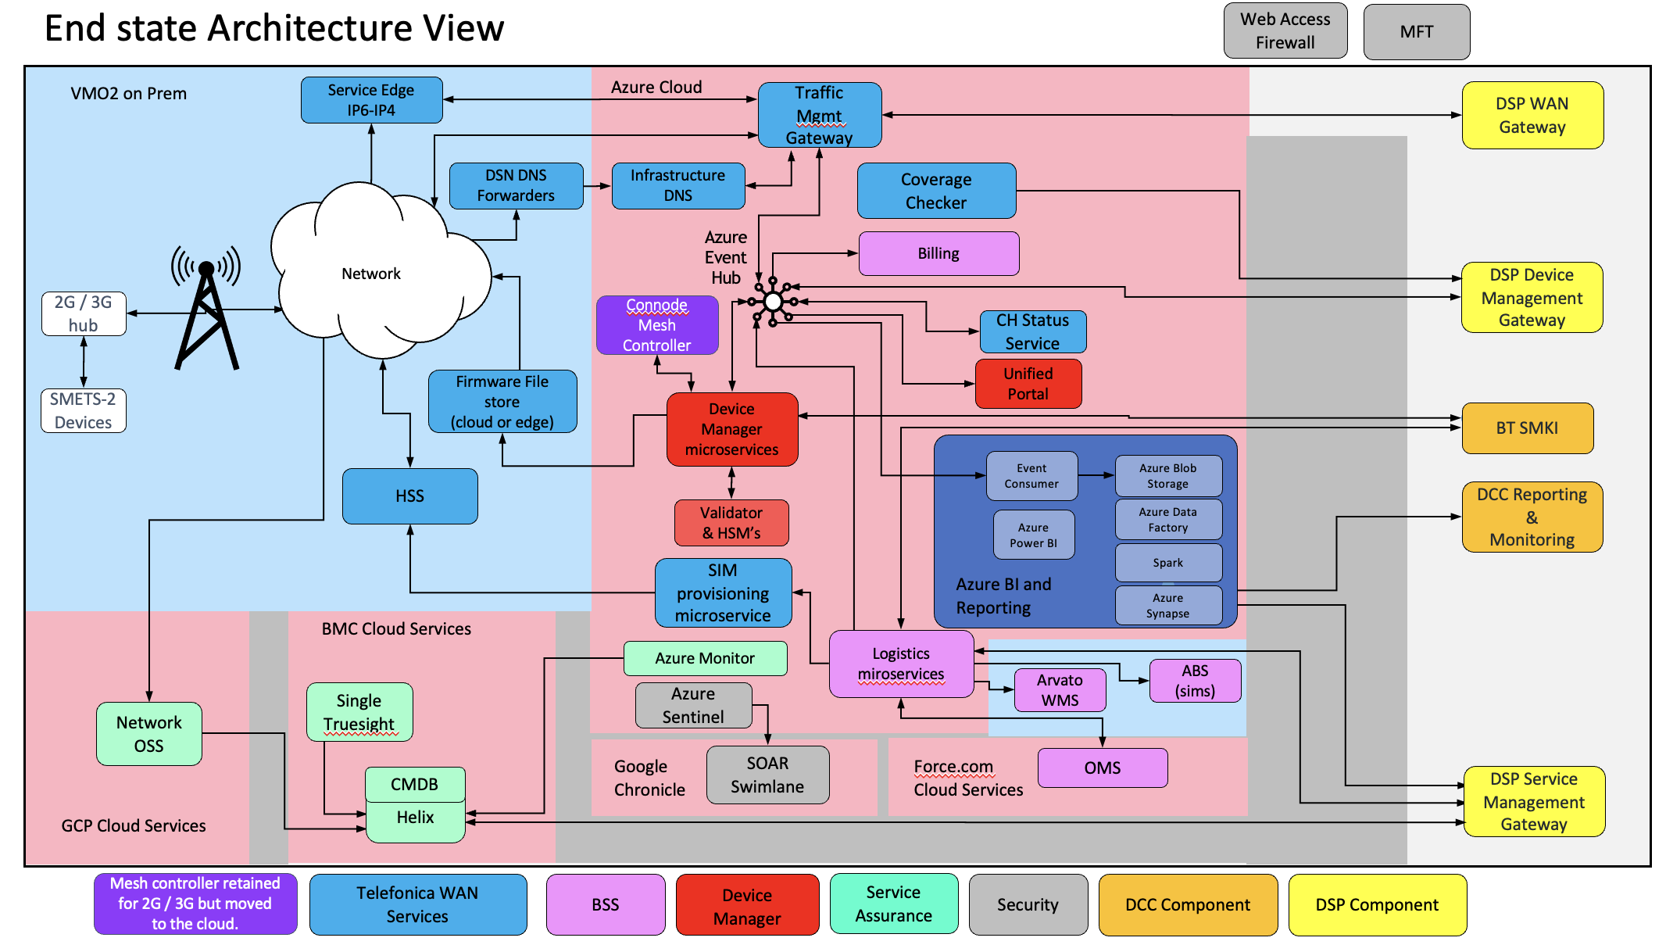

1. High Level Architecture

Key to the solution are the following principles:

* **Simple message transport service** – Agnostic to all underlying access technologies, allowing for direct addressing for all endpoints without significant protocol translation and/or API-based message requests from the DSP. All communication hubs will continue to be directly addressable and routable over a standards-based IP network from Telefónica’s Traffic Management Gateway.
* **HTTP** – use of HTTP as a proven technology to underpin pause and resume of firmware download by the communications hub.
* **Dynamic IPv6** – Needed to provide a scalable address space to the 30 million hubs without any segregation or address management overhead. This capability continues to support the mobile service. It was recognized during the design of the mobile service that from an IP level, support of 21M hubs cannot be accomplished given that the largest Ipv4 private address block only allows for 16.7M unique addresses. In addition, Telefónica will continue to leverage the resilience and load-balancing mechanisms implemented on the Telefónica core.
* **Always-on** –Provided through additional Cellular core system elements and one PDP context license per communication hub to allow for bi-directional flow of data between communication hubs and the Telefónica systems at any moment without the need of any out of band ‘wake-up messages’.
* **Standards-based solution** –Use of 3GPP and RFC standards and protocols to ease integration and de-risk value proposition.
* **Shared vs. Dedicated systems** – Wherever possible, Telefónica have re-used shared capabilities to minimise operational overheads. Exceptions may occur where:
  + the ECO system is housed within the cloud – Separation and segregation will be performed with all services that are part of the ECO system in the cloud.
  + Segregation from existing capabilities is required due to technical incompatibilities or DCC requirements
  + Operational concerns regarding the capacity and the potential impact on existing services drive the use of separate systems.

The following key decisions have been made:

* The traffic management gateway will be hosted in the public cloud, adopting a microservice, containerised model. It will take advantage of the insight, analytics, security, logging, and monitoring capabilities provided by the Cloud platform
* The Traffic Management Gateway will process:
  + WAN requests from the DSP and management commands from Device Manager
  + SR Responses from the communication hubs
  + Event/alert data from the CHs / device (incl. forwarding Power outage confirmation alerts to the DSP).
  + WAN or Device Management commands received from the DSP and Device Manager respectively will be signed. The Traffic Management Gateway takes no responsibility to sign commands it issues to the CH.
  + Message verification will also be the responsibility of the DSP or the Device Management function. The Traffic Management Gateway takes no responsibility to verify events / alerts received from the CH.
* The Traffic Management Gateway will support IPv4 connectivity to the DSP. It is the Service Edge responsibility to translate the IPv4 packets to IPv6 and issue the commands to the Communication Hub over the UDP connection to the packet core. Similarly, the Service Edge will translate IPv6 packets from the Communication Hub to IPv4 to support connectivity with the Traffic Management Gateway.
* Traffic Management Gateway will adhere to SD4.4.15 and SD10.4.15 specifications in total. This includes (but not limited to).:
  + Interface definitions
  + Retry policy
  + Error Handling
  + GBT processing (refer to section 2.10)
  + Code of Connection

All design and build teams must review these documents and incorporate the specification details in their artefacts

* Traffic Management Gateway will consist of discrete, loosely coupled services that will perform a specific functions e.g. send and receive data across the Ipv6/UDP connection, send CH data to the DSP / Device Manager, GUID to IP mapping, manage cell utilisation.
* The Traffic Management service will be designed, built, tested, and deployed independently of other services. Failure of a specific service will not impact other services and each service will be able to scale independently.
* Communication hub Vendors –Telefónica will continue to use WNC to manufacture the communication hubs.
* Service Management**–** The following capabilities will be used support the end-to-end service, including the Traffic Management Gateway:
  + Communication Hub Status Service (CHSS) –. The Communication Hub CI and asset store will be moved to the Communication Hub Status service. It will integrate with ITSM platform to support the incident management processes.
  + BMC Helix – The Helix platform has replaced Remedy as the ITSM platform for Smart Metering. It is a UK based cloud platform, adopting the Software as a Service (SaaS) model, leveraging the benefits of out of box capabilities, infrastructure management and automatic scaling. The integration with DCC’s platform is consistent with the service management interface specification, SD4.7.2 and its associated Code of Connection, SD10.7.2.

Key services to support the Traffic Management Gateway are described in section 2.7.

## REFERENCE ARCHITECTURE

The reference architecture is shown below:

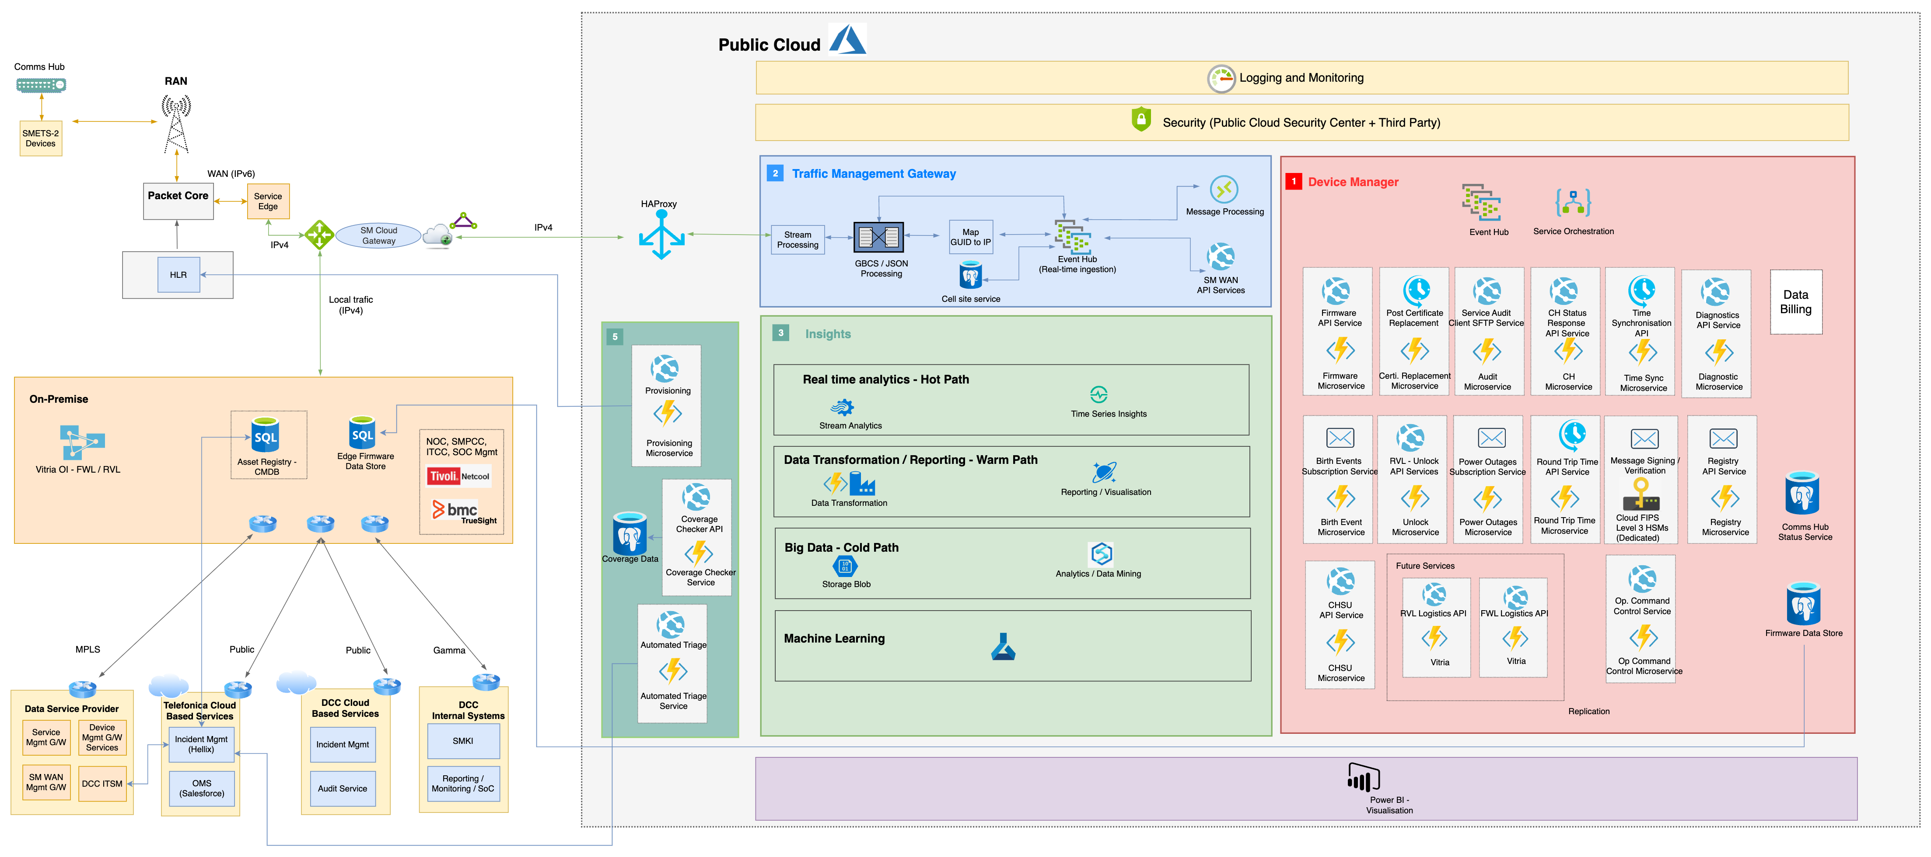

1. Reference Architecture

The Traffic Management Gateway will be hosted in the Public Cloud

* The solution will adopt a microservice based architecture, with loosely coupled, fine grained services, each aligned to a specific function e.g., send and receive data across the Ipv6/UDP connection, send CH data to the DSP / Device Manager, GUID to IP mapping, manage cell utilisation.
* A containerised model such as Kubernetes will be adopted for the deployment, scaling and management of the individual services that are not PaaS capabilities managed by the Cloud provider. This model will facilitate the move to another Cloud platform to meet portability requirements.
* Each service can be deployed independently through automated processes and failure will be isolated and managed independently of other services. Where specific PaaS services are used to facilitate message flows between the functional services e.g. message broker / event hub, the Cloud platform’s resilience and self-healing features will be leveraged. In addition, the upgrade and changes to these PaaS services will be infrequent. PaaS services will display segregation and separation.
* The key building blocks of the solution are stateless services, event ingestion / stream processing and service orchestration to support a scale of 30m devices and planned / unplanned outage scenarios.
* Auto scaling and self-healing capabilities of the Cloud will be used to manage load based on demand, for example, potential alert storms will be managed through the event broker which will be automatically scaled to meet demand.
* The device manager will be responsible for monitoring and managing the operational state of the communication hub.
* Load control and transaction rate flattening capabilities will be introduced to manage unexpected load and impact to the downstream services.
* The solution will leverage native Cloud security capabilities e.g., WAF, malware protection, and virtual capabilities available through the Cloud vendor’s marketplace e.g., virtual firewalls, vulnerability scanning. All security capabilities that will be introduced will be compliant with National Cyber Security Centre (NCSC) standards.

The Telefónica platform and its use of Cloud will allow the solution to be compliant with the following security standards:

* SO/IEC 2000
* ISO/IEC 9001
* ISO/IEC 27000
* ISO/IEC 27001
* ISO/IEC 27005
* ISO/IEC 27017
* ISO/IEC 27033
* ISO/IEC 223001
* SOC2
* TSRs (when introduced)
* SMKI PMA
* Communication hub CPA certification
* GPG-13 Level-2 logging requirements.
* NCSC
* MITRE ATT&CK Framework
* Cyber Security Framework (CSF)
* CRESENT accredited Penetration Testing
* Cloud Security Alliance

## DETAILED APPLICATION ARCHITECTURE

Please refer to CSP_TEF_SD01_04_Application_Architecture_Specification for a detailed description of the application architecture.

## CLOUD SERVICES

The Traffic Management Gateway application is a collection of services, each service aligns to the microservice architectural style with loosely coupled, well defined and independent services. Telefónica will leverage Microsoft Azure’s PaaS / SaaS off the shelf capabilities as the preferred option. The PaaS services are available for easy consumption and allows design to be extensible to meet the requirements of the new services. Building the services functionality on top of a managed PaaS maximises value and potential re-use for the DCC. Telefónica has proposed the use of the following off the shelf capabilities of the Azure platform:

* Event Hub
* HAProxy with WAF
* API Management
* PostgreSQL DB
* Azure Kubernetes Service (AKS)
* Data Factory / Synapse
* Blob Storage
* Machine Learning
* Stream Analytics
* Backup and Archiving

The solution will be highly scalable, highly available with high reliability and low TCO. The hosting requirements aligns well with Telefónica’s Cloud first policy which also addresses the mandatory DCC requirement for Device Manager to be cloud hosted.

Cloud hosting comes in different flavours, essentially organisations have a choice between three types:

* **Public cloud** where the cloud resources such as servers, storage, hardware, software and supporting infrastructure are owned and managed by a third-party cloud service provider (Microsoft Azure) and delivered over the internet or dedicated links. Key advantages are lower costs, no maintenance, near unlimited scalability up and down and high reliability which are mainly driven by economies of scale.
* **Private cloud** consists of cloud computing resources on a private network and used exclusively by one organisation. Key advantages are more flexibility, more control, and more scalability than dedicated hardware. However, the private cloud’s offering is limited to IaaS based capabilities and therefore does not align to DCC or Telefónica Cloud strategies which aims to make use of PaaS / SaaS services. In addition, the ability of services to scale will be constrained by the underlying infrastructure that supports the Private Cloud and is not comparable to the capacity offered by the public cloud providers.
* **Hybrid cloud** provides greater flexibility, more deployment options, security, compliance and getting more value from their existing infrastructure. Key advantages are around control, flexibility, cost effectiveness and ease.

The following drivers have been considered in the selection of the Microsoft Azure public cloud as the hosting approach:

* Delivery certainty
  + A public cloud-based solution would enable the implementation to begin with a short lead time, and ongoing support would be available for the environments (patching, license, upgrades)
* Commercial approach
  + Telefónica has an existing Global agreement with Microsoft Azure and Google Cloud, we expect to use Azure hosting.
* DCC requirements around Cloud first policy, scale up or down, containerisation/microservices:
  + DCCs Device Management requirements align with Telefónica’s and DCC Cloud First strategy.
  + Microsoft Azure is the DCC’s preferred Public Cloud platform of choice.
  + Use of CaaS and PaaS will allow the solution to adjust to load automatically and self-heal.
  + The platform will support the development and hosting of services that are loosely coupled with no cross-function dependencies.
  + The platform supports the management of planned and unplanned failure scenarios e.g. transaction failures through the event driven architecture.
  + The solution will be highly resilient with zonal HA redundancy offered out of the box that meets the RTO and RPO requirements and in some cases surpasses them. Telefónica will adopt a zonal approach as described in section 6.
  + The solution will leverage out of box analytics capabilities e.g., data mining, stream analytics and machine learning to build its data pipeline and analytic capability. This capability will provide insights into the operational performance of the Traffic Management Gateway and the wider end-to-end service.
  + The solution will support automated builds of environments – IaC
  + Development will be managed through an automated pipeline-based approach i.e., DevOps, Continuous Delivery (CD), Continuous Integration (CI) and a deployment strategy tailored for the programme.
  + Ensure higher composite SLAs by creating independent fallback paths e.g., in case of DB failure, the application will continue to be available as messages are queued.
* DCC Security requirements and risk appetite
  + The solution will leverage products and services that are approved by NSC and meets DCC security requirements.
* Mandated compliance/regulatory/standard requirements
  + The platform is compliant against the ISO standards stated in the DCC Requirement Traceability Matrix (RTM)
  + The solution will utilise open industry standards e.g., JSON REST APIs, AMQP, Publish and Subscribe to support interoperability and disaggregation.

## THE TRAFFIC MANAGEMENT GATEWAY

The traffic management gateway functionality will be implemented as a direct connection with the DSP to allow the DCC to send JSON objects containing GBCS commands for distribution to communication hubs (CH) and respond as defined in the DS.0921 SD4.4.15 SMWAN Interface specification. The Traffic Management Gateway will also be responsible for sending messages on behalf of the Device Manager.

The gateway:

* Allows Telefónica to effectively manage, monitor and optimise the use of their network.
* Allows independent management of traffic bandwidth / site vs all other traffic with overload risk reporting to enable mitigation
* Manages retries and throttling of events in line with cell site utilisation and bandwidth.
* Allows Telefónica to track network impact as approximately 7K CHs are installed on a daily basis and adjust to changes in the roll out profile by facilitating the re-dimensioning of the network.
* Provides insights into chatty devices (i.e., Communication Hubs and HAN devices) and the increased risks of overloading the network.
* Supports DSP downtime scenarios, planned or unplanned
* Removes the DSP’s reliance on the DNS solution. The traffic management gateway will utilise IP information stored in events and DNS lookup to facilitate GUID to IP mapping.
* Provides a more reliable integration approach with the DCC parties, adopting a store and forward based approach.

The high-level capabilities of the gateway will be:

* A Highly scalable solution hosted on the Microsoft Azure public cloud that can receive, process and respond to GBCS messages from DSP and communication hub, and Device Management (DMM) messages from Device Manager and communication hub
* The traffic management gateway will act as a single gateway that handles all outbound traffic and retries.
* Manages outbound traffic volumes on a per cell site basis.
* Introduces improved Communication Hub status accuracy due to traffic management.
* Introduces management of complete single cell failure (refer to section 2.9).
* Management of large GBCS messages fragmented using General Block Transfer (GBT). Regardless of the agreed integration method adopted between Telefónica and the DSP, the Traffic Management Gateway will manage GBT messages in line with an agreed approach between the two parties and captured in the SD4 and SD10 specifications. This includes handling and issuing of acknowledgements and GBT block retries.
* Hold the IP address of CH’s by using the last known IP address on received message from the communication hubs.
* Ensure messages are retried if no ACK of receipt of the request is provided by the Communication Hub. Retries due to no GBCS response from the hub will be managed by the DSP. However, the VMO2 will analyse the traffic to determine whether the retry policy needs adjusting.
* Manage large GBCS messages through the processing of General Block Transfer (GBT) messages
* Store IPs information with the data platform to support insights into the end-to-end service to support triage and service management use cases
* Segregate data from the communication hubs based on the criticality of the messages, for example, to allow for processing of critical alarms (such as power outage alerts) which may temporarily cause a process backlog separately from birth events. Other non-Service user facing events such as log event data will be processed on a low priority stream
* Support the sunsetting of Telefónica’s 3G network through enhancements of the Firmware service. The service will utilise cell site and communication hubs status data to optimise the use of the 2G radio network.
* Provide more in-depth analysis of the power outage alerts to facilitate a per site check for potential outages not received over the Ipv6/UDP connection

Specific Benefits to the DCC are captured below:

* Prioritises SR’s to vulnerable customers (inc. prepay) based on previous commands.
* Reduces DSP complexity and costs by removal of DNS lookup to all SMWAN traffic. The lookup will be performed by the Traffic Management Gateway.
* Removes message loss in the event of DSP gateway interface failure / outage.
* Real time dashboard of current SMWAN performance.
* The lack of cell site density and distribution across Telefónica c20K cells needs to the DSP unknowingly overloading cell sites due to current excessive retry strategy.
* Allows for creation of DNO specific views of outage maps.
* Decommission SMWAN usage files and associated SFTP interface from the DSP.

The Traffic Management Gateway capabilities can be grouped as follows:

* The Ipv6 / UDP Connectivity and Device Manager integration
  + issuing of device manager (DMM) and SR (GBCS) signed commands over the existing Ipv6 / UDP connection
  + receipt of CH alerts and events over the existing Ipv6 / UDP connection
  + Mapping of GBCS / DMM commands to JSON payloads to support downstream processing and analytics.
  + GUID to Ipv6 mapping to ensure commands are routing to the correct endpoint.
* Optimisation of the Cellular network and manage potential overload of the cell site
  + Services such as firmware will utilise Communication Hub status and cell site data to optimise the use of the Telefónica network and ease overload on the cell site. This level of intelligence that will be applied to CH related traffic will facilitate the sunsetting of 3G cellular network and ensure meter firmware updates fall within agreed SLAs and SLA’s associated with CAT 3 alerts
* Power outage Enhancements
  + The Traffic Management Gateway will analyse outages against postcode proximities and previous hub status to execute per site checks for potential outages not received. This enhancement is described in detail in SD02_06.
* Support of the SR requests / response and meter alerts
  + Replacement of the existing DSP Gateway to the SMWAN that supports the issuing and receiving of service user commands and responses as well as meter alerts.
  + The integration will be in line with DS.0921 SD4.4.15 SMWAN Interface Specification. Telefónica have agreed to use the current API interface instead of Telefónica’s preference for a publish and subscribe based integration. The publish and subscribe model would introduce a loosely coupled, scalable and more reliable interaction between Telefónica and the DSP, however this is not what has been agreed for the 4G interface and will ultimately improve DSP delivery timescales.
  + We have agreed with the DSP to uplift the interface to provide a new parameter which the DSP will share the timeout of each message on the DSP side before it is re-tried.
  + The Traffic Management Gateway will facilitate the creation of specific views in the Data and Reporting platform of outage maps based on requirements of the DCC / DNO.

The peak volumetric predictions for Traffic Management Gateway based on the details for the next 5 years (2023-2028) are:

* around 1000 requests per second from DSP
* around 1200 UDP (GBCS/DMM) messages per second sent and received from Communication Hubs
* around 400 UDP (GBCS/DMM) messages per second received and sent to Traffic Management Gateway from Device Manager

Future expansion is dependent on the forecasting provided by the DCC and further workshops are required to ensure forecasting is as accurate as possible.

## TRAFFIC MANAGEMENT GATEWAY ARCHITECTURE COMPONENTS

In line with the DCC’s requirements, the Traffic Management Gateway functionality will be implemented as a direct connection between Traffic Management Gateway and the DSP to allow the DCC to send JSON objects containing GBCS commands for distribution to communication hubs (CH) and respond. The Traffic Management Gateway will also be responsible for sending messages on behalf of the Device Manager.

The high-level capabilities of the gateway will be:

* A Highly scalable solution hosted on the Microsoft Azure public cloud that can receive, process and respond to GBCS messages from DSP and communication hub, and Device Management (DMM) messages from Device Manager and communication hub.
* Hold the IP address of CH’s by using the last known IP address on received message from the CH and DNS lookup.
* Ensure messages are retried if no responses are received based on the existing retransmission policies. *
* Receive IP data to support insights into the end-to-end service to support triage and service management use cases.
* Segregate data from the communication hubs based on the criticality of the messages, for example, to allow for processing of critical alarms (such as power outage alerts) which may temporarily cause a process backlog separately from birth events. Other non-Service user facing events such as log event data will be processed on a low priority stream.

* Note the initial retry count for SRs will be set to 0, pending further analysis of initial data and potential changes with DCC parties. The TMG will manage retries with Device Manager as described in section 2.8.2.

In order to support the Traffic Management Gateway, the rest of the Telefónica solution will continue to leverage the following existing capabilities:

* Use of multiple Access Point Names (APNs) for operational flexibility and avoid reliance on a single APN
* Connection time randomisation (within agreed limits) for HLR / vEPG connection overload in case of a massive power outage across GB to mitigate massive volumes hitting the Traffic Management Gateway
* MPLS connectivity across the multiple switch sites

The subsequent sections describe the sending and receiving capability of the Traffic Management Gateway and the architecture components that underpin these capabilities. The sections will describe:

* The capability to process requests from the DSP and Device Manager and issue commands to the CH
* Receipt of event data from the CH and publication of the event data so that the appropriate subscribers can pick it up e.g.,
  + DSP for WAN responses and meter alerts
  + Device Manager
  + SDR
  + CHSS
    1. TRAFFIC MANAGEMENT GATEWAY INTEGRATION APPROACH

The traffic management gateway will use the following cross cutting services to support integration with internal services and with external parties such as the DSP.

* + - 1. HAPROXY / API MANAGEMENT

This service supports the connectivity to and from external parties e.g., the DSP. Messages are then forwarded to a highly available storage for downstream processing or to the external destination endpoint. A set of policies can be configured on the gateway to support throttling (rate limiting) based on the baselined figures mentioned above and blacklisting (filter IP addresses). From an Azure Technical architecture perspective, this service will be provided by combining:

* API Management (APIM) which is a turnkey solution for publishing APIs to DSP and internal microservice customers. It provides features for managing public facing API, in addition to cross cutting tasks such as authentication, IP restrictions and rate limiting.
* HAProxy is a load balancing service hosted on Azure managed VMs that can perform layer-7 routing and SSL termination along with web application firewall (WAF).

API Management can handle 4000 API requests per second per unit on a premium tier and provide an individual SLA of 99.95%. However, although the service SLA is based the end-to-end solution as stated in section 6.3. All API requests will be stored in Event Hub for further processing. To align to DCC’s requirements, this architecture will support:

* Multiple destination IP addresses for communication hub messages will be utilised to manage priority channels for specific services such as birth events. While other channels will be used for events that have possibility for significant spike loading such as power outage alerts.
* Further Scaling on demand will be provided using the Event Hub message broker architecture.
* Stateless, light weight services that are independently managed through a containerised model.

The HAProxy / APIM services support connectivity and integrations with the DSP (e.g., SR requests/responses and confirmed power outage notification and other DCC parties such as SMKI). These interfaces are described in subsequent sections. The Device Manager interfaces are described in CSP_TEF_SD02_06_Device_Manager.

* + - 1. EVENT HUBS

This Azure native service introduces a messaging architecture to the Traffic Management Gateway for event and message ingestion and will be highly scalable to handle large number of transactions. It supports Telefónica’s approach in introducing an event-based architecture, following store and forward model.

This service will support:

* + Reliable delivery through storage of the DMM/GBCS/JSON messages for a defined period so that the messages can be retransmitted in scenarios where the receiving entity (e.g. DSP or communication hub) is not ready or available
  + Management of Planned / Unplanned scenarios like DSP outage, Internal services like Message Processing outages etc.
  + Auto Scale to handle large number of transactions up to a defined limit.

On Azure, the event and message ingestion functionality will be provided by leveraging the Event Hub which is a big data streaming platform and event ingestion service. It can receive and process millions of events per second and allows data transformation and storage by using real time analytics.

The event hub is a Platform as a Service (PaaS) service and has an auto inflate feature which allows it to automatically scale the number of throughput units to meet the usage needs. For example, a single throughput unit has an SLA of 99.99% based on dedicated tier and the following capacity (at the time of writing):

* + Ingress: Up to 1 MB per second or 1000 events per second (whichever comes first)
  + Egress: Up to 2 MB per second or 4096 events per second

The number of throughput units will be auto scaled as required for capacity compliance.

* + 1. COMMUNICATION HUB DATA SENDER

This section describes capability of the traffic management gateway to issue commands to the Communication Hub, whether the request is initiated from the service user (via the DSP) or the device manager.

Any retries from the Traffic Management Gateway to devices to support SR requests will be managed based on compliance to GBCS to ensure SMETS2 alignment. Retries relating to the issuing of Device Manager commands will be based on compliance to the DMM specification. For CHF and GPF messages, Traffic Management Gateway retries will be managed along with Communication Hub Acknowledgements.

The diagram below provides a high-level view of this capability with the functionality and integration touch points described in subsequent sections.

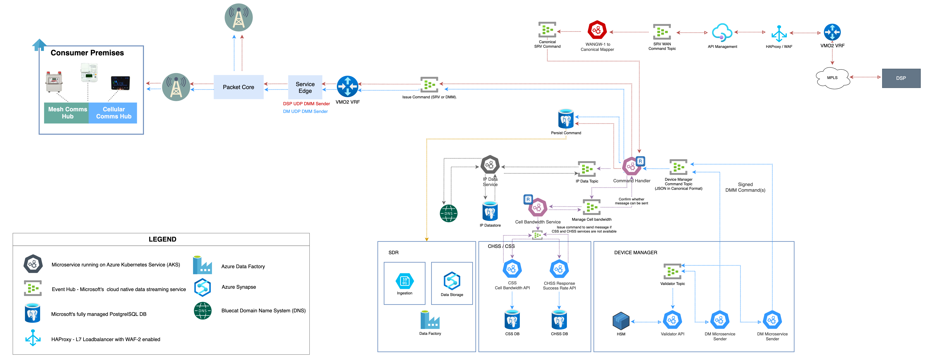

1. Traffic Management Gateway CH Sender

Please note, while the diagram is a logical view of the Traffic Management Gateway architecture, the specific configuration details is a lower level of detail.

* + - 1. SR REQUEST API
         1. FUNCTIONAL

This service is used by the DSP to send SR requests that are issued to end devices. It aligns to WAN-S1 described in SD4.4.15 – SMWAN Interface Specification.

Note that the connection between VMO2 and the DSP is with the HAProxy. The HAProxy is a boundary platform that will enforce security controls through its WAF capability and mTLS using X.509 certificates. Therefore, all DSP traffic will traverse the HAProxy first. TMG will issue the ACK to the HTTP(S) request after the message from the DSP is published to a topic to support an assured delivery approach.

* + - * 1. INTERFACES

The SR request API will have the following logical interfaces:

* IFID635 – To support the receipt of SR requests from the DSP across the WAN-S1 interface through HAProxy and API Management services.
* IFID636 – To support the flows of data to the canonical mapper.
  + - 1. CANONICAL MAPPER
         1. FUNCTIONAL

This service will consume the original JSON request from the DSP sent over the WAN-S1 API interface and map it to Telefónica’s canonical message definition used to support internal downstream processing. This service is only relevant to the SR requests as the DM requests will be in canonical form.

* + - * 1. INTERFACES

The canonical mapper service will have the following logical interfaces:

* IFID636 – To support the receipt of messages from the DSP across the WAN-S1 interface through HAProxy and API Management services.
* IFID637 – To support sending canonically formed messages to the command handler.
  + - 1. COMMAND HANDLER
         1. FUNCTIONAL

This service is responsible for:

* Retrieving the network address of the communication hub based on the queries to IP Data service (described in section 2.7.2.4) using the GUID.
* Acquiring CHSS and CSS data to ascertain whether the issuing of the command will not overload the cell associated with the Communication Hub and whether it should delayed for a short period. The period is specified by the response from the CSS service. Cell bandwidth optimisation is described in section 2.7.3.5. The microservice framework will execute the delay instruction provided by the CSS using the *deferred pattern* (refer to section 2.1.3).
* Upon confirmation of issuing the command following the cell bandwidth check, the JSON payload containing the IP information and signed GBCS / DMM command is sent to the Sender service.
* If the CSS and CHSS services cannot be reached, the Command Handler will issue the command without delay by default.
* The command handler will also write the command message issued to storage to support correlation of the SR or DM command and response. This data will be shared with SDR to perform analytics against the request / response data and will be used to generate the Traffic Management Gateway SR KPIs on the dashboard (please refer to section 2.7.4).
  + - * 1. INTERFACES

The Command Handler service will have the following logical interfaces:

* IFID638 – To support the cell bandwidth check via the Cell Bandwidth service;
* IIFID639 – To support enrichment of the data with IP information via the IP Manager service;
* IFID640 – To support persisting of the request data to correlate against the response;
* IFID641 – To support the issuing of the command to the DSP Sender service.
* IFID642 – To support the issuing of the command to the Device Manager Sender service.
* Related Interfaces:
  + IFID637 – To support the receipt of SR commands from the DSP (in canonical form);
  + IFID643 – To support the receipt of Device Management commands
    - 1. CELL BANDWIDTH SERVICE
         1. FUNCTIONAL

This service determines whether a command is issued to the Communication Hub or command needs to wait to increase the changes of success. It will rely on a number of factors including:

* The monitoring of traffic through the Traffic Management Gateway to build a profile of Communication Hub and associated cells
* Real-time status of the Communication Hub from the CHSS (refer to section 2.7.3.7).
* Cell data captured in the Cell Site Service (refer to section 2.7.3.8)
* Insights and analytics parameters provided by the Smart Metering data lake to support decision making. Note the cell bandwidth service is not dependent on this data but will make use of it if available in the CSS or CHSS.
  + - * 1. INTERFACES

The cell bandwidth service will have the following logical interfaces:

* IFID638 – To support the cell bandwidth check via the Cell Bandwidth service;
* IFID677 – Acquisition of cell site cell data to support the cell management process;
* IFID678 – Acquisition of real-time CH status to support the cell management process;
  + - 1. IP DATA SERVICE
         1. FUNCTIONAL

This service will support mapping of GUID to IP. The collection of this data is described in section 2.7.3.4.

* + - * 1. INTERFACES

The IP Data service will have the following logical interfaces:

* IFID639 – To support the receipt of a request from the command handler to enrichment the IP information in the canonical message by mapping the GUID to the IP.
* IFID644 – To support the lookup of GUID to IP in the IP datastore.
* IFID659 – To support DNS lookups and enrichment of local IP data;
  + - 1. SENDER SERVICES
         1. FUNCTIONAL

These services are hosted on the Service Edge and support the issuing of commands over the IPv6/UDP interface to the Packet Core. The services will consume the well-formed JSON payload issued by the command handler and extract the signed command and Communication Hub IP information before submitted the command. The DSP and Device Manager sender services will sit in their own subnet which will be allocated an IP range (/64) in line with the range configured in the Communication Hub.

* + - * 1. INTERFACES

The sender services will have the following logical interfaces:

* IFID645 – To support issuing of SR commands to the Communication Hub.
* IFID646 – To support issuing of DM commands to the Communication Hub.
  + 1. COMMUNICATION HUB DATA RECEIVER

This section describes the capability of the traffic management gateway to receive and process events / alarms from the Communication Hub. The diagram below provides a high level view of this capability.

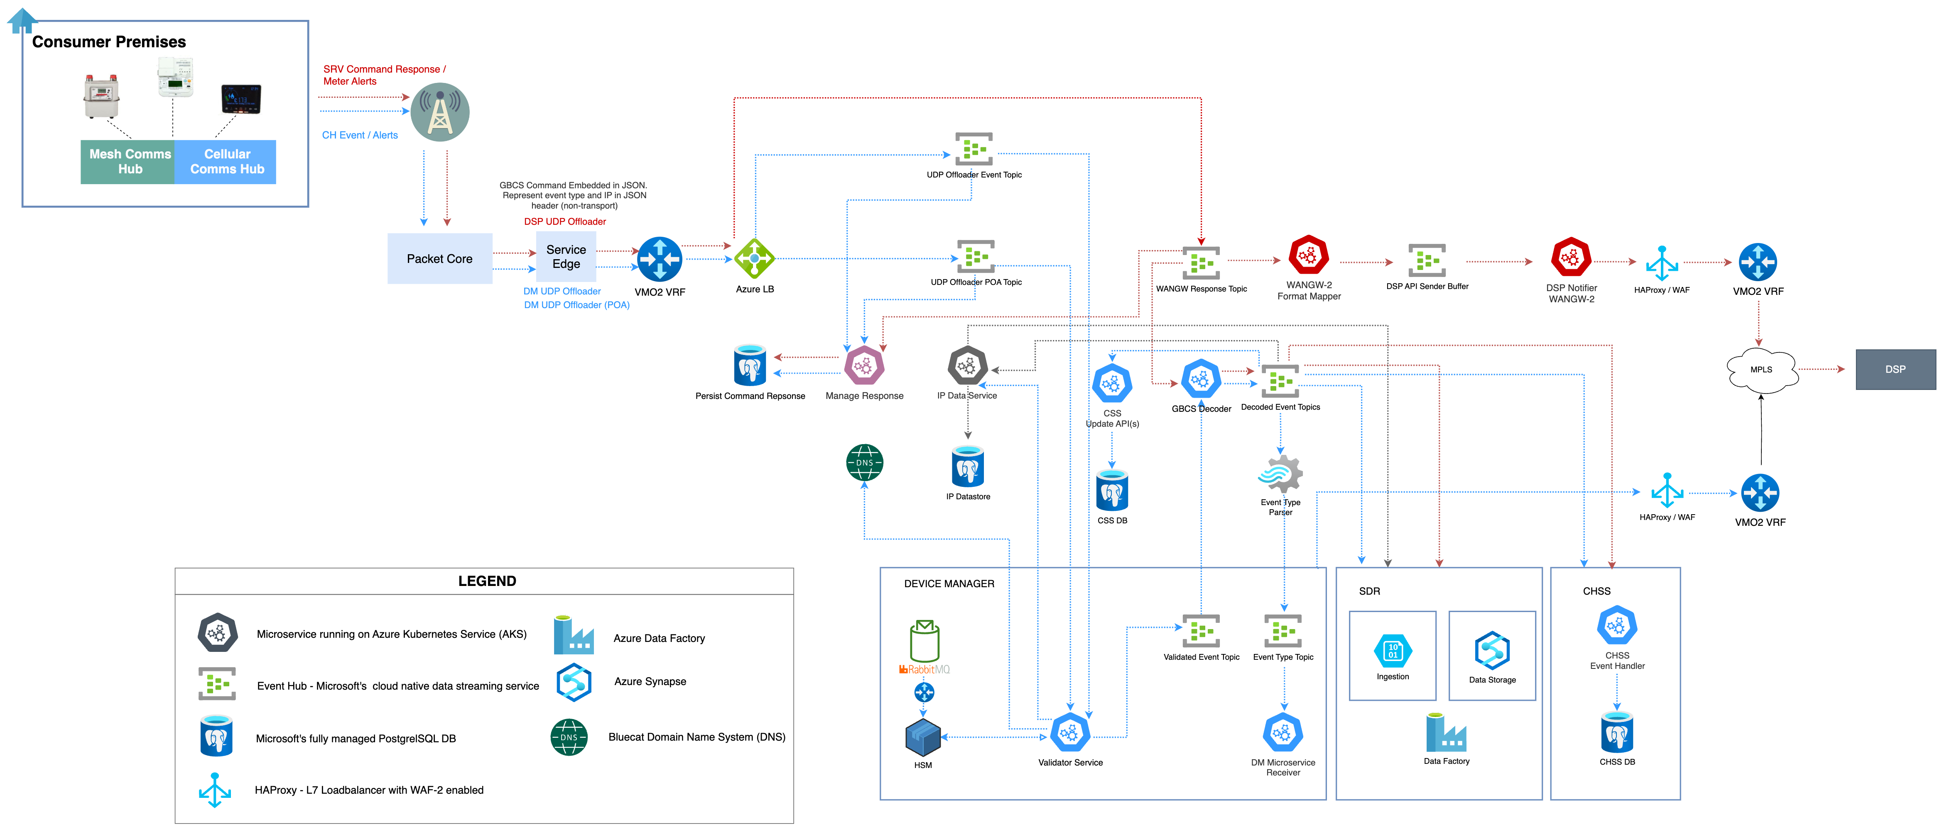

1. Traffic Management Gateway CH Receiver

Note, anomaly detection will continue to be enforced by the DCC as captured in the SD4.4.15 specification.

* + - 1. IPV6/UDP RECEIVER SERVICES (OFFLOADER)
         1. FUNCTIONAL

This service is hosted on the Service Edge and is responsible for the receipt of data traffic across Telefónica’s radio and core network. Data will be ingested into the event hub for translation and downstream processing.

The services will be responsible for publishing messages to the appropriate topic based on the IP segregation implemented by the hubs. The existing solution segregates traffic at an IP level is as follows:

* response to SR commands and DCC meter alerts
* power notifications, confirmed outages (3 minute) and restore;
* all other event types

The DM offloader services will create a JSON formatted message with the GBCS message embedded and related meta-data (like IP information) and publish them for message verification before they are parsed and consumed by downstream services described in the subsequent sections. Note the specific information extraction of the GBCS data to JSON to support the Device Manager functions will occur further downstream as the Offloader services will be kept light weight and the Communication Hub response still needs to be validated. Once validated, the GBCS message will be decoded and mapped to JSON for downstream processing.

Note that the Traffic Management Gateway itself will not validate messages it receives from the Communication Hub. Instead, this function will be performed by the Device Manager services and it will be the responsibility of the Traffic Management Gateway to forward the GBCS data to the Device Manager Validation service. A GBCS signature will be captured in the JSON formatted messages consumed by the Device Manager validator service. SR responses and meter alert messages will be validated by the DSP.

The architecture’s Data and Reporting layer will also consume the data from the bucket event hub as it is interested in all events to support its analytics, reporting and self-serve functions and not just specific events types. While this design describes the consumption of event data exposed by the Traffic Management Gateway by the reporting platform, its capabilities and design sits outside the scope of the Traffic Management Gateway and is described in CSP_TEF_SD01_04_Application_Architecture_Specification.

* + - * 1. INTERFACES

The IPv6/UDP receiver services will have the following logical interfaces:

* IFID647 – To support the receipt of SR responses and meter alerts from the Communication Hub;
* IFID648 – To support the receipt of DM messages / events from the Communication Hub;
* IFID649 – To support the forwarding of SR responses and meter alerts to WAN GW mapper service.
* IFID650 – To support the forwarding of DM responses and CH events to the validator service. This service will issue verification requests to the DM validator service.
* IFID651 – To support the forwarding of POA restore events to the validator service for IP based verification using to the IP data store and DNS.

* The Power outage is described in CSP_TEF_SD02_06_Device_Manager.

* + - 1. GBCS DECODER
         1. FUNCTIONAL

This service consumes validated Device Manager GBCS messages from the validated event topic and decode them aligned with the canonical JSON message format for downstream processing. Once decoded, the service will publish the event to a specific Communication Hub event topic to be consumed by interested Device Manager services.

* + - * 1. INTERFACES

The decoder service will have the following logical interfaces:

* IFID652 – To support the consumption of validated event data from the validator topic after verification of the WAN Provider message signature by the Azure Device Manager validation service or IP verification for power restore events.
* IFID653 – To support the consumption of the Communication Hub traffic by the IP Data service to ensure the Communication Hub IP repository is kept up to date
* IFID654 – To support consumption of decoded messages by the Cell Site Service (CSS). Refer to section 2.7.3.8.
* IFID655 – To support consumption of decoded messages by the Communication Hub Status Service (CHSS). Refer to section 2.7.3.7
* IFID656 – To support the publication of decoded messages for consumption by the event type parser. These messages will be parsed based on event type for consumption by Device Manager services (described below).
* IFID657 – To support consumption of decoded messages by SDR to support analytics and insights. Refer to section 2.7.3.9.
  + - 1. EVENT TYPE PARSER
         1. FUNCTIONAL

This service will consume decoded GBCS messages and parse them based on event type before publishing them to specific topic for consumption by Device Manager services.

* + - * 1. INTERFACES

The event type parser service will have the following logical interfaces:

* IFID656 – To support the consumption of decoded GBCS messages;
* IFID658 – To support the publication of messages to the appropriate Device Manager topic for consumption by Device Manager services.
  + - 1. IP DATA SERVICE
         1. FUNCTIONAL

This service will support the gathering /extracting of IP addresses from incoming communication hub messages. It is a consumer of the bucket event hub where all event data from the Communication Hub are sent. The service will also perform DNS lookup for those GUID where GUID to IP data is not available in the local data store. IP data returned by the DNS lookup will be used to enrich the local IP datastore. This service will support GUID to IP lookup described in section 2.7.2.4.

IP data will be pushed into the Architecture’s Data and Reporting layer to blend with the other data sets to support an end-to-end view**.** The blended data will support triage and operational use cases, allowing Telefónica to adopt proactive measures to make improvements to the service.

* + - * 1. INTERFACES

The IP Data service will have the following logical interfaces:

* IFID660 – To support storage and retrieval of IP data from the IP data store.
* IFID661 – To support the storage of IP related data to support Insights and triage;
* IFID721 – To support the forwarding of POA restore events to the validator service for IP based verification using to the IP data store.
  + - 1. WAN-GW FORMAT MAPPER
         1. FUNCTIONAL

This service will support the mapping of the SR response and the meter alerts to the interface format defined in SD4.4.15. The GBCS response / meter alert message will be mapped as a Base64 encoded string in the payload.

* + - * 1. INTERFACES

The WAN-GW format mapper service will have the following logical interfaces:

* IFID649 – To support the receipt of meter alert and SR responses from the DSP offloader service;
* IFID662 – To support the forwarding of mapped data to the DSP. The message will be published to the DSP API Sender Buffer topic for consumption by the DSP Notifier service. The use of the DSP API Sender Buffer facilitates the throttling of requests to the DSP and provides a mechanism to store events in a planned / unplanned scenario, guaranteeing the delivery of messages across the interface;
  + - 1. WAN-GW NOTIFIER
         1. FUNCTIONAL

This service will support the sending of the SR response and the meter alerts to DSP across the WAN interface. The interface is described in SD4.4.15 and associated Code of Connection.

* + - * 1. INTERFACES

The WAN-GW notifier service will have the following logical interfaces:

* IFID662 – To support the receipt of meter alert and SR responses from the API Buffer topic. The messages will be formatted in line with SD4.4.15;
* IFID663 – To support the issuing of the API request to the DSP. Retry and throttling requirements will align to Telefónica’s equivalent of SD4.4.15 and its associated code of connection.
  + - 1. COMMUNICATION HUB STATUS SERVICE (CHSS)
         1. FUNCTIONAL

This service will support a centralised real-time view of the Communication Hub’s status to support operational processing. In the context of the Traffic Management Gateway and receipt of event data, the gateway will expose the data from the Communication Hub for consumption by the CHSS normalisation service. This service will extract information from the event data to ensure the CHSS presents the most up to date view of the hub’s status.

This service is described in detail in CSP_TEF_SD02_06_Device_Manager and CSP_TEF_SD11_09_Communication_Hub_Status Service_Capability.

* + - * 1. INTERFACES

CHSS will have the following logical interfaces:

* IFID655 – To support the receipt decoded event data for normalisation into the CHSS tables;
  + - 1. CELL SITE SERVICE (CSS)
         1. FUNCTIONAL

This service will provide a cell site view to support cell bandwidth management and mitigate cell overload. The CSS and cell management is described in section 2.9.

* + - * 1. INTERFACES

CHSS will have the following logical interfaces:

* IFID654 – To support the receipt decoded event data for normalisation into the CSS tables;
  + - 1. STRATEGIC DATA AND REPORTING (SDR)
         1. FUNCTIONAL

SDR is Smart Metering’s data lake solution. It supports the acquisition and assembling of data across smart metering, including the Traffic Management Gateway, so that trend analysis and insights (data warehouse) and operational reporting via data marts can be supported. Data governance and data lineage are core capabilities of this service. The SDR platform will also be reasonable for the creation of contractual Performance Measure reports and will provide self-service capabilities for service management and triage teams.

In the context of cell management and leveraging the data lake platform to support TMG decision making, refer to section 2.9.1.2.

* + - * 1. INTERFACES

SDR will have the following logical interfaces:

* IFID657 – To support the receipt event data into SDR;
  + 1. DASHBOARD

Telefónica will create enhanced reporting capabilities and reporting analytics dashboard to provide simplified visualisation of key metrics and performance indicators in relation to the processing of service user commands, firmware distribution and power outage management. The scope will also cover the introduction of the DNO outage screen / mapping. A mock-up of the Traffic Management Gateway dashboard is presented below:



1. Mock-Up Traffic Management Dashboard

The dashboard will present real time or near real time view of:

* SR received and response success rate (refer to section 2.7.2.3)
* This early version of the dashboard shows message prioritisation which is out of scope of CR5220.
* Round trip time for critical commands e.g., meter topups and reads
* Message retry rates
* AD1 correlation with alerts received
* Firmware related data

It should be noted that the final dashboard may differ from that presented above. In addition, information it presents will be adjusted based on agreement with the DCC and internal service management.

## ACK AND RETRY POLICY

This section describes the principles that drive the Traffic Management Gateway’s behaviour in relation to issuing of acknowledgement and managing retries. It also provides a set of use cases that highlights this behaviour.

* + 1. ACKNOWLEDGEMENTS

The key principles in relation to acknowledgements adopted by the Traffic Management Gateway are categorised for DMM processing and SR processing:

* + - 1. SERVICE REQUESTS AND METER ALERTS
* The Traffic Management Gateway will not return ACKs of SR commands it issues to the Communication Hub to the DSP. The DSP are only interested in responses to commands.
* The Traffic Management Gateway will issue ACKs to all SR responses and meter alerts it receives from the Communication Hub.
* Where the Traffic Management Gateway does not receive ACK to SR commands issued to the Communication Hub, the Traffic Management Gateway will retry to deliver the message based on an agreed (configurable) retry count and intervals*.
* The Traffic Management Gateway will take responsibility to retry the issuing of commands when an expected ACK is not received within an agreeable period within the DSP’s own retry block*.
* Where an ACK to the issuing of an GBT block is not received, the Traffic Management Gateway will retry that specific block based on configurable parameters*. Once all retry attempts are exhausted, the Traffic Management Gateway will not return an error to the DSP. Instead, the DSP will manage the retry through the GBT resend process. The TMG will not attempt to deliver further blocks from the series.

* Note, the initial retry count will be set to 0, pending further analysis of initial data and potential changes with DCC parties.

* + - 1. DEVICE MANAGER COMMANDS
* Acknowledgements to autonomous events/alerts from the CH e.g., birth events, PTS will not be issued by the Device Manager. Instead, the Traffic Management Gateway will issue ACKs to all autonomous events it receives.
* Responses to commands are not acknowledged by the Traffic Management Gateway. Timeout to responses will be retried as described in section 2.8.2.

Note that the Communication Hub does not issue an ACK for DMM commands issued by the Traffic Management Gateway but rather waits for the command to be validated/processed before sending the Alert/Response.

The existing Device Manager’s platform capability to react to responses or lack of response will need to be considered during the transition phase. For example, all responses from the hub will be made available to the legacy platform (through the publish and subscribe model) to prevent it from initiating a retry as part of its current behaviour. Other scenarios will be reviewed with the legacy platform team.

* + 1. RETRIES

At deployment TMG will utilise the exact same retry strategy as the DSP. All messages and their retries will be initiated immediately in the same timeframe as the DSP would have done. The TMG will therefore not be acting in a management role at its first release.

During this time, TMG will be gathering the data on a per cellsite level and analysing it (through the Smart Metering Strategic Data and Reporting capability) to identify the success or otherwise of retries in relation to the current cell status and the current Commhub status.

Post initial release:

* Telefónica will propose to DCC and DSP how the DSP retry strategy and VMO2 retry / throttling will be implemented to improve bandwidth management on a per cellsite level.
* Backing off on retries will only be utilized where we believe overall throughput can be increased by initiating less commands.
* It is expected that the reverse will also be true; in some circumstance initiating more retries may result in messages being successful that within the current regime would have failed the 30 second response target. However, as in case bullet 2, Telefónica will need to analysis this data collected to allow us to make these informed decisions and create a dynamic autonomous retry strategy for the TMG.
* These algorithms are expected to be implemented as soon as is viable to complement 3G sunset timescales.

The key principles in relation to retries adopted by the Traffic Management Gateway are categorised for DMM processing and SR processing:

* + - 1. SR AND METER ALERTS
* The Traffic Management Gateway will issue retries to service user requests that are not acknowledged within a specified time interval by the Communication Hub.
* The Traffic Management Gateway will not issue retries to service user requests are acknowledged by are not responded within the response timeout period. GBCS responses and associated timeouts will be managed by the DSP.
* The Traffic Management Gateway will not issue retries for failure responses from the meter or comms up. All responses will be returned to the DSP.
* GBT block messages with respect to retries will be treated the same as standard GBCS messages.

A review of the SRs will be required with the DCC to confirm whether a delay in issuing commands due to retries will not cause an adverse effect on the outcome of the command.

The current DSP timeout for command responses is set to 40 seconds but is a configurable parameter. Telefónica has recommended a timeout of 120 seconds, allowing Telefónica to progress with the retries described above. Alternatively, the message will include response timeout that the DSP will wait for that specific service request that allows the Traffic Management Gateway to manage its own retries within the provided time boundary.

* + - 1. DEVICE MANAGER COMMANDS
         1. RETRIES TO THE CH

For messages to the communication hub, retries will be enabled by the Traffic Management Gateway on behalf of the sending party in the scenario where:

* No response is received or timeout – the hub does not respond within a configurable time; the Traffic Management Gateway will initiate a retry sequence;
* The hub returns an error code – the traffic management gateway will enter retry if it receives a failure code from the hub.

In both cases, once the retry count is exhausted, the initiating system will be sent a failure code.

However, there are exceptional cases to this behaviour that the solution must consider:

* Time critical commands e.g.,
  + Force Time Sync – The time stamp will be inaccurate due to the time incurred through the retry process. Providing inaccurate time to the hub accelerates time drift issues occurring in the hub and therefore a new message will need to be generated.
  + RTT2– the round-trip time is used to measure the performance of our network and the information is used by the device manager platform and fed into performance measures reports. Delays incurred due to retries will impact the accuracy of the round-trip time.
* In addition, a number of SRs have “Protection Against Replay” mechanism active. The difference between the CH not receiving the command and that is actively ignoring the command as a result of this protection may not be clear to the Traffic Management Gateway. Further discussion will be required with the DCC to understand the expected behaviour of the Traffic Management Gateway.

The Traffic Management Gateway framework will cater for those scenarios:

* Where a retry must not be initiated, rather the initiating system will be notified that a failure occurred in attempting to send the command and
* Cases where it is deemed ‘safe’ to initiate the retry.

This will be driven by the command type that is being issued. The Traffic Management Gateway will not recreate commands, for example, create a new FTS with the current timestamp. That responsibility always lies with the Device Manager.

Retry considerations and related design decisions during the transition phase has been captured in section 2.13.

In addition, cell management in the context of delaying the issuing of specific commands and / or retries is covered in section 2.9. This section describes how the Traffic Management Gateway will build up a picture of specific communication hubs and groups of communication hubs over a period in the Communication Hub status service (CHSS) to ascertain whether further retries should be initiated. Under certain circumstances no further retries will be requested, for example when the Traffic Management Gateway confirms that the current state of the hub is in power outage. These characteristics will include algorithms such as if other hubs in the locality aren’t responding at a moment in time, an insight RTT request can be issued to confirm outage.

The table below summaries the retry responsibility against each Device Manager service:

|  |  |
| --- | --- |
| DMM Command | Retry Initiating Service / Application |
| Force Time Synchronisation (FTS) | Source system (Azure DM or Smart M2M) |
| Round Trip Times (RTT) | Source system (Azure DM or Smart M2M) |
| Firmware Download Start | Traffic Management Gateway |
| Operational Commands:   * WANInterfaceSelfDiagnosis, * RetrieveSecurityLog. * WarmReboot, * ColdReboot, * ResetWANInterface | Traffic Management Gateway |
| Critical Command* | Follows the DSP SR retry policy |

1. Device Manager Retry Policy – Issuing Systems

* While the critical command is deemed a device manager service, the issuing of commands is performed by the DSP through the Traffic Management Gateway. As such, the retry policy will align with the SR retry policy.

* + - * 1. RETRIES FROM THE CH

Retry attempts will be configured between the communication hub and the WAN as well as queues that will hold messages and alerts that cannot be delivered, allowing corrective action once the network is re-established.

* + 1. USE CASES

This section describes the expected behaviour of the traffic management gateway against a set of use cases. The ACK and RETRY is also captured per use case.

* + - 1. SR REQUESTS AND RESPONSE – GBCS COMMANDS

This section provides a sequence view of the SR command and response for GBCS commands i.e., those that are up to 1200 Octets in size:

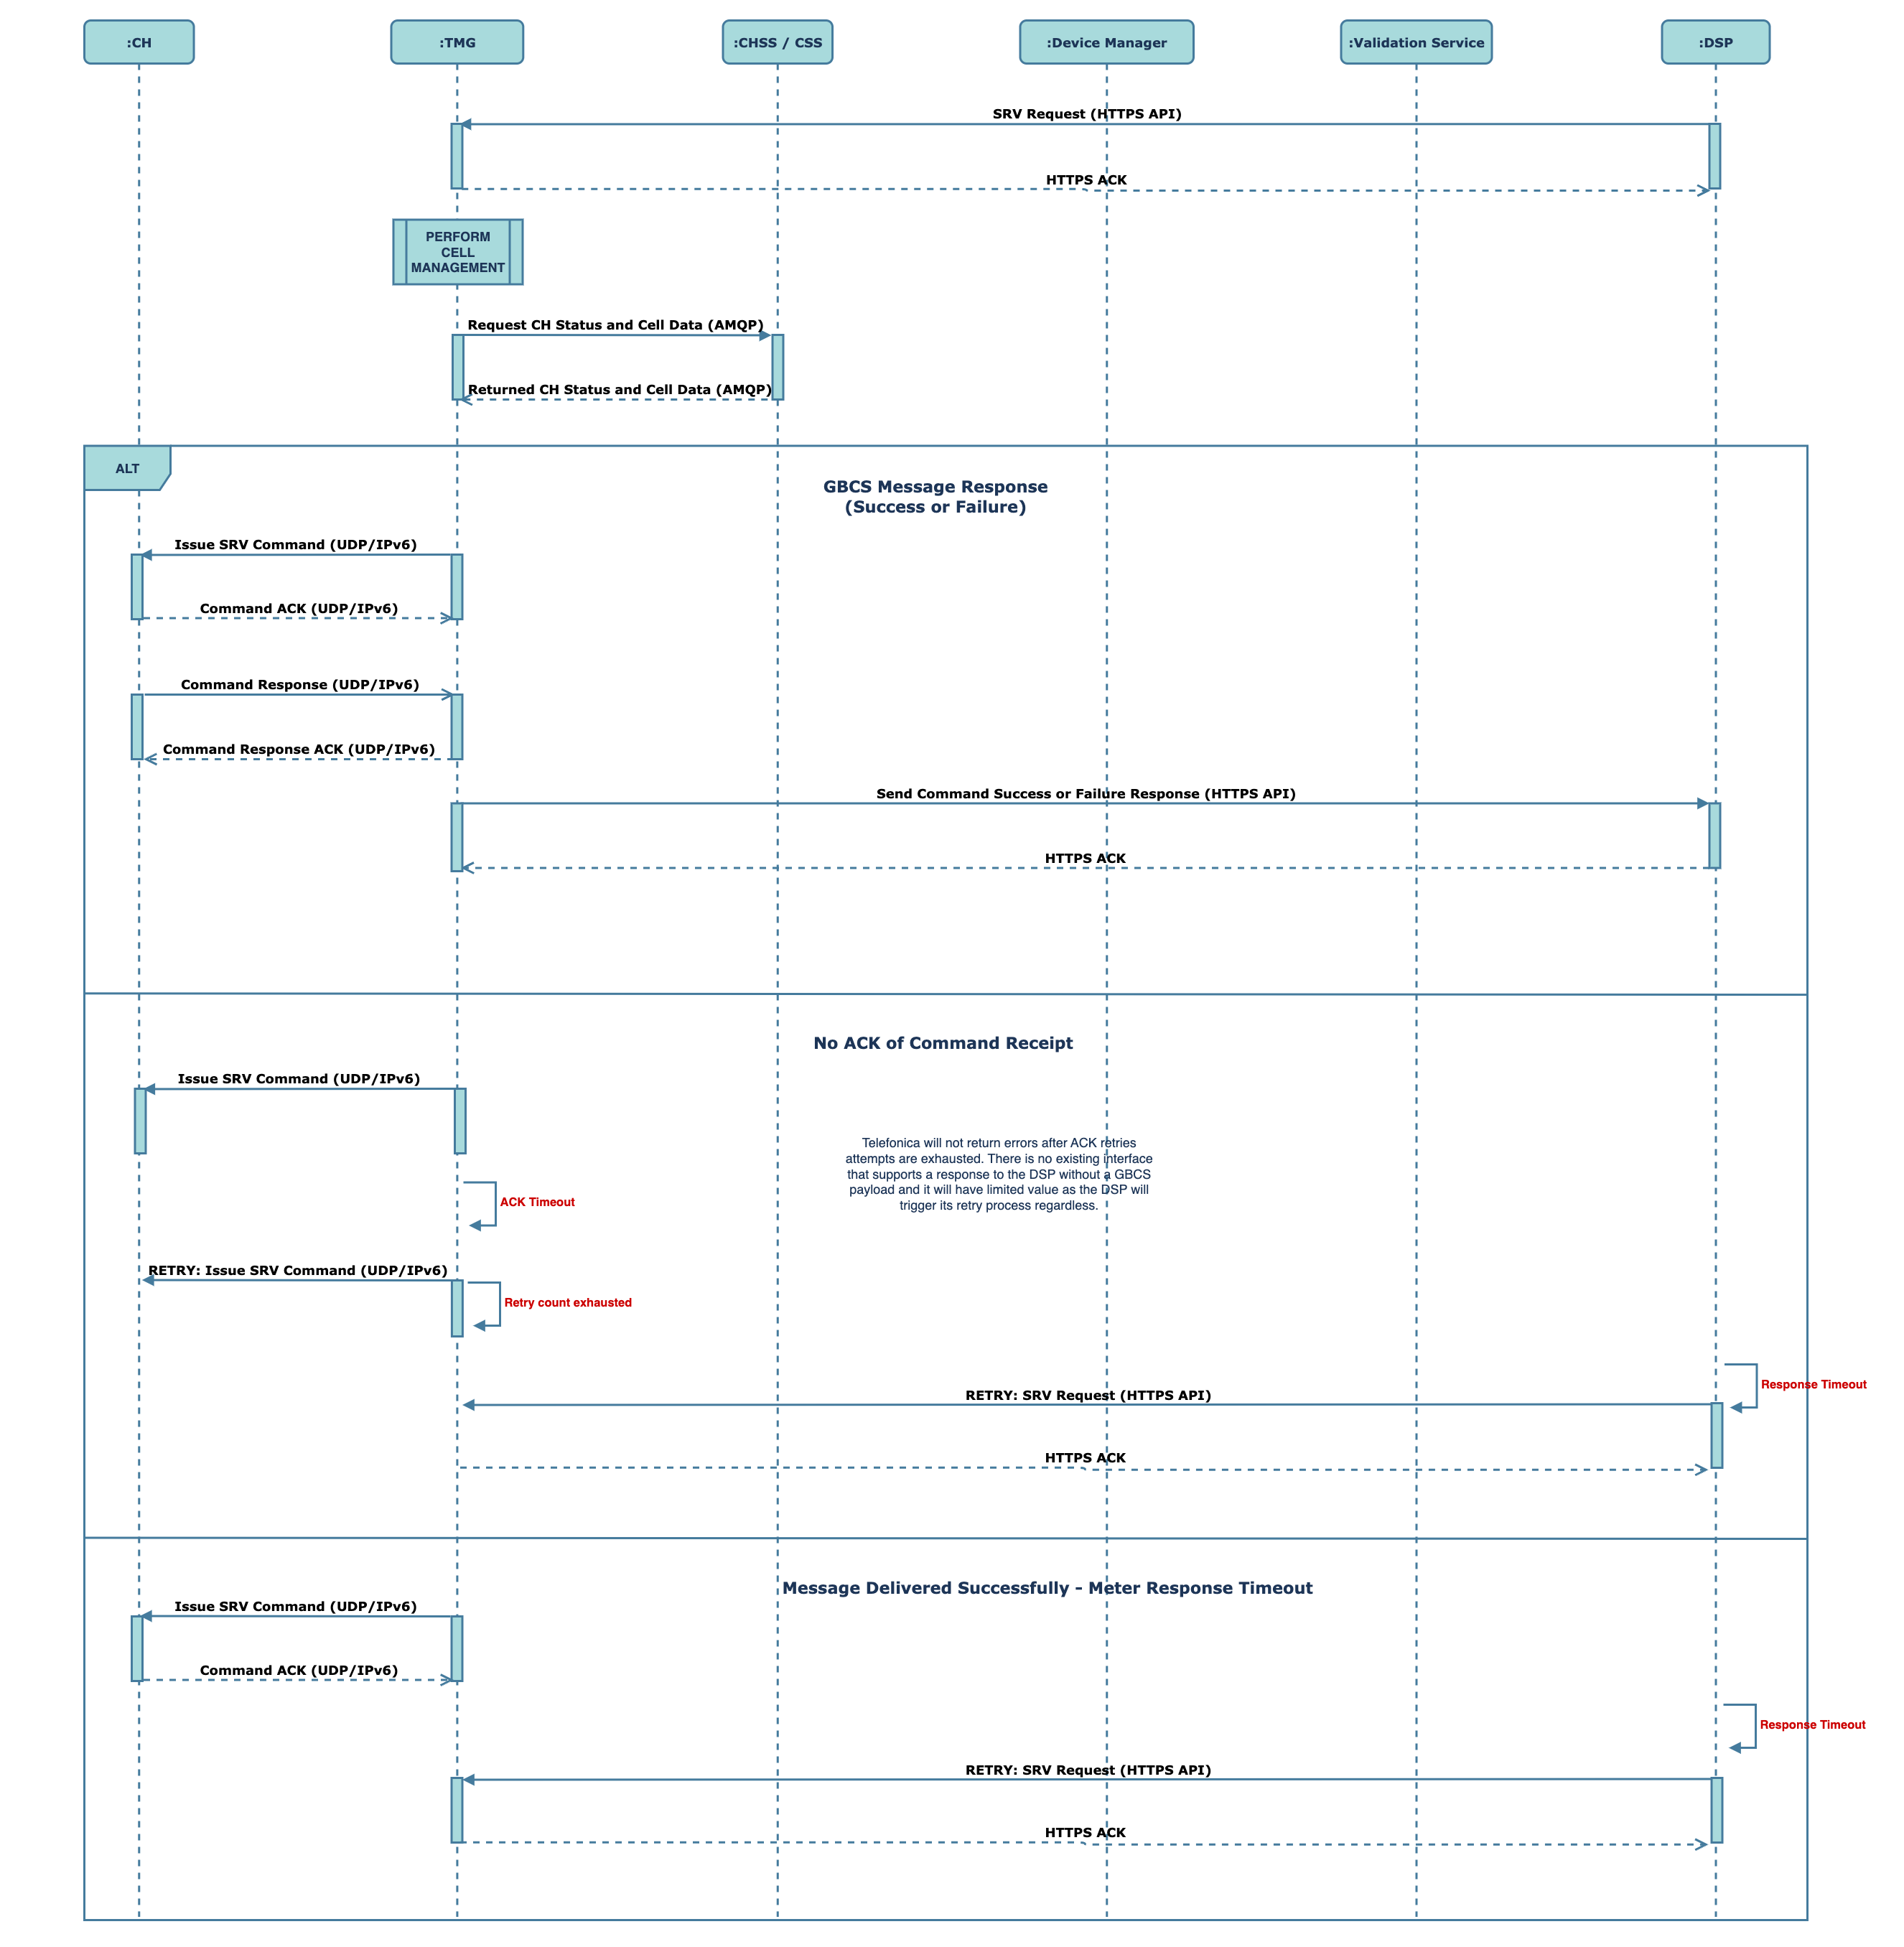

1. SR Request and Response Sequence - GBCS

The sequence is described below:

* The DSP will issue SR commands (up to 1200 Octets) to the Traffic Management Gateway.
* The gateway will utilise Communication Hub status and cell information to establish the highest probability of success (refer to section 2.9).
* The Traffic Management Gateway will issue the SR command over the UDP/IPv6 connection and accept receipt of the command ACK from the Communication Hub.
* The Traffic Management Gateway will accept the command response from the Communication Hub and forward the response to the DSP over the API interface. This is true regardless of whether the Communication Hub sends a command response that is expected or is a failure response. The Traffic Management Gateway will not interrogate the response payload.
* The following alternative outcomes are described below:
  + Upon issuing the command, if the Traffic Management Gateway does not receive a command ACK from the Communication Hub, it will enter its configurable retry process.
  + The Traffic Management Gateway will not notify the DSP if no ACK is received after the retry attempts have been exhausted. There is no existing interface that supports a response to the DSP without a GBCS payload and it will have limited value as the DSP will trigger its retry process regardless.
  + Where an issued command is acknowledged to the Traffic Management Gateway but subsequently the command response timeouts out, the DSP will issue the retry. Traffic Management Gateway will not manage SR response timeouts.
    - 1. SR REQUESTS AND RESPONSE – GBT COMMANDS

This section provides a sequence view of the SR command and response for GBT commands i.e., those that are greater than 1200 Octets in size:

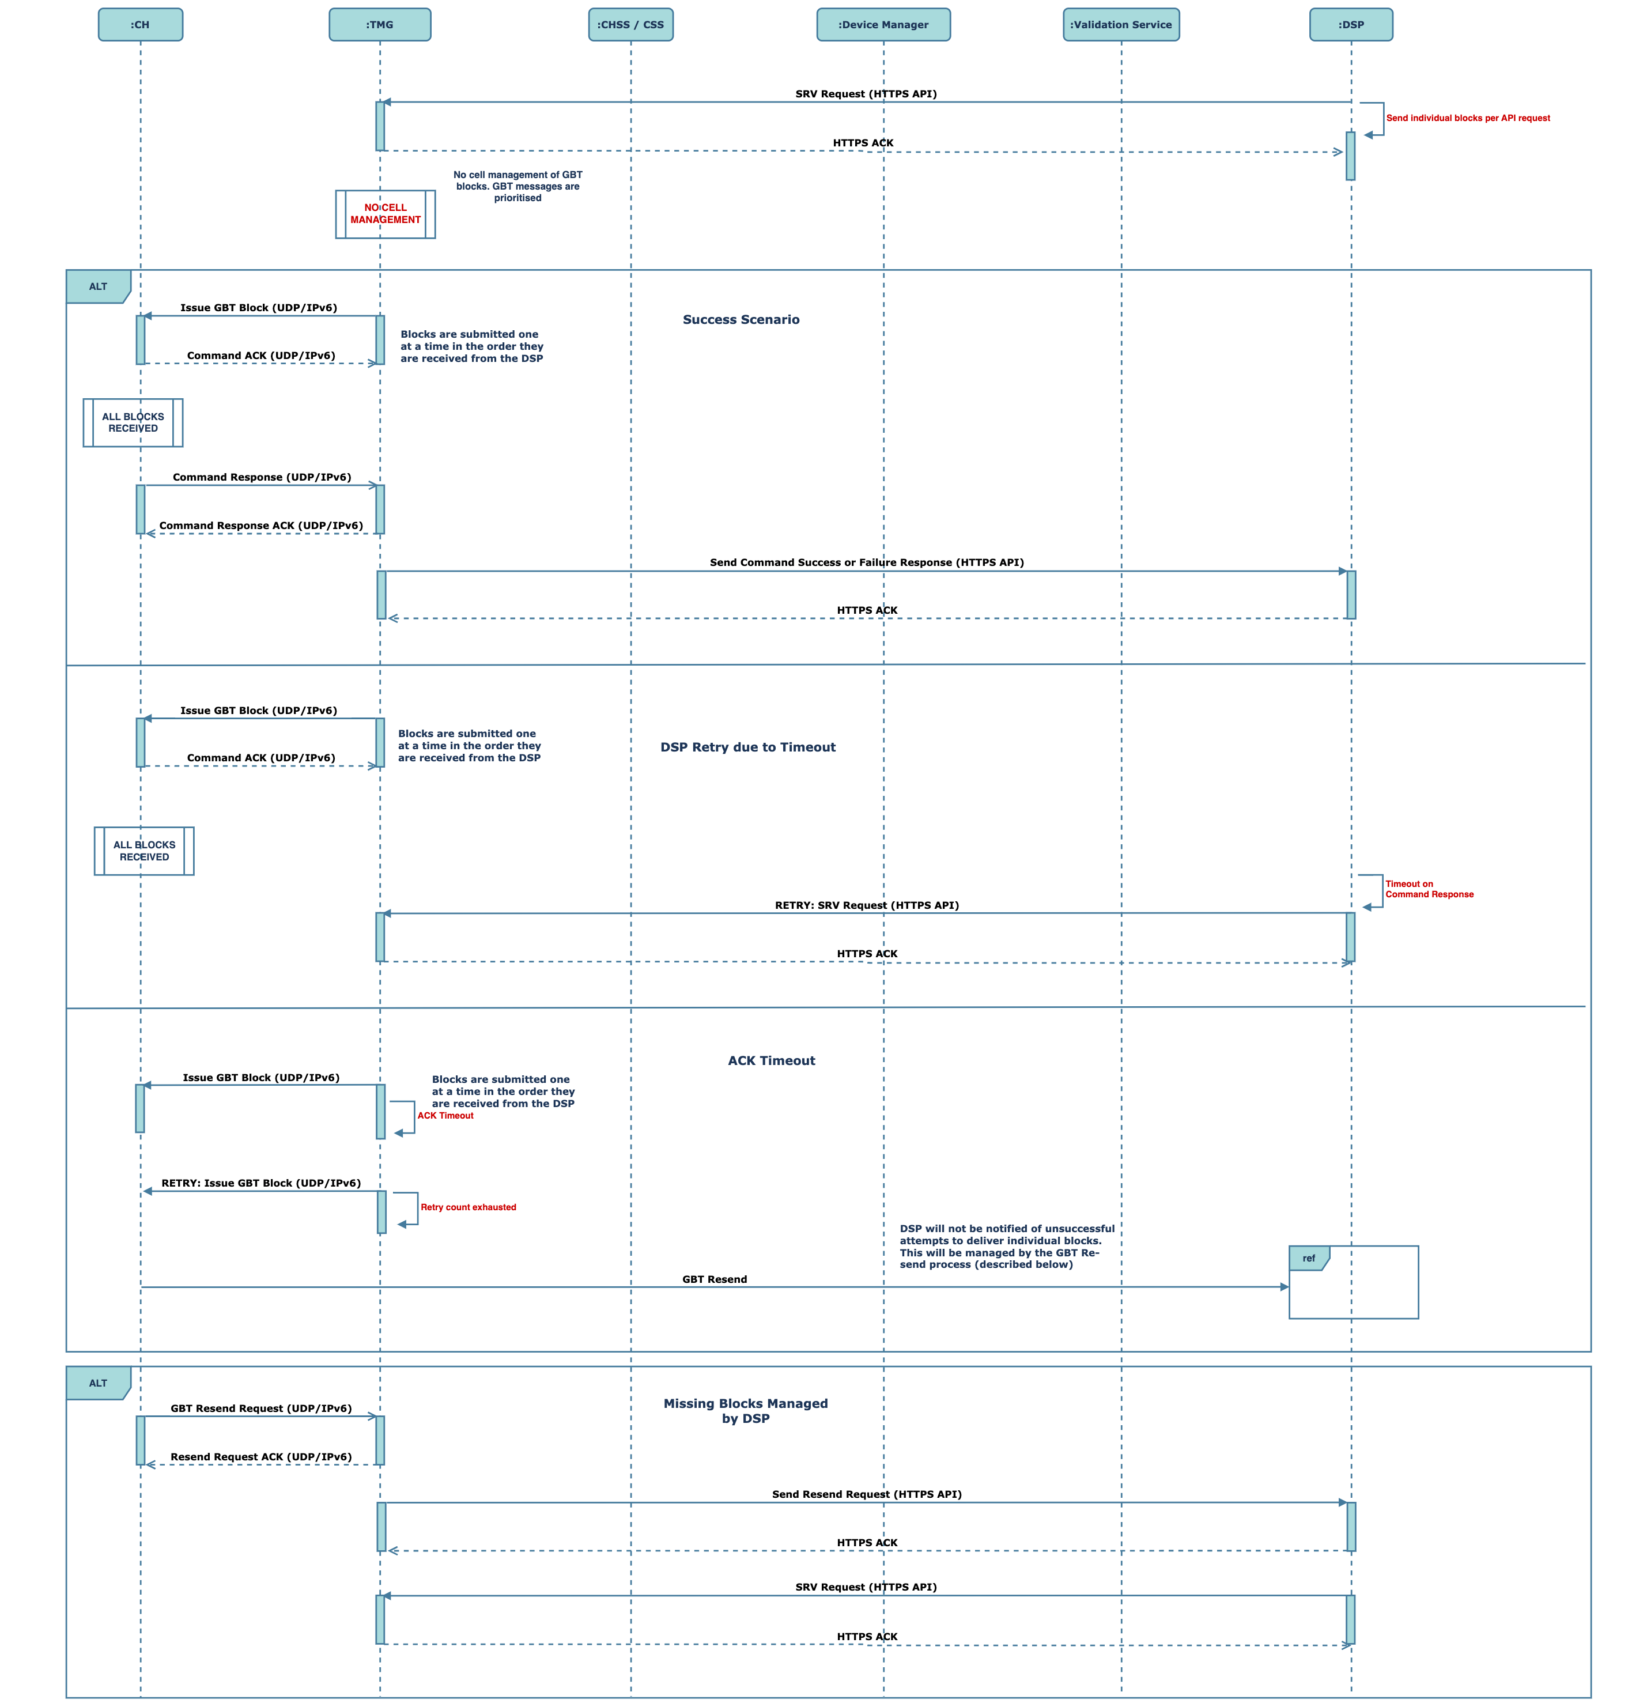

1. SR Request and Response Sequence - GBT

The sequence for processing of individual GBT blocks is aligned to processing of a GBCS command with the following notable considerations:

* GBT blocks will be issued to the Communication Hub in the order they are received. However, this is not a strict consideration as the meters themselves order GBT blocks.
* Command responses will be issued by the Communication Hub upon receipt of all GBT blocks. Upon receipt of all blocks, the command response responsibility of the Traffic Management Gateway will align to response of GBCS commands.
* Where individual GBT blocks are not acknowledged, the Traffic Management Gateway will enter the (configurable) retry process.
* If an ACK is not received after the retry attempts, the Traffic Management Gateway will not notify the DSP. Instead, management of a missing block will be managed by the existing capability of the Communication Hub to issue GBT resend notification which the Traffic Management Gateway will forward to the DSP. The DSP will then issue missing block.
* A lack of an acknowledgement from the issuing of a GBT block will not prevent other GBT blocks in the GBT series from being processed by the Traffic Management Gateway. A stated, missing blocks will be managed between the Communication Hub and DSP through existing capabilities.
* For GBT blocks issued by the device for consumption by the DSP, the Traffic Management Gateway will attempt to send individual blocks received from the hub. Ordering is not strictly enforced as any GBT block ordering requirements will be fulfilled by the DSP. Any missing blocks will result in the DSP issuing a GBT resend request to the device, facilitated through the Traffic Management Gateway.
  + - 1. METER ALERTS

This section provides a sequence view of the meter alerts:

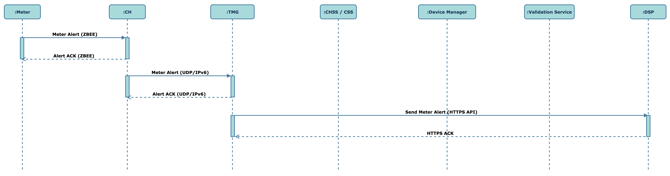

1. Meter Alert Sequence

The sequence is described below:

* The Communication Hub will send the GBCS alert to the Traffic Management Gateway;
* The Traffic Management Gateway will acknowledge the alert forwarded by the Communication Hub.
* The Traffic Management Gateway will embed the GBCS alert in a JSON object which will be sent to the DSP aligned to SD4.4.15.

Please note that the Service Edge will ACK the UDP/IPv6 alert from the Communication Hub. While not illustrating in the sequence diagram, it can be inferred sitting between the Communication Hub and the TMG.

* + - 1. AUTONOMOUS EVENT PROCESSING WITH DEVICE MANAGER

This section describes the Traffic Management Gateway’s responsibility in processing autonomous events to the device manager (i.e., not responses to commands). This sequence will be referenced in subsequent flows.

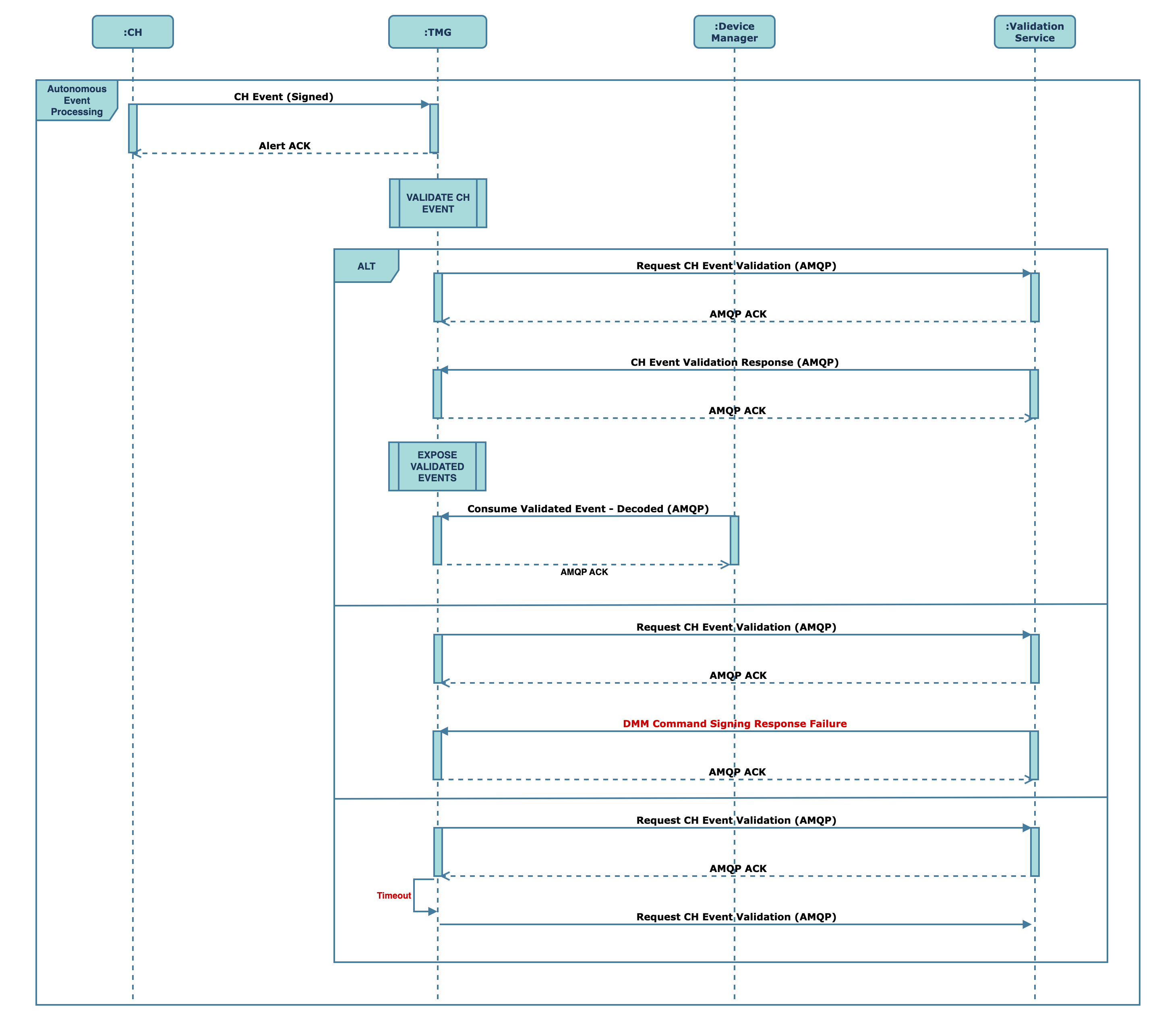

1. Autonomous Event Processing with Device Manager

The sequence is described below:

* Events / alerts will be sent to the Traffic Management Gateway with the WAN Provider signature.
* The signature will be validated using the Validator service:
  + Upon successful validation, the event data will be exposed for downstream processing.
  + Where a failure response is returned from the validator service, the event will not be exposed for downstream processing. Instead, the failure will be logged as a security incident.
  + Where the call to the Validator service timeouts, the event will not be exposed for downstream processing. Instead, the failure will be logged as a security incident.
    - 1. DEVICE MANAGER COMMAND AND RESPONSE

This section describes the Traffic Management Gateway’s responsibility in issuing device manager commands and processing responses. This sequence will be referenced in subsequent flows:

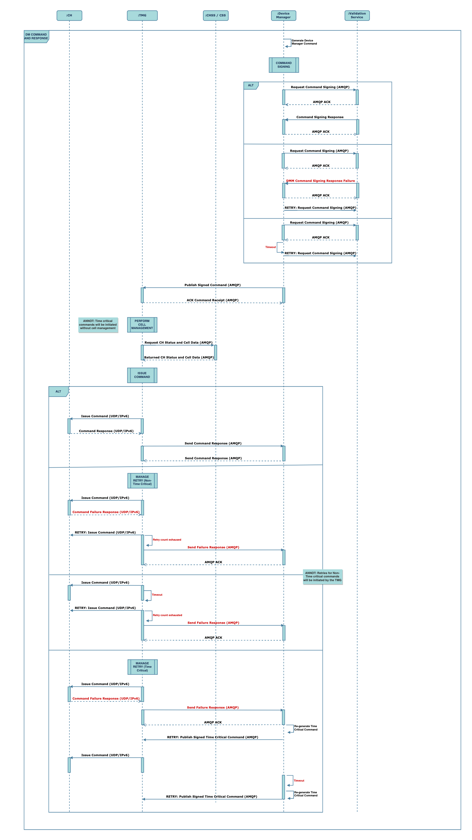

1. Device Manager Command and Response

The sequence is described below:

* Device Manager will generate the DMM command it intends to issue to the Communication Hub.
* It will then issue a request to sign the message. The signing service is also a Device Manager function.
* Any failure in signing the request will trigger the retry and incident management process.
* Commands that have been successfully signed by the Device Manager will be sent to the Traffic Management Gateway.
* Upon receipt of the command, the Traffic Management Gateway will determine the success criteria for the command based on the command type, monitoring of traffic through the gateway, network data and Communication Hub status. Refer to section 2.9 for more details on how the Traffic Management Gateway manages the issuing of commands through the cellular network.
* Cell management will not be performed against time critical commands as described in section 2.9. Instead, they will be prioritised and issued immediately upon receipt from the Device Manager.
* Upon issuing of the command, the Traffic Management Gateway will process its response and forward that response to the Device Manager.
* The Traffic Management Gateway will retry to send non-time critical commands for which a response has not been received within a configurable time period or a failure response has been received.
* If the error persists after the retry count is exhausted, the Traffic Management Gateway will notify the Device Manager of the failure.
* For time critical commands, any failure responses or timeout will be managed by the Device Manager. The Traffic Management Gateway will not generate commands to the hub.
  + - 1. FIRMWARE DOWNLOAD COMMAND

This section provides a sequence view of the firmware download command:

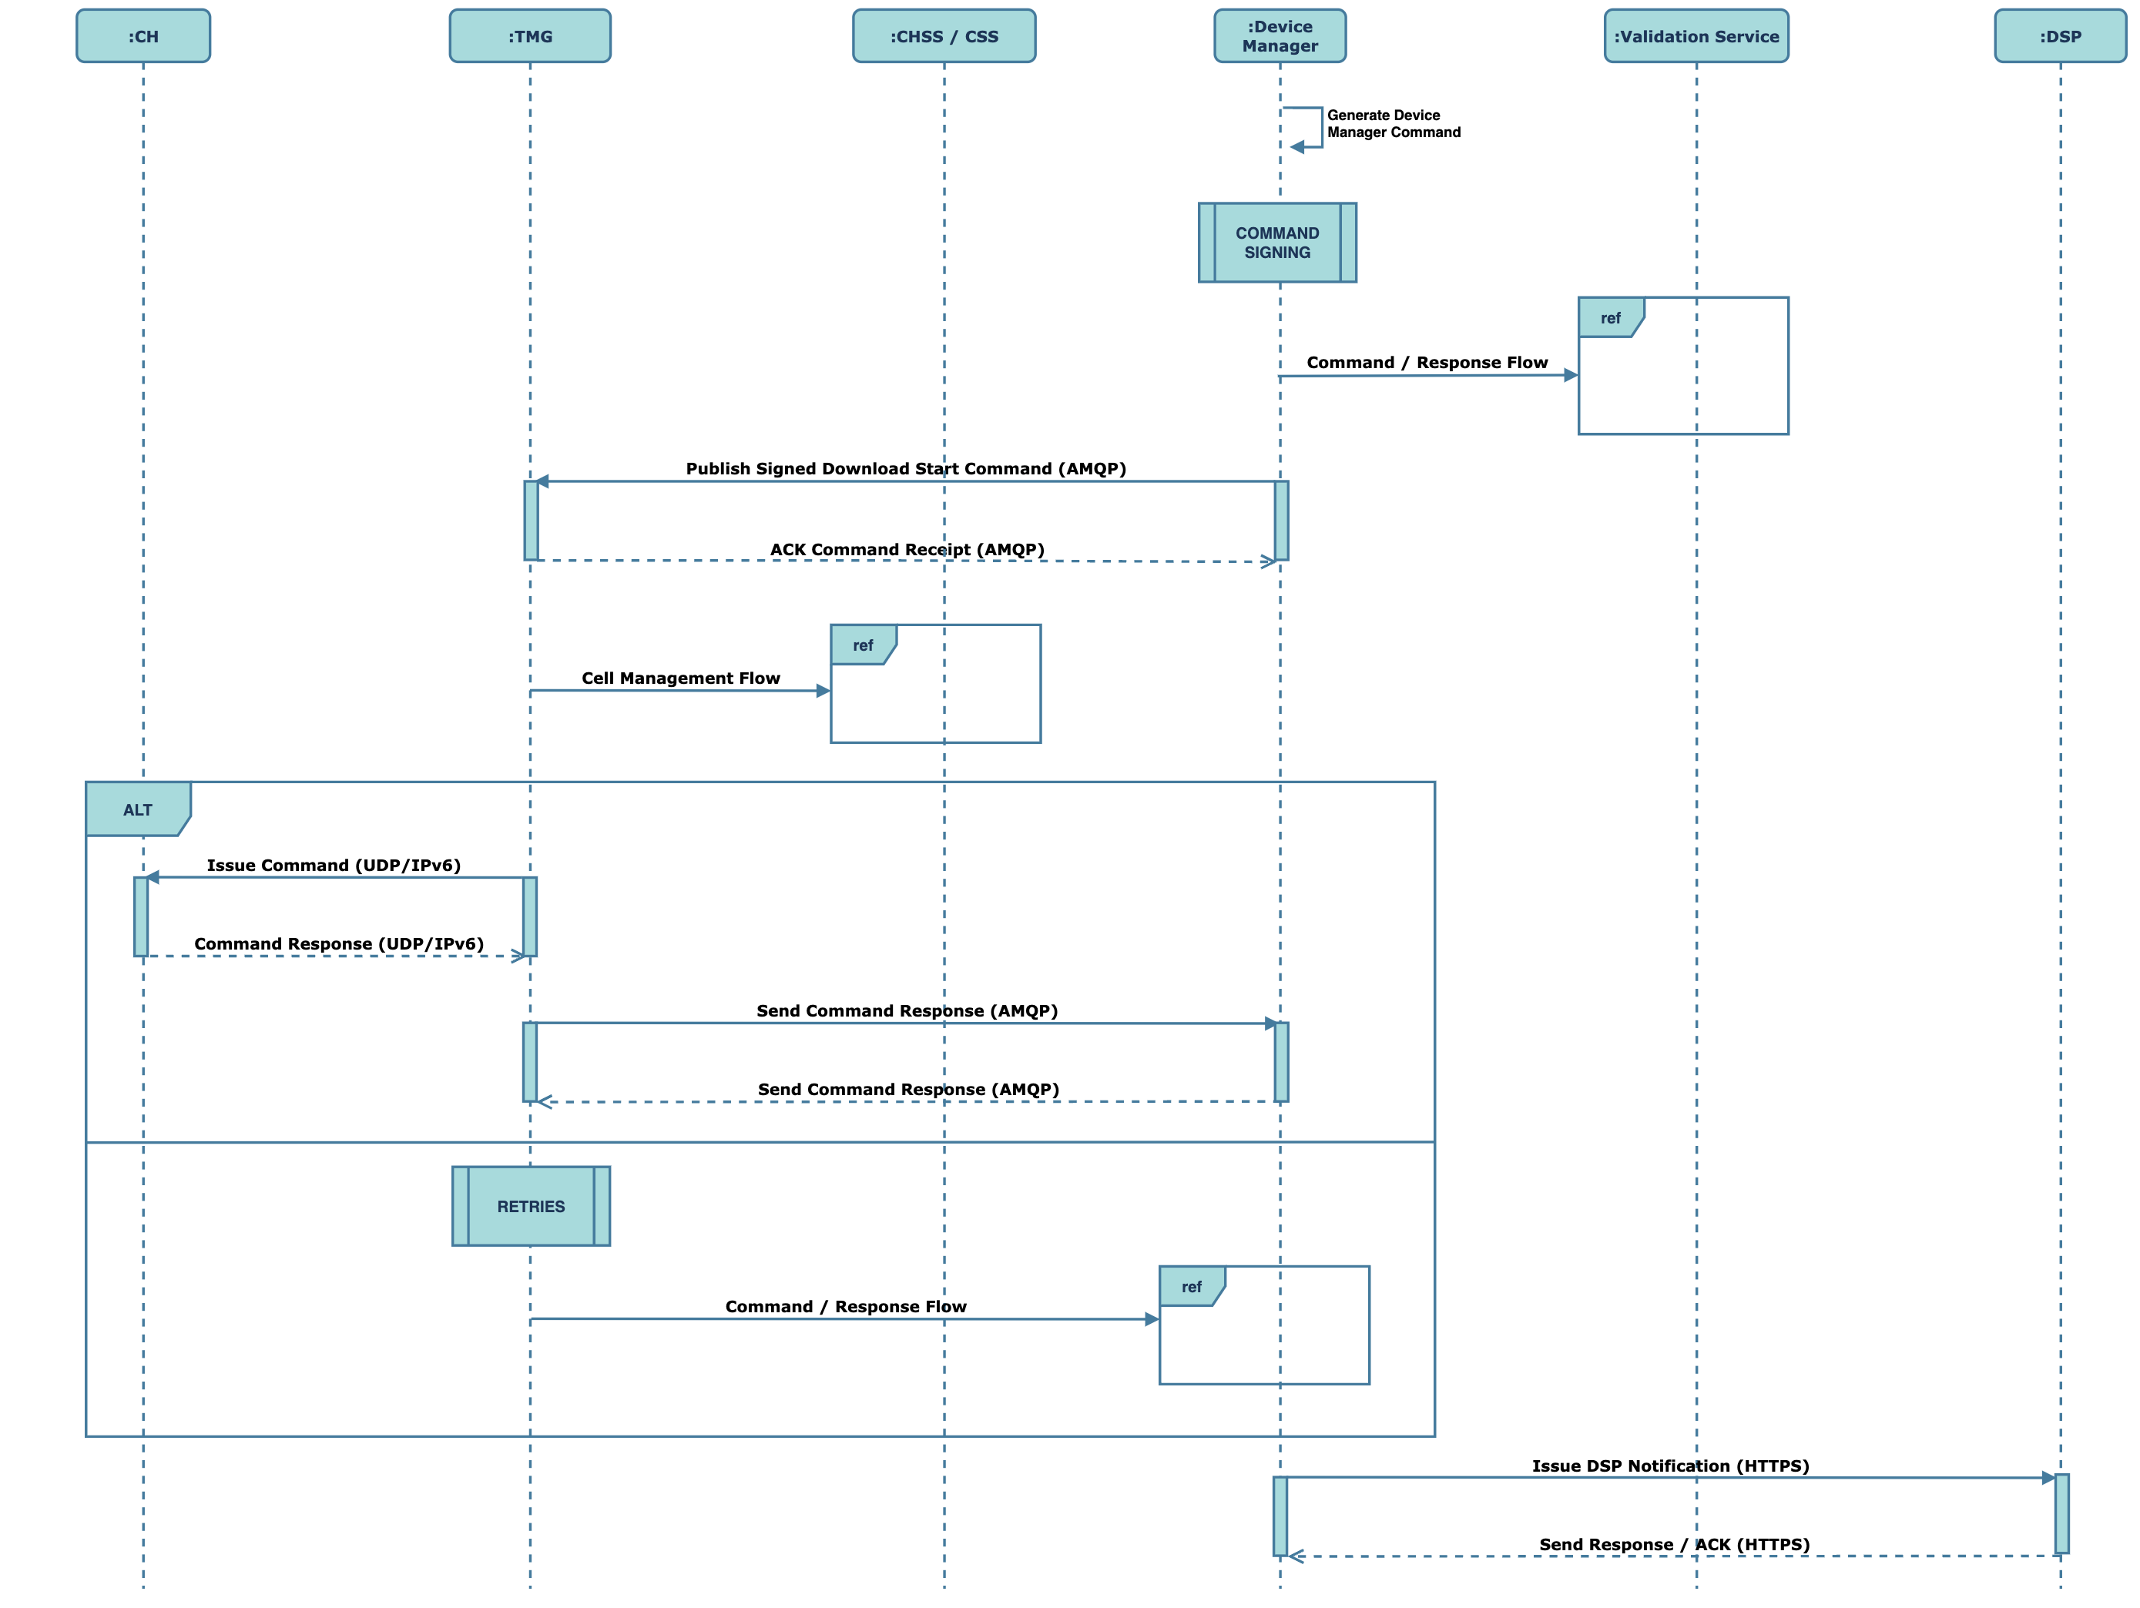

1. Firmware Download Sequence

The sequence is described below:

* The download command is generated by the Device manager.
* The message is signed as described in section 2.8.3.5 and sent to the Traffic Management Gateway.
* The Traffic Management Gateway will perform cell management as described in section 2.8.3.5.
* The DMM command is then issued to the Communication Hub by the Traffic Management Gateway;
* The Communication Hub will send the Traffic Management Gateway a command response;
* The response will be sent to the device manager;
* Error and retries will be as described in section 2.8.3.5.
* The device manager will issue the API download status request to the DSP as described in SD4.4.2.

Note that further issuing of commands to the meter will be required for the meter to download the firmware and for it to be activated. These are standard GBCS commands.

It is worth noting that in November 2024, the firmware service runs from Sm2m and therefore the service described is SD11-02 is correct. From June 2025 the firmware service will move to Azure and therefore SD02_05 will be correct. The set up for November is the same as it is now. The set up for June 2025 will be as described above. For example, the Device Manager will request validator to sign a command it generates as part of DM Phase 2 when the firmware service is migrated to Azure. While the service is hosted on Smart M2M, signing responsibility will lie with the TMG to reduce the complexity on the legacy platform as part of the transition. Also refer the transition section in CSP_TEF_SD01_04_Application_Architecture.

* + - 1. PUSH TIME SYNC (PTS) AND FORCED TIME SYNC (FTS)

This section provides a sequence view of the PTS and subsequent issuing of the FTS command:

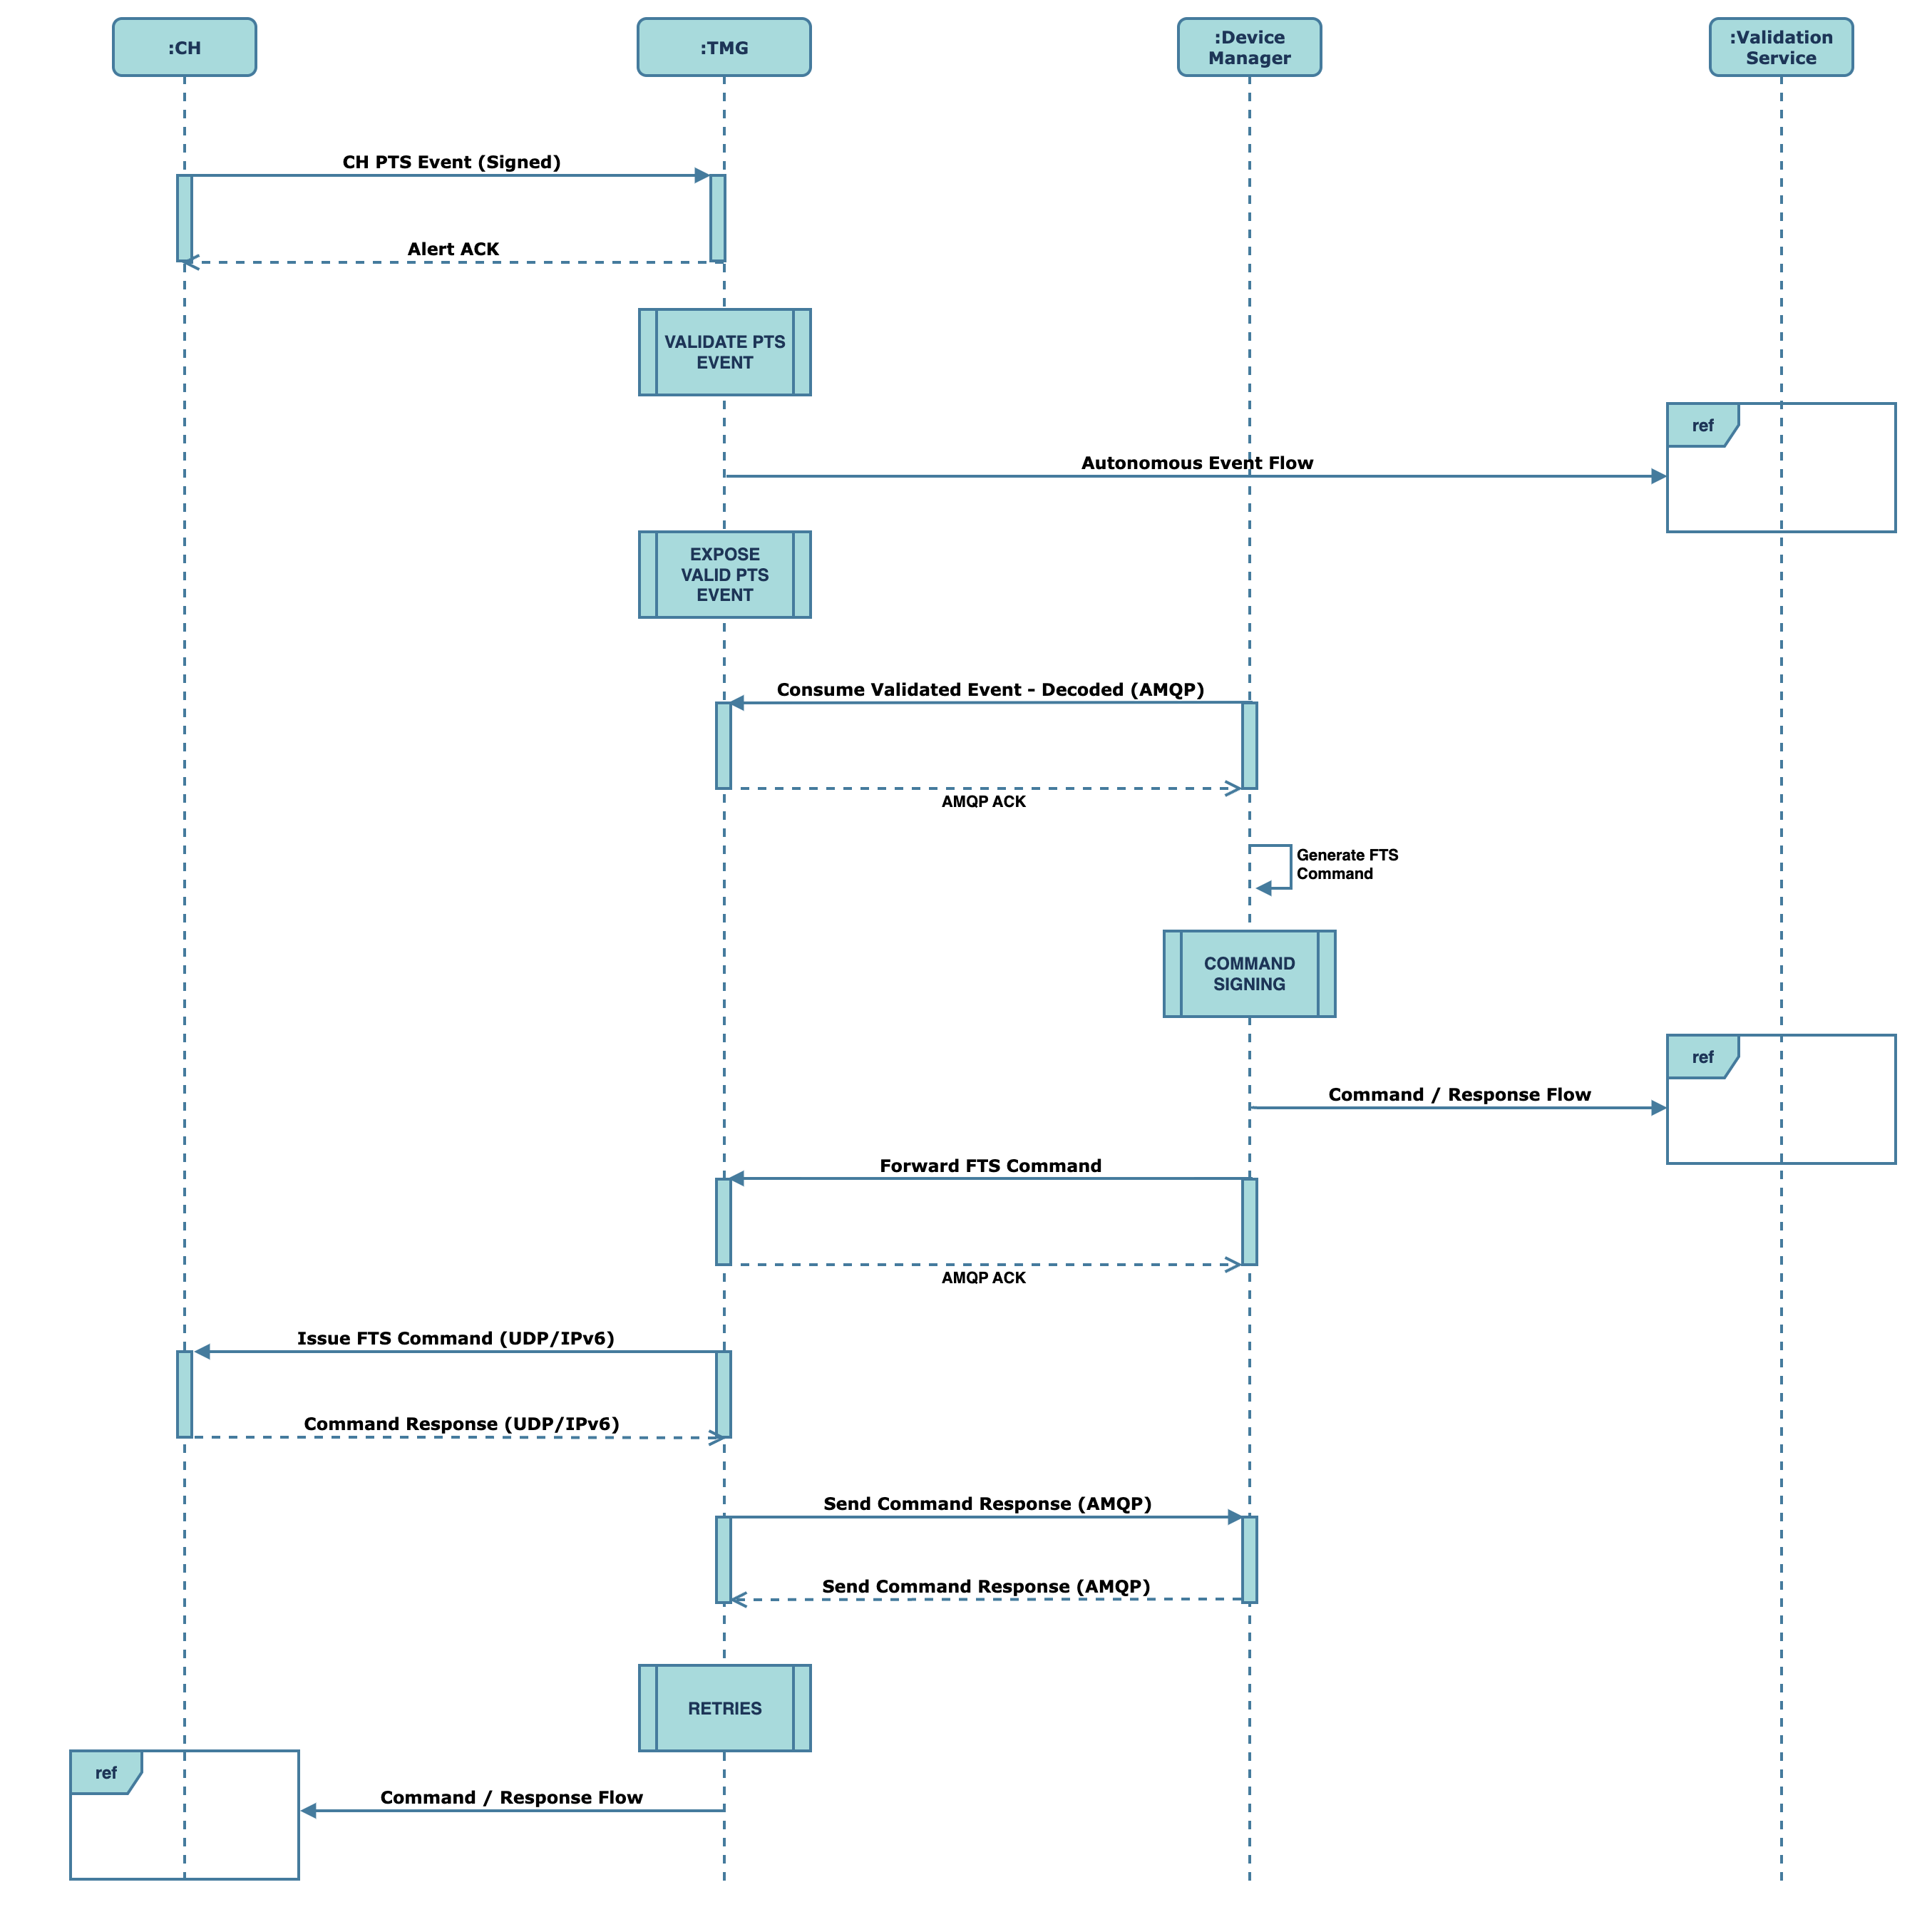

1. PTS and FTS Sequence

The sequence is described below:

* The Communication Hub will issue the scheduled Push Time Sync to the Traffic Management Gateway;
* The Traffic Management Gateway will acknowledge the receipt of the PTS alert and request validation.
* The validation sequence will follow the Autonomous Event process described in section 2.8.3.4.
* The Traffic Management Gateway will decode and expose the validated PTS message for processing by the Device Manager.
* The Device Manager will generate and issue the Forced Time Sync command to the Communication Hub via the Traffic Management Gateway as described in section 2.8.3.5.
* The response to the FTS from the Communication Hub will be forwarded to the device manager via the Traffic Management Gateway.
* Errors and retries will be handled as descried in section 2.8.3.5.

Telefónica will consider deprecating the PTS end-to-end process where it is deemed appropriate to issue the FTS on a per day basis.

* + - 1. BIRTH EVENT AND FORCED TIME SYNC (FTS)

This section provides a sequence view of the Birth event and subsequent issuing of the FTS command:

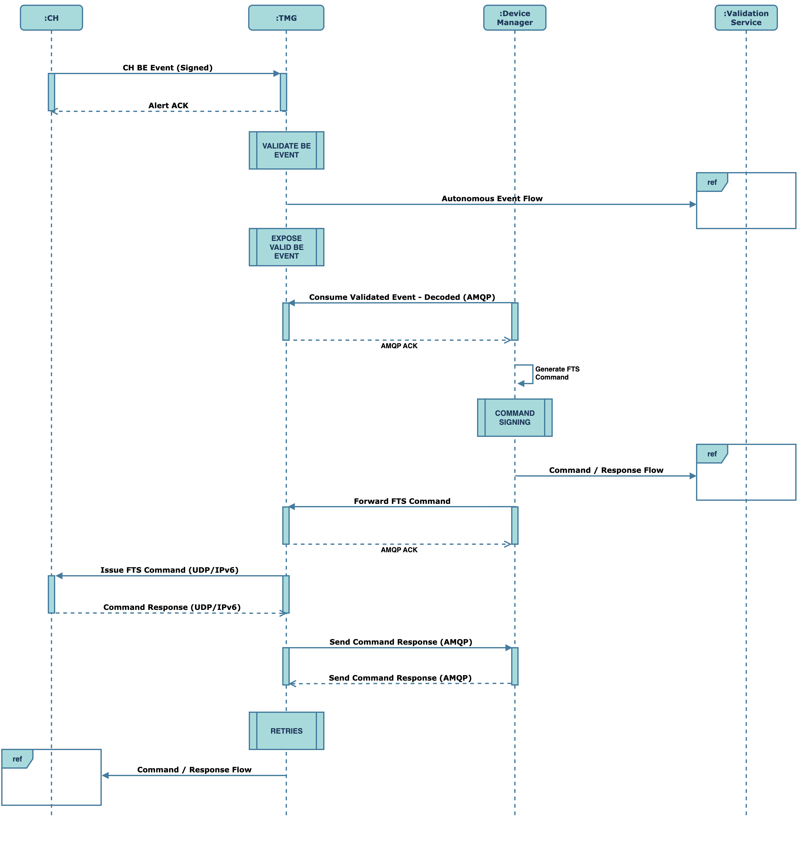

1. Birth Event Sequence

The sequence is described below:

* The Communication Hub will issue the birth event to the Traffic Management Gateway when it first connects to the network;
* The Traffic Management Gateway will acknowledge the receipt of the birth event alert and request validation.
* The validation sequence will follow the Autonomous Event process described in section 2.8.3.4.
* The Traffic Management Gateway will decode and expose the validated birth event message for processing by the Device Manager.
* The Device Manager will generate and issue the Forced Time Sync command to the Communication Hub via the Traffic Management Gateway as described in section 2.8.3.5.
* The response to the FTS from the Communication Hub will be forwarded to the device manager via the Traffic Management Gateway.
* Errors and retries will be handled as descried in section 2.8.3.5.

It should be noted that all notifications to the DSP (birth events) as well as requests received from the DSP (diagnostics, CHSU) will continue to align to the SD4.4.4 interface.

* + - 1. UTILISING AZURE PLATFORM SERVICES FOR RETRIES

Hosting Traffic Management Gateway and Device Manager on Azure allows Telefónica to leverage the platform’s out of box resiliency capability.

## CELL BANDWIDTH MANAGEMENT

The sequence diagram below illustrates the capability of the traffic management gateway to manage cell utilisation and ensure cells are not overloaded.



1. Cell Bandwidth Management

Under CR5220, Traffic Management Gateway will not take action against any message prioritisation information available via the DSP interface.

The cell management will be built on the following principles:

* The Traffic Management Gateway will rely on real time monitoring to ascertain a current view of the cell bandwidth.
* The Traffic Management Gateway will only manage Smart Metering traffic, however using visibility of real time Smart Metering traffic per cellsite, TMG will be able to infer a real time view of the individual cellsite status for ALL traffic.
* Cell bandwidth information will be stored in the Communication Hub Status Service (CHSS) and the Cell Site Status (CSS) to inform the Traffic Management Gateway of the likely success factor for a particular hub. The success criteria will be based on limits of the cell and the Traffic Management Gateway will manage requests within those limits based on expectation of other traffic.
* This cellsite status view will be used to determine the use of back off algorithms for traffic when smart metering traffic volumes for that cell are high in order to reduce cell loading and therefore increase the overall message success rates for Smart Metering traffic.
* TMG can also use similar algorithms to enhance / reduce any retry period when messages are not responded to where the deemed traffic volumes are low. For this scenario there is a possibility that a successful retry would be within the initial 30 second response time, something that is not possible today as all retires only start after 40 seconds.
* Data traversing the Traffic Management Gateway will be shared with the Strategic Data and Reporting (SDR) platform. Any analytic processing of this data by SDR can be shared with the CSS and the CHSS to provide insights that further support the Traffic Management Gateway’s ability to determine the success factor for submissions to the hub. Primary focus, however, will be gathered through monitoring and real-time data from the Communication Hub and not data provided by SDR.
* If access to the CSS and CHSS is not available, the Traffic Management will send traffic to the hub by default.
* The Traffic Management Gateway will not perform the heavy lifting in terms of analysis data and making conclusions that the gateway can utilise to help determine whether a message should be sent.
* Traffic Management Gateway itself will perform light weight logic on status and dynamic data it receives from the CHSS and CSS.
* The data to help answer this question can be grouped in two broad categories:
  + Static data such as threshold limits.
  + Collection of data over a period (24hrs initially for now but can be adjusted) to build a picture of when we have success against a cell or not as the case may be. This information that allows the TMG is determine whether the request should be submitted or throttled for a few seconds.

The snapshot below highlights the interactions between the Traffic Management Gateway and the CHSS and the CSS. Details of the interaction are described in section 2.7.1:

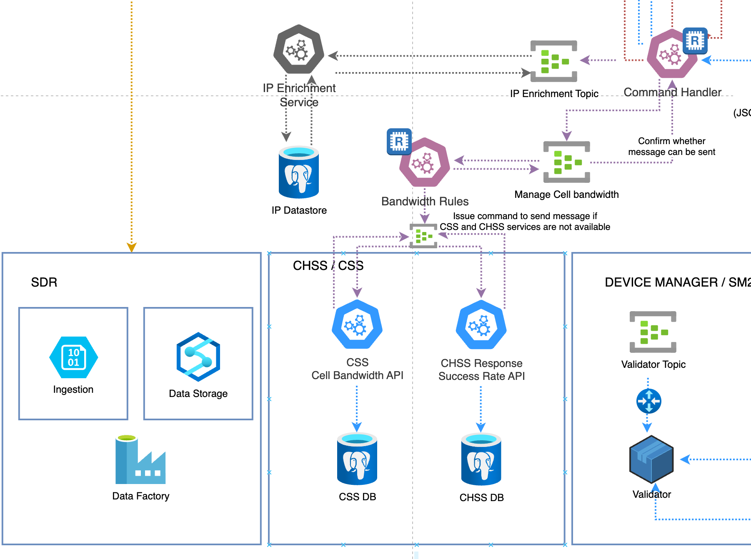

1. CHSS and CSS Interactions

The key attributes captured in the CSS include:

|  |  |
| --- | --- |
| Attribute | Description |
| Mobile Connection ID | Unique identifier for the mobile connection. |
| Mobile Connection PS Status | Indicates the Packet Switched (PS) status of the mobile connection, whether it is connected or disconnected. |
| Mobile Signal Received Signal Strength Indicator (RSSI) Value | Measurement of the power level received by an antenna, indicating the signal strength. |
| Mobile Signal Bit Error Rate (BER) Value | Signifies the quality of transmission to and from the cell, with lower values indicating better transmission quality. |
| Mobile Signal Connection Neighbouring Cells | Lists the neighbouring cells to which the mobile device is connected or can connect. |
| Mobile Connection Local Area Code | Identifier for the local area where the mobile connection is established. |
| Last Updated Timestamp | Timestamp indicating the last time the data associated with the mobile connection was updated. |
| Create Date Timestamp | Timestamp indicating when the mobile connection record was created. |
| Mobile Signal Ec/Io Value | Measure of the quality/cleanliness of the signal from the tower to the modem, indicating the signal-to-noise ratio. |

In the initial release, Telefónica will gather this data and derive any calculated columns used for the forwarding rules.

Section 2.8.2.1 describes the retry approach when commands are issued to the hub. It describes how delaying issuing of commands for specific command types e.g., time critical commands. These considerations also apply to issuing of commands that are delayed due to cell congestion. For example, retrying RTT2 and FTS will have an adverse effect on the accuracy of the outcome of the command (as described in section 2.8.2.1). Deferring issuing a command for a configurable period of time, will similarly affect the accuracy of the information sought from issuing the command. As such, for those message types where it is not desirable to delay the issuing of commands to the hub, the initiating system will be notified that the command could not be issued due to cell congestion.

As stated in section 2.8.2.1, a review of the SRs will be required with the DCC to confirm whether a delay in issuing commands will not cause an issue.

* + 1. CELL BANDWIDTH DATA GROUPS

The solution will consider the following data types to support cell bandwidth management.

* + - 1. STATIC DATA

The solution will acquire the Location Area Code (LAC) of the cell and the number of CH associated with the LAC. If the number of CHs is less than a set threshold against the LAC, then no delays in transmission are required, otherwise submission of the message will be delayed. The delay time will be a configurable parameter in the CSS but is not expected to exceed more than a few seconds.

* + - 1. DYNAMIC DATA

A cells status can indicate a success transmission of data if:

* Messages can be handled immediately.
* On usual success patterns that we have acquired over time
* On usual success patterns + time of day that we have acquired over time

To determine the success criteria, the traffic activity will be monitored through the gateway and a picture of cell utilisation will be built over e.g., a latest 24 hr view.

It is expected that the CHSS and CSS will hold granular hub and cell information. For example, against a particular cell, the success criteria for different hubs may slightly differ and the gateway will derive the appropriate information from the CHSS and CSS datasets.

Exceptional cases will not drive the success criteria. For example, if 90% success is achieved against hubs attached to a cell, the 10% failure will not be considered in determining success. Conversely, if we get 0% success, this leads to the conclusion, the issue is against the cell.

It is accepted that the success view will need to be built over time and may not be ready on Day 1. SDR will utilise cell information sourced from Netpulse, Telefónica’s data lake for mobile network data, to update the CSS and CHSS with information that will help determine success from Day 1. Focus from Day 1 will be on monitoring and analysis of traffic. The Netpulse data is not available in real time and will only be used for analysis of historic events to further enhance real time algorithms. Telefónica’s will make real-time decisions based on traffic patterns and event data feeds. Analysis will be performed against different data sets (events data, Netpulse) and the CHSS and CSS will be updated where it makes sense to support the TMG’s decision making. Telefónica is not dependent on the analytic outcomes, but these outcomes will facilitate the decision-making process. Telefónica does not rely on the data lake to support real-time operational decision making as it goes against the principles of the platform.

It should be noted that there are different types of cells with bandwidth affected differently across the different types. The modelling will need to consider the different types (both for static and transient data).

* + 1. COMMUNICATION HUBS UNAVAILABLE STATUS

The Communication Hub status service will deem a hub in a status of ‘unavailable’ in the following scenarios:

* Power outage – status set in the CHSS upon receipt of the power outage
* RRR – receipt of a RRR after a hub is removed from the wall
* No PDP – established by SDR which can blend outage and RRR data with PDP packet data from Netpulse and the Communication Hub contact profile it has built over a period of time e.g., the hub has been sending and receiving messages for 6 months but has not done so

Additional information can be added over time but this is deemed to be expected day 1 scenarios.

The Traffic Management Gateway will attempt to send the command to the hub regardless of the unavailable status a configurable number of times (initial value set to 2). If delivery of the command fails after the configurable retry count is exhausted, any attempt to send the message will cease. The status in the CHSS will remain unchanged although the last attempt time will be recorded.

Any successful attempt (i.e., through a receipt of an ACK or response) will result in the “Unavailable” status moving to “Available”.

As described in section 8.1.2, the Traffic Management Gateway can ping other hubs in the postcode area to establish their availability status which implies an outage for which an outage event was not received. This scenario will also set the hub’s status to “Unavailable”.

## GENERAL BLOCK TRANSFER PROCESSING

GBCS defines the General Block Transfer (GBT) protocol for transfer of large (greater than 1200 octets) GBCS messages. GBT is an end-to-end protocol between the DSP and devices, whereby the GBCS (command or response or device alert) is divided into blocks and sent as a collection, called a GBT Message Series.

Where the DSP intend to send a large GBCS command, the Traffic Management Gateway will receive the GBT Message series in the API request. The structure of the GBT message series is depicted below:

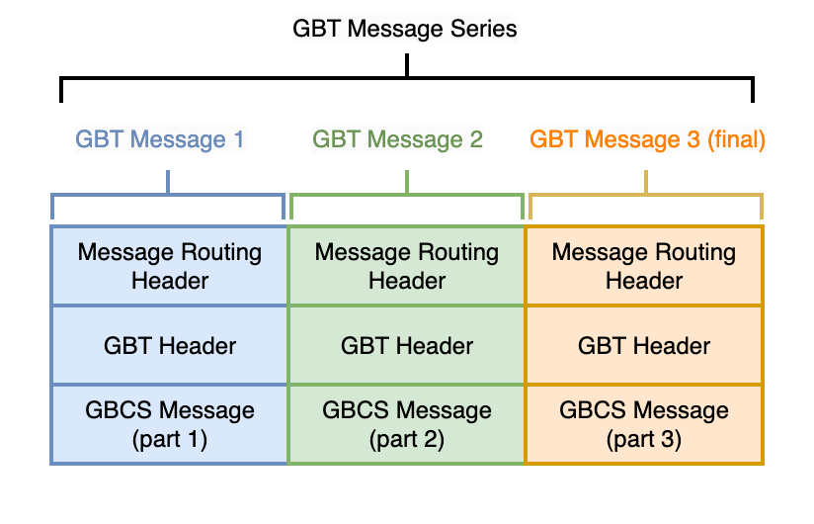

1. GBT Message Series

The Traffic Management gateway will attempt to send each message in the block in sequence they are received from the DSP although the ordering is not mandatory as the GBT blocks are ordered by the meters. The Traffic Management gateway will retry each message if an acknowledgement has not been received by the Communication Hub but will not attempt to retry if a GBCS response is not received in line with the DSP’s retry policy. Command response timeout will continue to be handled by the DSP.

The Communication Hub processing of GBT messages will not change. The processing is described in the Communication Hub Vendor CHDS documentation. An extract from the documentation is captured in APPENDIX A.

The CHDS documentation describes the fragmentation of the GBT series within the Communication Hub and the subsequent ACK and error handling scenarios. In addition, SD4.4.15 states:

* + 1. GBT MESSAGE FROM DSP TO DEVICE

If the DSP has sent all the blocks in a GBT command but has not received any response after a configured number of seconds (initially set at 40 seconds), then the DSP shall resend the last block in the GBT Message series for all device types other than GSME.

For GSME devices DSP will resend the whole GBT message series, since CHFs will not forward a GBT message series to the GSME until the CHF has received all the GBT blocks, and the CHF is unable to issue GBT resend requests for missing GBT blocks.

The DSP shall continue to resend the last block (for device types other than GSME) or the whole GBT message series (for GSME devices), following the short retry process, at set intervals from the original attempt (initially set at 40 sec x 3).

If during this process the device requests a GBT Resend, then the DSP will resend the missing blocks. This activity runs in parallel with the short retry process.

* + 1. GBT MESSAGE FROM THE DEVICE TO DSP

If the DSP has failed to receive all the blocks in a GBT Streaming Window then the DSP shall send a GBT Resend for the missing block(s) after a set period (initially set to 120 seconds).

The device is responsible for ensuring that all the blocks are transferred to the DSP, and will implement its own retry procedure if the expected GBT Acknowledgements are not received.

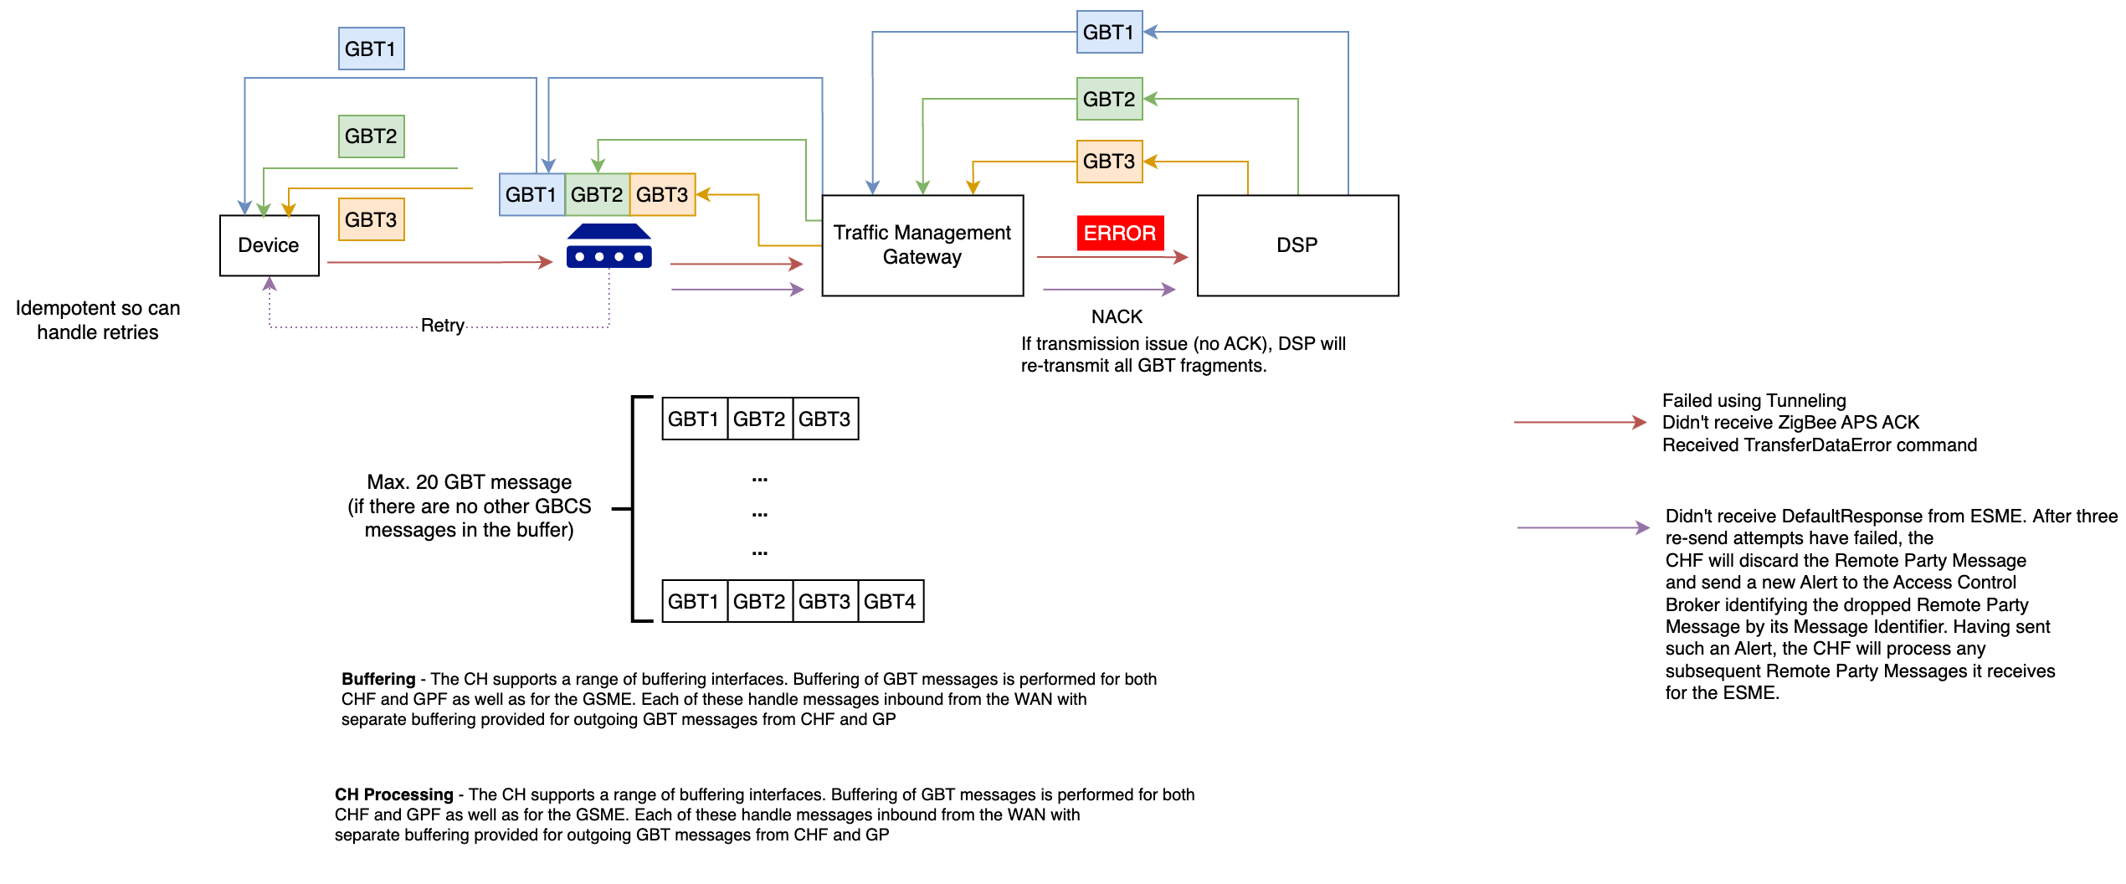The high-level view of the required processing in the Traffic Management Gateway is presented below.

1. GBT Processing Overview

As the core processing of the GBT message is managed by the DSP and the Communication Hub, the Traffic Management Gateway’s responsibility remains unchanged. All individual API requests will contain commands (GBCS or GBT blocks) that will be issued by the gateway in a consistent manner. The gateway will not perform fragmentation of the GBT series as this is the responsibility of the Communication Hub.

Any GBCS NACK or Failed retry alert received by the gateway (if no response is received by the device) and subsequent issuing of retry requests by the DSP (be it individual blocks or the complete GBT series) will not change the Traffic Management Gateway processing. It continues to act as a conduit between the DSP and CH / devices, extracting commands received by the DSP and forwarding responses to the DSP received by the Hub.

As described in section 2.8.3.2 the Traffic Management Gateway will not inspect the GBCS payload returned by the meter to initiate a retry. It will only initiate GBT block retries if it fails to receive acknowledgement of receipt of the command.

This design does not intend to duplicate the contents SD4.x interface specifications or the CHDS provided by the Communication Hub vendors. All GBT processing implemented by the Traffic Management Gateway must align to the SD4.4.15 interface specification and consider the CH implementation described in the CHDS referenced in APPENDIX A. Full alignment with these interface specifications and design documents remain a priority.

## CHATTY METERS

Currently, chatty meters are identified by the existing on-premise Device Manager platform based on rules specified below and the events from the associated hubs are blocked to protect the service:

* high volume of the same alert sent continuously to the Device Manager
* excessive number of alerts of the same type over a specified period.

While the Traffic Management Gateway Cloud model mitigates capacity constraints, Telefónica will need to ensure it protects itself from adverse OPEX charges as a result of the increase in traffic. The Traffic Management Gateway will:

* Monitor and identify potential unexpected load due to chatty meters and reflect the status in the CHSS.
* It will allow a specific volume of the traffic to be consumed by the Strategic Data and Reporting platform to identify commonalty and correlation between misbehaving devices through analytics and machine learning.
* Based on a configurable parameter, the Traffic Management Gateway will drop specific event types from a particular hub
* SDR can share any findings on chatty meters with the TMG to support its operational processing.
* Internally generated reports from SDR can be used to support discussions with the DCC.

## TECHNICAL IMPACT

The impact of delivering the Traffic Management Gateway is described below

1. Technical Impact
2. Introduction of the traffic management gateway. The gateway will be built using Microsoft’s PaaS and CaaS capabilities such as the Event hub and AKS to support a simplified, agile, resilient and scalable architecture.
3. Connectivity and integration with the DSP – Telefónica will deliver an API based interface (aligned to SD4.4.15). Telefónica can route traffic through existing private links or utilize the Microsoft backbone if the DSP hosts their WAN gateway service on MS Azure, DCC’s preferred Public Cloud platform. A level of IP design work will be required to support the routing requirements. Telefónica will provide the DSP with support for the SD4 uplift.
4. The DNS lookup currently performed by the DSP will no longer be required as the function to support GUID to IPv6 mapping will be performed by the Traffic Management gateway.
5. Connectivity to the Communication Hub – the Traffic Management Gateway will include a service that supports the receipt and issuing of GBCS / DMM commands over the existing IPv6/UDP connection to the packet core. The scope will include provisioning of the /64 IP range aligned to the allowable ranges configured in the Communication Hub.
6. Connectivity from existing Device Manager to support receipt and issuing of commands / events through the Traffic Management Gateway.
7. Introduction of the publish and subscribe architecture to support two-way communication between the Traffic Management gateway and device manager services.
8. Introduction of the cell site service to provide the Traffic Management gateway with cell bandwidth utilization information to optimize issuing of service requests and firmware downloads.
9. Introduction of the hotspot notification service, an uplift of the power outage service, to analyze outages against Communication Hub postcode proximities and previous hub status gathered from Traffic management gateway traffic. The service will continue to send the confirmed outages as defined in SD4.4.15. The power outage service and the hotspot service is described in SD02_06.
10. Uplift of the firmware distribution service to optimise the distribution of firmware on the 2G radio network, utilising Communication Hub and cell site status information. The API traffic, defined in SD4.4.2, will be routed through Azure App Gateway and API Management services.

Note, no changes will be made to the Communication Hub to support the introduction of the Traffic Management Gateway.

## TRANSITION TO END STATE ARCHITECTURE

Please refer to Transition Architecture section in CSP_TEF_SD01_04_Application Architecture for a detailed view of Telefónica’s transition approach.

## DEVICE MANAGER

Device Manager is an existing on-premise capability that will be migrated to Azure as part of Telefónica’s ESA. It will transition to a cloud hosted solution and will continue to provide management capability for communication hubs and smart meters, including installation, in-life operations, authentication, configuration, and control, monitoring and diagnostics and firmware management. However, it is not the subject of this design outside providing context for the Traffic Management Gateway capability and is described in CSP_TEF_SD02_06_Device_Manager.

## DATA ARCHITECTURE

Please refer to CSP_TEF_SD01_04_Application_Architecture_Specification for a detailed description of the data architecture.

## SUPPORTING SERVICES

Please refer to CSP_TEF_SD01_04_Application_Architecture_Specification for a detailed description of the supporting services that sit outside the bounds of the Device Manager and the Traffic Management Gateway.

1. ARCHITECTURE ROADMAP

This section provides a view of the Traffic Management Gateway delivery timescales as part of Telefónica’s wider roadmap to the End State Architecture. It should be noted at this time that this ESA is not funded and therefore is a potential timeline for the implementation of the suggested Architectural end state.



1. Smart Metering Roadmap to ESA Business Capabilities

The services are described in more detail in section 2.7.

1. AUTOSCALING

Telefónica will be able to make significant improvements in overall performance flexibility and autoscaling as a result of placing the Traffic Management Gateway components in a cloud environment. Autoscaling is the process of dynamically allocating resources to match performance requirements. As the volume grows, the service may need specific components to utilise additional resources to maintain the desired performance levels and satisfy service level agreements (SLAs). Once demand subsides, the additional resources can be de-allocated to minimise costs**.**

1. HOSTING

Telefónica’s hosting approach will take advantage of cloud capabilities to provide an agile flexible service that can provide on demand scaling but still remain compliant when it comes to our security obligations. Telefónica will be able to align to the DCC’s Cloud Policy. In addition, Telefónica will utilise its recently signed Global agreement with selected Cloud provider for hosting our cloud solutions.

The key business goals that a more simplified architecture aims to achieve are:

* Reduce CAPEX and OPEX costs
* Align to the requirements of the DCC
* Proactive Insights
* Ability to autoscale (as described in section 4).

Telefónica considers the following value drivers that achieves the business goals:

* **Agile Development** – Leverage the Cloud pipeline delivery approach, adopting a DevOps, CI, and CD principles. Teams are optimised for collaborative continuous delivery of incremental value. Delivery workflows are automated at an increasing pace, productivity, quality, and operability. Delivery of new solution iteratively and incrementally allows value to be unlocked early and continually realised.
* **Microservices & an Event-based architecture** - A software pattern than enables multiple independent delivery streams to focus on discrete functionality and performance. Highly compatible with Cloud scaling techniques.
* **Platform as a Service** - Services are available on Cloud for easy consumption and allows design to be extensible to meet the requirements of the new service. Building the service functionality on top of a managed PaaS maximises value and potential re-use for the DCC.
* **Cloud Economic and Innovation** - Benefit from the economics of Cloud - shift from Capex to Opex and increased automation, align cost to serve with revenue. Benefit from the Cloud Providers heavy investment in services and innovations. The new innovations could be incorporated into the solution where they meet a Telefónica or DCC enhancement need.

Telefónica will review the capability to create Cloud environments and the Smart Metering services programmatically (IaaC) e.g., Pulumi.

Telefónica will adopt an agile approach to deliver DevOps, Continuous Integration (CI) and Continuous Development (CD) approach to run builds, test, and deploy automatically in both test and production environments.

The introduction of Cloud based environments allows performance testing to be conducted across the test phases and not isolated to a performance test environment. The environments that support the path to production and associated underlying capability will be sized consistently. During PIT and SIT phases, any performance related issues can be identified and addressed earlier in the development cycle. Telefónica will review the test strategy in relation to this opportunity.

With the addition of cloud environments, Telefónica will look to reduce operating costs by tearing down environments when not in use or in the use of SaaS model where price is per transaction and not time based. Telefónica will need to liase with the DCC for optimisation of availability vs cost for this process.

Cloud based solutions (IaaS/PaaS) will be used where existing on-premise infrastructure is End of Life (EoL) or End of Service Life (EoSL).

## TRAFFIC MANAGEMENT GATEWAY

The service will be hosted on the Public Cloud platform. Doing so provides the following benefits and innovations:

* Mitigates the costs and delivery impact associated with procurement of hardware and its maintenance (patching, license, upgrades).
* The hosting platform will allow the solution to adjust to load automatically and self-heal through the ability to scale in and scale out.
* Traffic Management Gateway services will adopt a microservice abstraction model in line with industry best practice. For example, security, monitoring, and logging will be implemented as common services, abstracting away from the core logic of the traffic management gateway.
* The platform supports the development and hosting of microservices that are loosely coupled with no cross-function dependencies. Services will recover from failure without impacting other services.
* Through the use of PaaS services e.g., Event Hub, the Traffic Management Gateway will adopt an event broker architecture. Doing so allows Telefónica to manage planned and unplanned scenario, mitigating the risk of message loss.
* The solution will support out of box insight capabilities e.g., data mining, stream analytics, machine learning.
* The solution will support automated builds of environments based on a demand-based model. Environments will be stood up and torn down as required to manage OPEX costs of running services in the Cloud based on agreement with the DCC through the use of Infrastructure as a Code (IaaC).
* The solution will leverage products and services that are approved by NSCS, aligned to DCC security requirements.
* The solution will utilise open industry standards e.g., JSON APIs, AMQP, Publish and Subscribe to support interoperability and disaggregation.
* Telefónica will leverage the High Availability and Geo redundancy capability of the Cloud platform.
* The solution will be scaled with specific capacity expectations, which will be price capped. When exceeded there will be additional charges for excess processing. Exact details to be discussed with the DCC.

## SECURITY

To meet its security obligations, Telefónica will deploy security controls for end to end security. The controls are listed below:

* Web Application Firewall (Cloud only) – supports cross site scripting and SQL injection protection
* Anti-Malware
* Intrusion Detection
* Data Loss Prevention
* Vulnerability Scanning

Azure SIEM, Sentinel, is currently exposed to the Security Operations Centre. The Traffic Management Gateway services will utilise the framework and processes to support the security incidents and monitoring of the Traffic Management Gateway.

## OSS PLATFORMS

The NOC, SOC, SMPCC and ITCC capabilities will remain on-premise with tailored data being sent from the Cloud (Azure monitor) to support a single plane of glass view. Most of these systems are shared capability and used to monitor on premise hardware.

1. DISASTER RECOVERY AND HA

Telefónica have three Availability Performance Measures for the SMETS2 service as summarised below:

* PM6.1 – Core Network Availability – target of 99.98% has been met 23/24 months in the last 2 years.
* PM6.2 – SMWAN Availability – 100% (target 99.98%) has been achieved for past 2 years
* PM6.3 – Access Node (“RAN”) Availability – the average performance since go live in November 2016 has been 99.87% (target 99.7%) with no monthly failures across both regions.

Telefónica intends to use Microsoft Azure as the cloud hosting platform for Device Management and Traffic Management Gateway. The ability to meet DCC’s High Availability (HA) targets will consider Microsoft platform capabilities, Core WAN network and design of Device Manager / Traffic Management Gateway application. Delivering the highest level of availability to meet DCC targets can be achieved by using resiliency built into the Traffic Management Gateway Cloud application. The Traffic Management Gateway is the entry point to the Telefónica WAN service and is therefore designed with high availability, resilience, and scale in mind using cloud-based capabilities (see below).

Utilising cloud-based services enables resilience to be established by using underlying capabilities:

## HA OFFERED BY THE AZURE PLATFORM

Microsoft Azure proactively mitigates potential failures by using deep fleet telemetry, enables platform failure predictions with Machine Learning and then does an automatic live migration for several types of hardware failure cases e.g. disk failures, I/O latency etc. As a result, Virtual Machines are live migrated off “at-risk” machines before they show signs of failing.

## HA OFFERED BY SERVICES ON THE AZURE PLATFORM

Telefónica will use Azure provided HA services to mitigate against hardware failures, datacentre outage or zonal level outages.The Disaster Recovery and High Availability model of the Cloud platform is shown below:

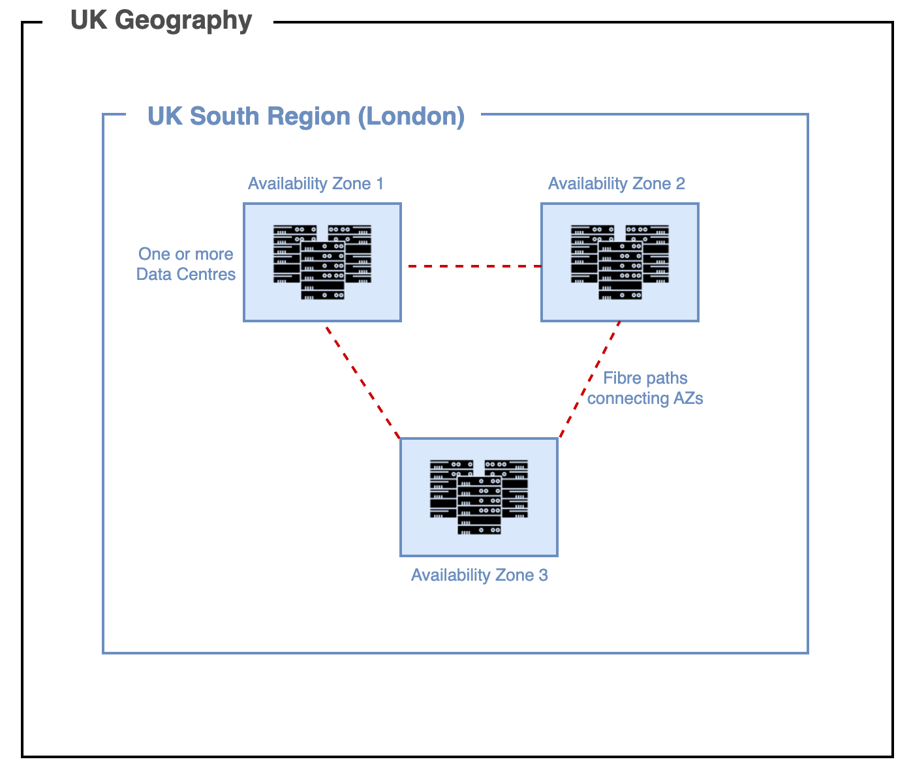

1. Azure Disaster Recovery and HA Model

The Azure platform offers geo-redundancy capabilities, with deployment options to UK South and UK West. Microsoft offers two options to recover from regional failures:

* Manual failover
* Microsoft initiated failover.

The manual failover approach provides a lower RTO in line with DCC SLAs as Microsoft do not prioritise specific tenant solutions. In addition, the manual approach supports DCC requirements for DR testing.

However, CSP C&S will implement the capability using UK south Azure zonal redundancy in line with DCC guidance outlined in the Cloud Adoption Framework (v2.0) which states the following:

*DCC service designs should leverage deployment across availability zones and should consider cross-region deployment or replication where architecturally appropriate for improved resilience.*

Microsoft provide a shared responsibility model, and this underpins how HA/DR is managed in Azure as described [here](https://learn.microsoft.com/en-us/azure/reliability/business-continuity-management-program#shared-responsibility-model). All of the Azure infrastructure does support cross region redundancy but requires additional components to balance traffic across regions as well as doubling down on costs. Whilst zonal redundancy is acceptable in the cases of availability, it should be reviewed against the SLA offered by each individual service described [here](https://www.microsoft.com/licensing/docs/view/Service-Level-Agreements-SLA-for-Online-Services?lang=1).

Microsoft Azure’s south region and their zonal HA capability, provides resilience over and above the active-passive site resilience offered by the on-premise solution.

BCDR testing / changes to allow for Azure zones (3 within Azure UK South) will be used without manual interventions (including manual testing or failover) and no regional redundancy is expected as part of the drive to keep costs to a minimum.

Azure UK South will consist of availability zones, each zone being made up of multiple data centres. High-speed fibre links will be available between all data centres within the region.

The solution will provide service level agreements offered by the public cloud provider in line with DCC SLA requirements.

The following are the resource types that Traffic Management Gateway solution is comprised of:

* App Service Plans (Azure Functions) – Telefónica have no control other than to configure zonal redundancy in a single region. As a design principle, Azure functions are only used for triggering backend reports and failure of that service will not impact any critical path. If geo-redundancy is required, then a design change is needed as described [here](https://learn.microsoft.com/en-us/azure/reliability/reliability-app-service?tabs=graph%2Ccli#disaster-recovery-in-single-region-geography).
* HAProxy – Telefónica are using virtual machine scale set with 3 VM's set across 3 zones behind a load balancer which is also zone redundant. We can switch off virtual machines manually to replicate a zonal failure, but we have no control of replicating a failure of the load balancer component.
* Redis cache – Telefónica will adopt zonal redundancy but have no control over failover as described [here](https://learn.microsoft.com/en-us/azure/azure-cache-for-redis/cache-high-availability#zone-redundancy).
* PostgresDB – Telefónica will use zonal redundancy but have no control over failover as described [here](https://learn.microsoft.com/en-us/azure/postgresql/flexible-server/concepts-high-availability).
* Azure Kubernetes Service – Telefónica will use zonal redundancy. In this setup, Telefónica can control taking down nodes within the cluster to replicate a zonal failure but cannot do so for the control plane (only worker nodes) as described [here](https://learn.microsoft.com/en-us/azure/aks/availability-zones).
* Azure Load Balancer – Telefónica use zonal redundancy but have no control over failover as described [here](https://learn.microsoft.com/en-us/azure/load-balancer/load-balancer-standard-availability-zones).

As a result, Telefónica cannot BCDR test all services provided by the Traffic Management Gateway. Where testing of specific services is possible, the test will not provide an end-to-end view. Telefónica will provide test evidence that the solution can tolerate those failure types in development setup. The solution will be setup in an active/active/active configuration across three regions.

## APPROACH TO RESILIENCE

Telefónica has a structured approach to achieve HA and resilience throughout the lifetime of the Traffic Management Gateway – from design and implementation to deployment and operations:

* Current service’s Network Availability is 99.98% and will be met using the capabilities provided by the Azure platform. The Microsoft ExpressRoute circuit is 99.95%. Once individual services are identified, build a composite SLA which is based on the SLA’s offered by individual services selected as part of the architecture like Core WAN network, Load Balancer, API Gateway, PostgreSQL etc.

For example, Azure Kubernetes Service (AKS) offers a 99.95% SLA which writes to an PostgreSQL Database which offers a 99.99% SLA then the composite SLA for this application is 99.95 x 99.99% = 99.94%.

If the composite SLA is lower than HA requirements, the architecture will be improved by adding fallback paths with increasing complexity and trade-offs in mind. For example. if Azure PostgreSQL database is offline, transactions are put into a queue to be processed later.

* Design the Traffic Management Gateway to handle hardware, datacentre, regional, transient failures, heavy load, accidental data deletion or corruption and application development failures (non-exhaustive list).
* Implement strategies to detect and recover from HA failures identified in the Design phase. For example, Load balance across instances to handle spikes in UDP traffic from communication hubs due to Power Outage event or automate deployments with a rollback plan to handle deployment failures.
* Test implementation by load testing, simulating faults and triggering forced failovers in an environment closely resembling production. Some failure scenarios to test (can be combination of HA failure scenarios) with Traffic Management Gateway would be expired certificates, crash/stop a microservice handling requests coming from Traffic Management Gateway, change access keys, shutdown DNS service, Load testing and Disaster recovery drills. Recovery times will be measured to verify that the HA requirements are met.
* Deploy Traffic Management Gateway into production using a reliable and repeatable process. Manual deployments of updates to production can present a potential source of errors causing downtime. To automate provisioning of Azure resources, tools like Terraform or Ansible will be used and Azure DevOps (or Jenkins) to automate application deployment into the SIT/PIT/UIT and Production environment.
* Monitor the application to detect failures and respond to failures that require manual interventions. The high availability inherent in the proposed solution is protected by means of comprehensive mature Network Monitoring, and Event and Incident management processes. These processes ensure any failure in the solution is detected and/or resolved.

However, there will be times when repairs/upgrades need to be made. In this scenario, Telefónica operate a robust and proven operational Change process, fully aligned with the DCC process, and integrated with DCC Operations via the DSMS. This well-defined process is followed rigidly in Telefónica with KPIs monitored and reported for Change process adherence and restrictions placed on Change implementer groups if KPI targets are not met.

Typically, changes are made on standby side of resilient applications, then activated. All Change, barring emergencies, is implemented at the time of least service impact, in Change windows agreed with Smart DCC.

## RETRIES TO THE CH FROM THE TRAFFIC MANAGEMENT GATEWAY

Please refer to section 2.8.2.

## STORE AND FORWARD

Telefónica will adopt a message based, store and forward integration model (e.g. Azure Event Hub) to support high throughput and reliable delivery. Where services are not available to process the message, it will remain on the broker until such time that the receiver becomes available (or return an error code if a timeout expires).

This feature of durable subscribers will support planned and unplanned scenarios. For example, power outage messages are sent from the communication hub and will be ingested by the event broker that is scaled for large volumes of events and high throughput demand. Telefónica will review whether a dedicated event hub node needs to be provisioned to support Power alerts. If the API that consumes the power outage data at the DSP is not available, the internal consumer can be turned off (in a planned outage scenario) or the solution can be configured to prevent the message from being removed from the broker queue until such time a successful response is received from DSP in an unplanned scenario. The solution can be configured to temporarily pause the service if a set number of HTTP errors are returned by the DSP within a specified period.

Telefónica will also consider use of persistency to mitigate message loss in the event of failure of a specific broker instance. As persistence incurs cost and performance overhead, the out of box HA capabilities of the Azure platform will be considered to mitigate message loss before persistence is enabled.

## API PROCESSING

At the API level, incoming traffic from the DSP will be handled by an API management function i.e. Azure API Management within Azure platform. The API manager will allow message rates to be controlled to ensure backend network components e.g. Radio Access Network (RAN) are not overloaded. In addition, if a specific period of peak traffic is expected (e.g. to catch following a planned DSP or DCC Adaptor outage), the Cloud platform can scale to meet demand within the parameters of the agreed Code of Connection.

## RESILIENCE BASED TESTING

**Test** **the implementation** by carrying out test activities to ensure the resilience requirements are met. For example, ensuring that messages are still delivered in the case of a DR event.

## DEPLOYMENT

Deploy the applications into production using a reliable and repeatable process which preserve the data within the system components. Automation tools will be used where available to minimise manual deployments of updates to the SIT/PIT/UIT and Production environment.

## MONITOR

The health of the service, using out of box capabilities to detect failures and monitor indicators of potential failure. Data analysis will provide insights into the service and will enable Telefónica to take proactive measures to prevent a service degradation and failure, for example, if a change in traffic flows occur through a load balancer highlighting the failure of a specific system instance. Telefónica will implement transaction tagging and use the data to show both the reliability and performance of the overall service. Any areas in the service that have constant failings will be identified and reviewed to check whether further improvements can be made as part of the service improvement process.

## AZURE CLOUD INTERCONNECT

A new Azure Cloud Interconnect will be implemented to support the LIVE Smart Metering service from the Telefónica IP network to Microsoft Azure Cloud using Telefónica Virtual Forwarding Routing (VRF) service . This will ensure dedicated bandwidth for smart metering traffic and allow the link to be optimal terminated in the appropriate LAN inside Telefónica’s network to underpin the Smart Metering Service.

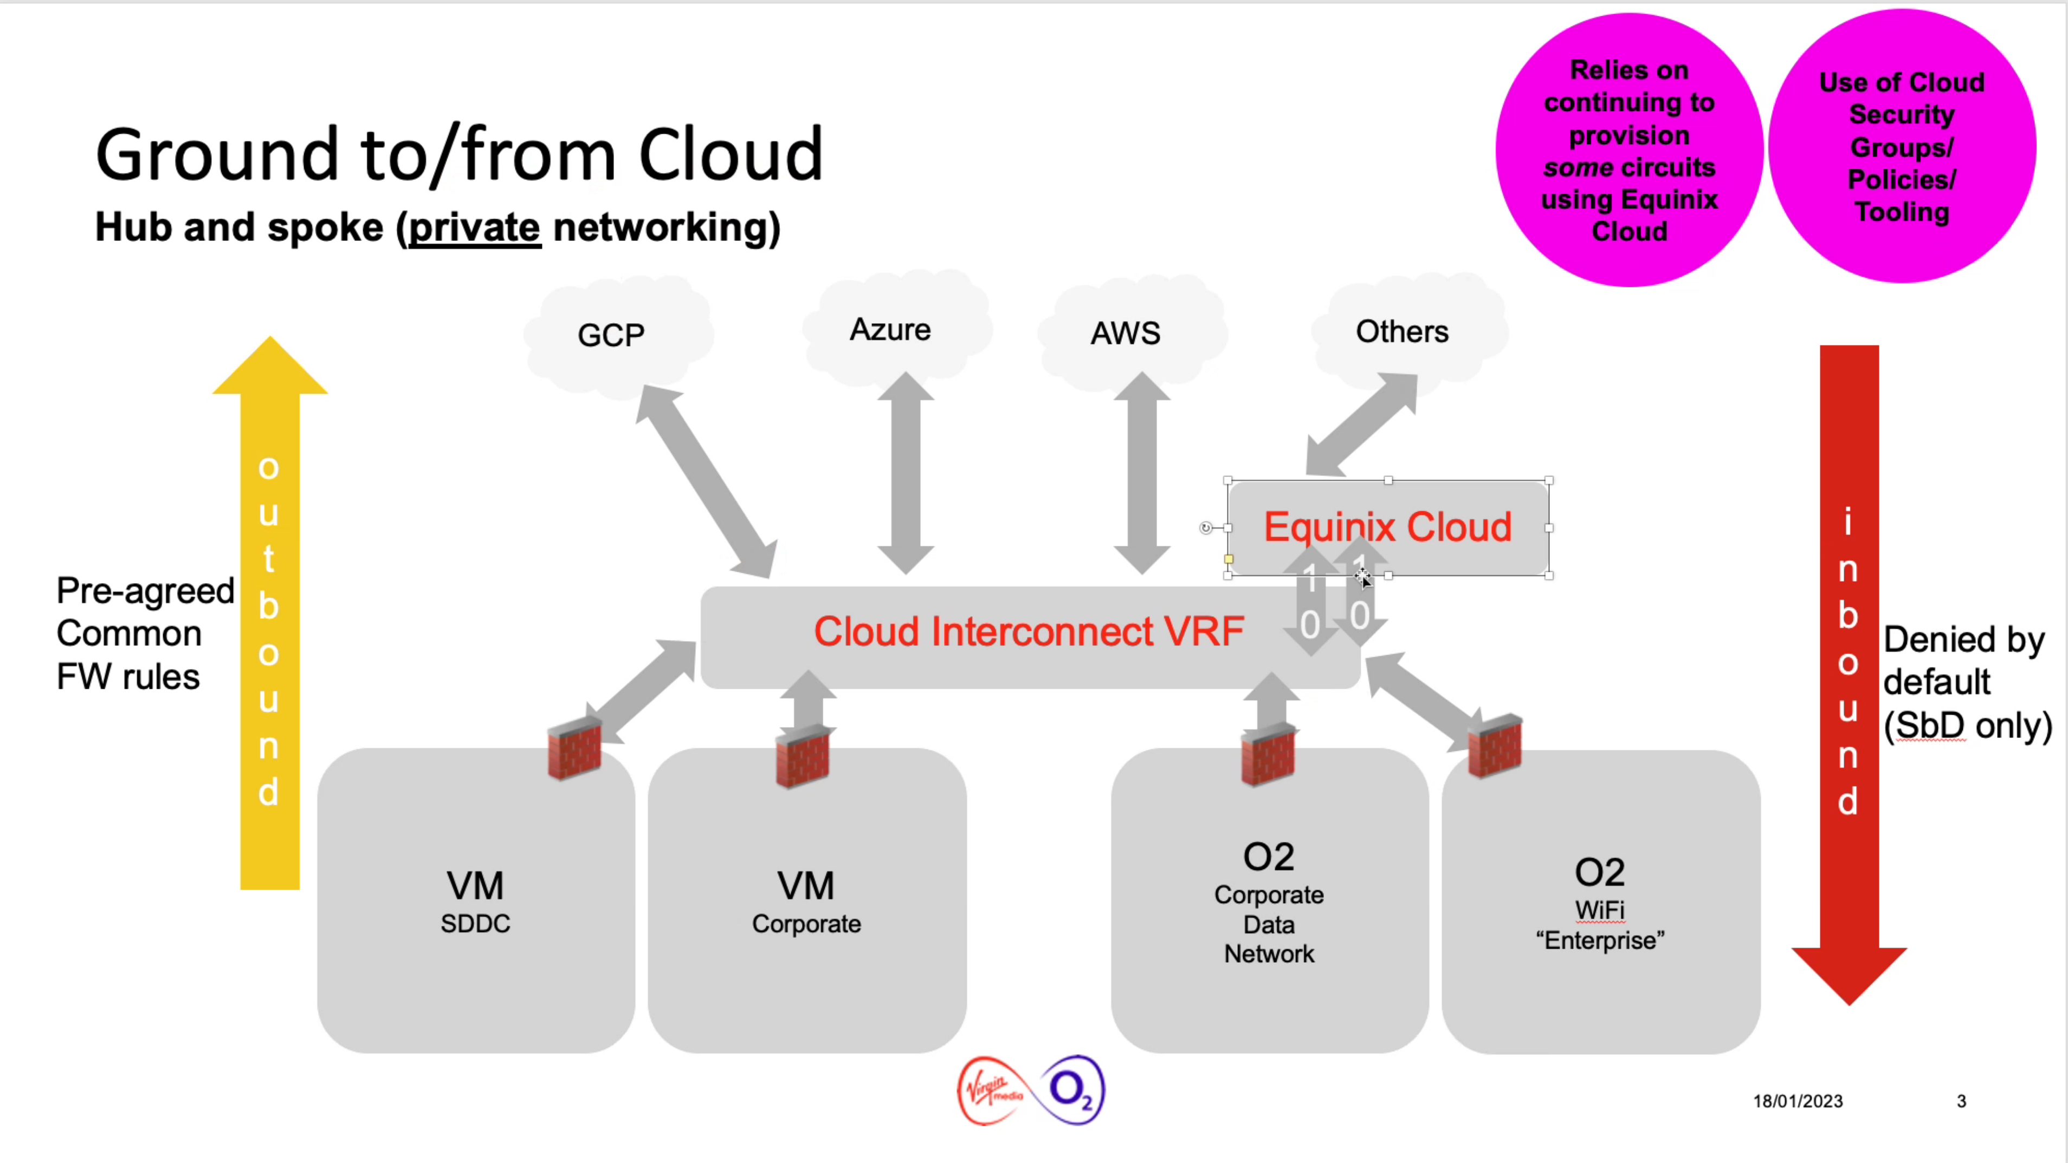

1. Cloud Interconnect

The Cloud connections from Telefónica will be connected to diverse Azure PoPs (Point of Presence) providing Geo resilience capability for the overall solution.

New fully resilient network and security components (i.e., routers, firewalls and IPS) will be used to link to the on-premise Smart Metering network. The Cloud connections and the new landing zone or Virtual Routing and Forwarding (VRF) will allow connectivity to the communication hub, DSP, SMKI and smart metering operational systems. Any third-party or Telefónica access to support the applications in the Cloud will also go via the Cloud Interconnect. The highly resilient Telefónica MPLS core will provide on-premise connectivity across the required Telefónica sites and switch centres for the management and delivery of data.

With the introduction of new cloud capabilities, Telefónica will adopt an agile, shift left approach to delivery, testing the integrated solution as early as possible during the delivery cycle. A development and test pipeline approach will be adopted to support the DevOps, Continuous Integration (CI) and Continuous Development (CD) approach to run builds, test, and deploy automatically across all environments.

The environments that underpin the Smart Metering service are described in section 0. The build of the Cloud based development and test environments will adopt a programmatic approach e.g. the use of Azure Resource Manager Templates (ARM) to build environments automatically. On agreement with the DCC, environments will be stood up or brought down leveraging this automated process.

1. ENVIRONMENTS

The following section details the environment strategy to support development, Test and Production for the Traffic Management service.

Each environment has the necessary IT, Network and security components that provide the service, thereby enabling the test capability of the solution in each of the test phases.

* PIT – Pre-Integration Testing
* SIT – System Integration Testing
* UIT/UTS – User Test Service

These environments are set up to support the following test phases:

| **CSP Environment** | **Test Function** | **Testing Capability**  **Supported** |
| --- | --- | --- |
| Ref 0 | SIT B | Production +1 test SIT |
| Ref 1 | PITB | Production +1 test PIT |
| Ref 2 | PIT A | Defect Fix on Fail |
| Ref 4 | UIT A | Defect Fix on Fail on production platform UIT |
| Ref 6 | SIT A | Defect Fix on Fail SIT |
| Ref 7 | UIT B | Production +1 test UIT |

1. Environments

In order to minimise the number of additional environments and the associated costs to build out and maintain, the capabilities in the existing environments will be re-used and enhanced to support the new solution. The diagram below shows the environment estate that Telefónica will continue to use to meet its obligations on the existing service.

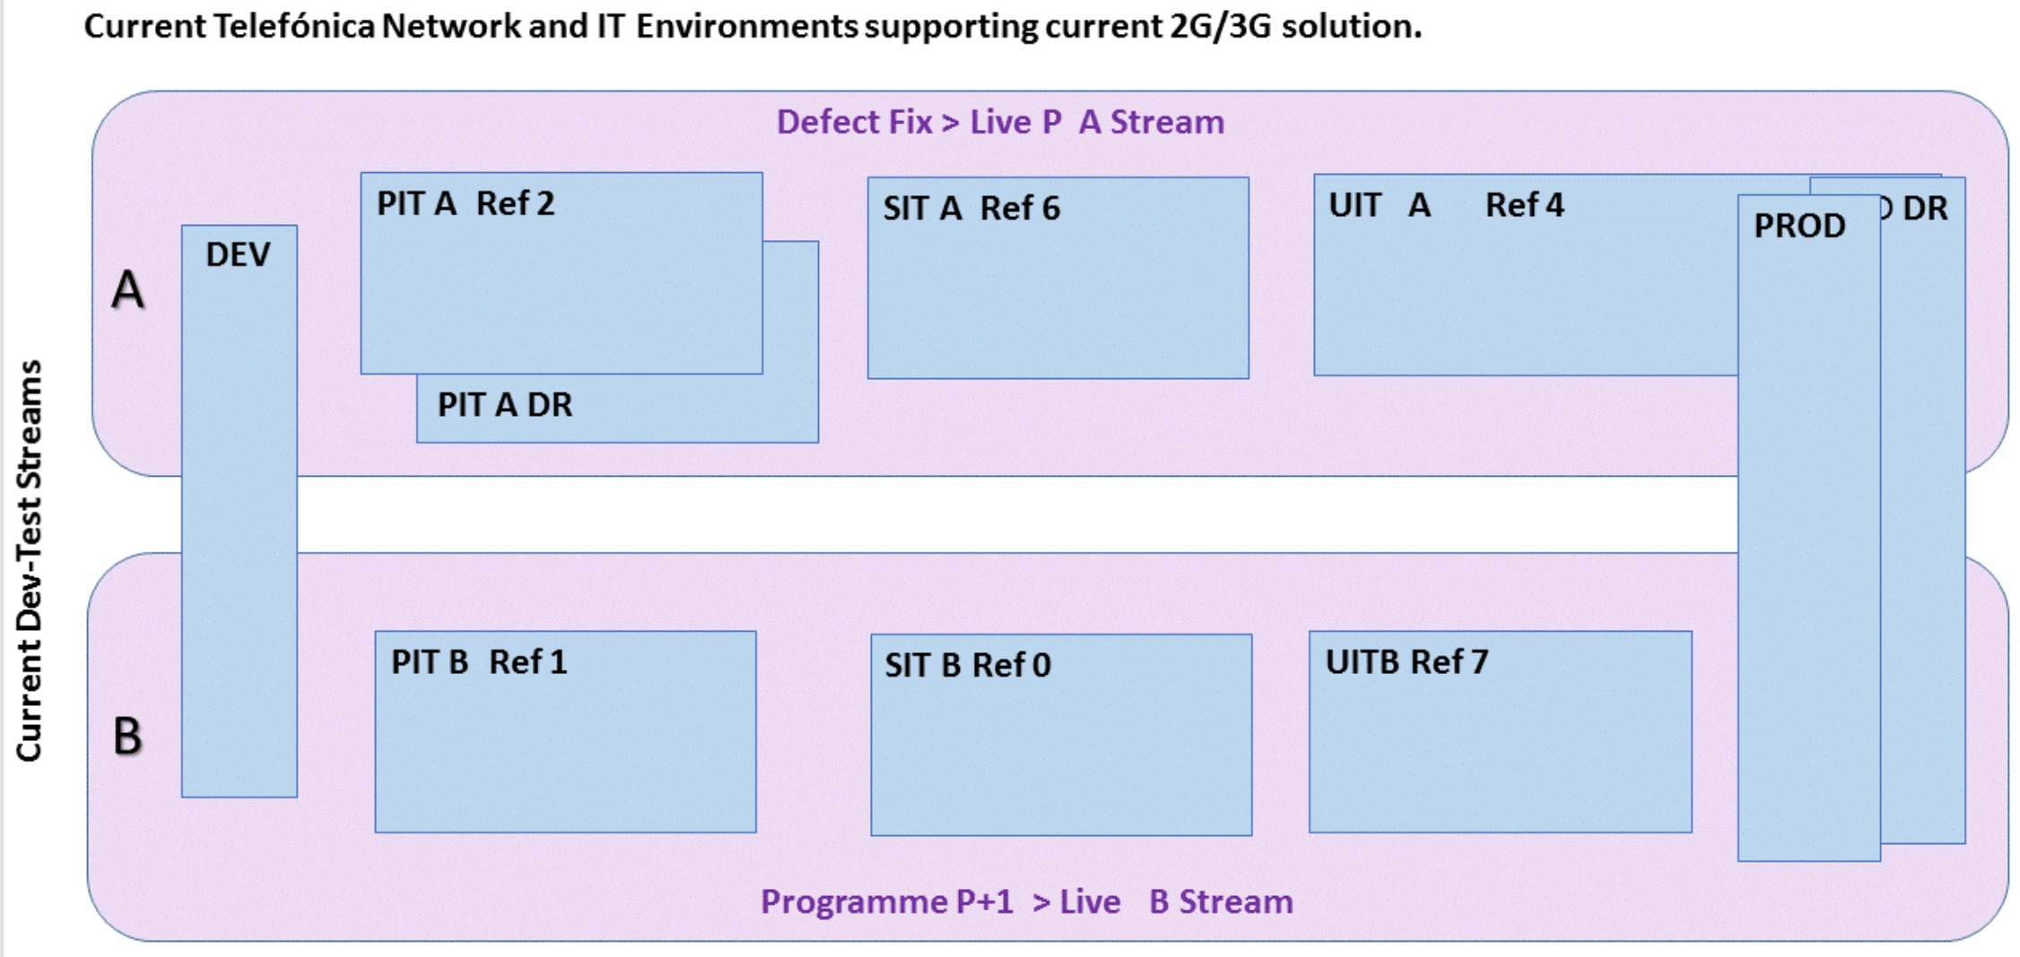

1. Environment Setup

Enhancements to the Smart Metering service will be developed and configuration changes will be required where platforms are reused to support the Traffic Management Gateway solution and the integration between legacy on premise and new cloud-based solution e.g., enhancements to the Vitria solution.

It is the intention that as legacy environment tech refresh occurs then components would be repurposed as microservices rather than deploying new on-premise equipment.

Telefónica will review the capability to create Cloud environments and the Smart Metering services programmatically (IaaC). Azure, for example, exposes a set of APIs and the Azure Resource Manager Templates (ARM) to build environments automatically.

Telefónica will adopt an agile approach to deliver DevOps, Continuous Integration (CI) and Continuous Development (CD) approach to run builds, test, and deploy automatically in both test and production environments.

## STRATEGY

The strategy involves:

* Instrumentation and monitoring systems at the application, service, and infrastructure levels. These systems capture key metrics, such as response times, queue lengths, CPU utilization, and memory usage
* Decision-making logic that evaluates these metrics against predefined thresholds or schedules and decides whether to scale
* Components that scale the system
* Testing, monitoring, and tuning of the autoscaling strategy to ensure that it functions as expected

The Traffic Management Gateway solution covers the cloud infrastructure and there are two approaches for the solution to scale to meet DCC requirements:

* **Vertical scaling** typically seen On Premise, also called scaling up and down, means changing the capacity of a resource. For example, move an application to a larger virtual machine size. Vertical scaling typically requires making the system instance temporarily unavailable while it is being redeployed and not an ideal candidate for automation.
* **Horizontal scaling** typically seen on Cloud platforms, also called scaling out and in, means adding or removing instances of a resource. For example, the Traffic Management Gateway service continue running without interruption as new resources are provisioned to handle an increase in traffic volume. When the provisioning process is complete, the services are deployed on these additional resources. If demand drops, the additional resources can be shut down cleanly and deallocated.

Telefónica is currently the largest CSP, with assets across Radio Access Network (RAN), packet core, HLR, underlying transport & data networking (IP/MPLS/leased lines/optical fibre transmission) as well as the Smart Metering specific applications and infrastructure. To run such a large and complex operations, Capacity Management and scaling is fundamental to Telefónica’s operations and is practised across all disciplines.

The COVID-19 pandemic highlighted the need for a more flexible approach to demand management. The number of installs dropped considerably during the lockdown. In this scenario in future, the proposed architecture will automatically scale as capacity and throughput demands decrease. As any lockdown eases, the capacity will automatically increase in line with demand, providing an automated, cost-effective approach to capacity management.

Telefónica’s existing and proven Capacity Management process will continue to be used to ensure each component of the end to end architecture is sized to meet demand thereby ensuring that adequate capacity is available to meet future demands up to an install base of 13m Communication Hubs.

The DCC forecast and order forecast data from supply chain provides input into the capacity management process as highlighted below:

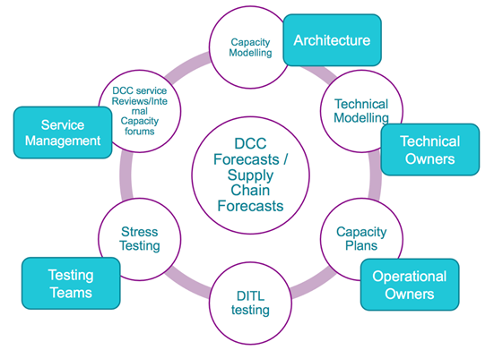

1. Capacity Modelling

Telefónica then models this forecast with actual volumes that have been seen over the duration of the service. The capacity model output is then used to create a technical, granular view (CPU, memory, IO disk, queue depth) of Telefónica’s ability to manage capacity against the DCC forecast.

In addition, the model is used to ensure the performance test volumes and rates align with the DCC’s projections. The output from performance test is analysed to determine the non-functional impact of a change to the live service with plans to remove potential bottlenecks either through configuration, code updates or through an infrastructure upgrade path.

As part of this response, Telefónica created a Volumetric engineering model using data from running the existing solution and forecasts shared by DCC. This gave us the peak number of messages (for 5 years) passing through the ingress and egress along with the data size volume and a view on the ability of existing systems to scale and choices for new systems (e.g. services on Azure cloud) to satisfy DCC technical requirements.

We used the following assumptions to build the model:

* 23 SR commands, responses, and alerts per communication hub per day
* 3.5 Device Management (DMM) commands, responses, and alerts per communication hub per day
* Average SR command payload size: 472 bytes
* Average SR response payload size: 475 bytes
* Average GBCS alerts payload size: 129 bytes
* Average DMM command payload size: 339 bytes
* Average DMM response payload size: 251 bytes
* Average DMM alert payload size: 304 bytes
* Average communication hub installation per year: 1.2M

Using these assumptions, we derived the peak number of messages:

* Egress: 346 million GBCS and DMM messages, 131 GB data per day
* Ingress: 326 million GBCS messages, 438 GB data (includes JSON / HTTP header) per day
* Device Manager: 21 million DMM messages, 22 GB data per day

With these numbers as reference, the following technical choices were identified that can address autoscale to align with the DCC requirements, without impacting operational service.

## ON CLOUD

* + 1. THE AZURE PLATFORM AND SERVICES

In Azure platform, autoscaling takes advantage of the elasticity of cloud environment and reduces the need for an operator to monitor the performance of a system and make decisions about adding or removing resources. Following Azure compute infrastructure will be used for autoscaling the Traffic Management Gateway:

* **Azure Kubernetes Service (AKS)** uses the cluster autoscaler component and watches for pods in the cluster that cannot be scheduled because of resource constraints. When the cluster autoscaler detects issues, it scales up the number of nodes in the node pool to meet the application demand. It also regularly checks nodes for a lack of running pods and scales down the number of nodes as needed
* **Azure Event Hub** uses throughput capacity units to manage throughput. A single unit allows:
  + Ingress: Up to 1 MB per second or 1000 events per second (whichever comes first).
  + Egress: Up to 2 MB per second or 4096 events per second

The Auto-inflate feature of Event Hubs automatically scales up by increasing the number of throughput units, to meet usage need

* **HAProxy / API Management** do not need any autoscale rules to be configured. Instead, these services automatically allocates compute power when the code is running, scaling out as necessary to handle load
* **PostgreSQL DB** uses the Flexible server options to burst out compute / storage to meet demand
  + 1. DESIGN PHASE CONSIDERATIONS

Adding resources to a system or running more instances does not guarantee that the performance of the system will improve. All solution designs, including Device Manager and Traffic Management Gateway will be cognizant of the autoscale cloud principles and pitfalls such as:

* **Avoid instance affinity** – the design of the services should be stateless to avoid requiring a series of requests to be routed to the same service instance. For example, when designing the Traffic Management Gateway service that receives and stores UDP messages into Event Hub queue for further processing, the design will take into consideration autoscaling so that as the queue length grows, additional Event Hub units can be added. The key is not making any assumptions about which instance of the service handles a specific message.
* **Limit max scale out** to prevent a system from attempting to auto scale out excessively, and to avoid the costs associated with running many thousands of instances.
* **Throttling design pattern** will be coupled with autoscaling to handle a sudden burst in workload as it takes time to provision and start new instances of a service or add resources to a system, and the peak demand may have passed by that time
* **Keeping some of the resources hot** - We propose to use a scheduled policy that starts enough instances to meet the maximum load before that load is expected (e.g. during peak load for overnight reads or firmware updates)
* **Analyse the metrics to refine the autoscale configuration** - autoscaling mechanism should monitor the autoscaling process and log the details of each autoscaling event (what triggered it, what resources were added or removed, and when) to analyse the information to help measure the effectiveness of the autoscaling strategy and tune it if necessary.
  + 1. DATABASE DESIGN CONSIDERATIONS

If a single database system data will be divided across multiple partitions with each partition hosted on separate server there by enabling the solution to scale almost infinitely.

We will use of best practices around data partitioning strategies and introduce new shards to improve current baseline capacity requirements:

* Horizontal partitioning (often called sharding) with data store for each partition but same schema for all partitions. Each shard / partition will hold a subset of data.
* Vertical partitioning – each partition holds a subset of the fields for items in the data store. For e.g. frequently accessed fields will be placed in one vertical partition and less frequent ones in another
* Functional partitioning – partitioned based on the functional usage

As part of the database design, the size and workload for each partition will be analysed and balanced as required so that data is distributed to achieve maximum scalability. Some best practices we will adhere for scalability:

* Analyse and identify key components of the architecture with high demands based on data access patterns such as size of returned query result set, latency, frequency of access and compute processing requirements
* Based on the analysis, determine the current and future scalability targets in terms of data size and workload for the identified components and distribute the data across the partitions to meet the scalability target
* Allocate sufficient resources like storage space, computation power and network bandwidth for each partition to handle the scalability requirements
* Monitor the system to verify that data is distributed as expected and that the partitions can handle the load
  + 1. IMPLEMENTATION CONSIDERATIONS

All cloud-based solution will be hosted in public Cloud, with preference to use a containerised, Platform as a Service (PaaS) / Software as a Service (SaaS) to provide the key functionalities.

The core architecture principles of the ESA are around event driven, store and forward, microservice and containerisation pattern which can handle increasing throughput and make use of cloud native autoscaling capability of Azure services.

Capacity requirements of the Traffic Management Gateway are estimated as follows:

* Peak volumes across the existing SMWAN:
  + approximately 60Mbps for Outbound and
  + 20Mbps for Inbound
* Consider potentially higher volumes when DSP have mass meter firmware deployments, increased reads/diagnostics, and incidents where SRs are queued and then sent all at once.
* Factoring in growth of the install base, processing of UDP data alone would require approximately 120Mpps capacity but with the additional overhead of the JSON wrapper with HTTP/TCP header, approximately 600Mpbs is required.

Note that the solution has been scaled with small amount of headroom. Where additional capacity is required, the service will autoscale based on demand.

The Traffic Management Gateway architecture will utilise Azure cloud native services at egress and ingress like:

* Event Hub which is a big data streaming platform and event ingestion service. It can receive and process millions of events per second and allows data transformation and storage by using real time analytics. The event hub is a Platform as a Service (PaaS) service and has auto inflate feature which allows to automatically scale the number of throughput units to meet the usage needs. For e.g. a single throughput unit has the following capacity (at the time of writing):
  + Ingress: Up to 1 MB per second or 1000 events per second (whichever comes first)
  + Egress: Up to 2 MB per second or 4096 events per second
  + SLA of 99.99% based on dedicated tier
* API Management / Gateway for all integrations with external systems through APIs (e.g. with DSP) which supports:
  + Autoscaling features to scale in and scale out based on through put from the DSP.
  + Rate limits on specific APIs to manage load into the Telefónica service
  + Each unit of API Gateway can support 4,000 requests per second and can auto scale up to 10 units based on throughput demands which is much higher than our peak volumetric predictions for the next 5 years
  + SLA of 99.99% using Premium tier

The monitoring and analytic services provided by the Azure platform will provide insights into the performance of the service that will allow Telefónica to make pro-active decisions in ensuring the service meets its service level agreements in a cost-effective manner.

In addition, the event and alert will be segregated at the VIP level to facilitate routing of the data to specific points within the architecture. For example, responses to meter reads will be routed directly to the DSP over the Traffic Management Gateway while birth event data will be processed by the DM to update state before notifying the DSP. Where applicable, alerts can be redirected to additional broker instances where there is a risk of impacting other services e.g. a power outage storm.

1. DCC PARTIES

The following existing interactions between Telefónica and DCC parties are unaffected by the introduction of the Traffic Management Gateway:

* SMKI / DCCKI
* Service Management Gateway
* CSP Management Gateway
* DCC Service Desk
* DCC CMDB
* Smart Metering Inventory
* DCC Self Service Portal
* DCC Anomaly Detection (Critical Commands)

The DCC services impacted by the introduction of the Traffic Management Gateway are described below.

* + 1. (DSP) DCC SM WAN GATEWAY

This is an existing gateway that allows Telefónica to send and /or receive GBCS compliant metering message to and from smart metering devices, via Communications Hubs;

With the delivery of the Traffic Management Gateway, there will be no direct connectivity between the DSP gateway and the hubs via IPv6 and DNS lookup. Instead, the interface will be JSON/API based. All GBCS messages intended for the devices via the Communication Hub will be embedded in the JSON payload. It is the responsibility of the Telefónica Traffic Management Gateway to extract the message and issue it to the Communication Hub. Similarly, all responses to commands and events of interest to the DCC parties e.g., power alert / restore will be forwarded to the DSP WAN Gateway via the JSON / API invocation.

Telefónica is not responsible for the message signing of GBCS commands from the DSP WAN Gateway or verification of responses destined for the DSP WAN Gateway. Where the Telefónica Traffic Management Gateway will service commands from the Telefónica Device Manager or receive events of interest to the Device Manager, these messages will be signed or verified by the Device Manager. IP level segregation will facilitate the routing of events to the DSP WAN Gateway or Device Manager. It is the responsibility of the Traffic Management Gateway to manage the GBT blocks and management in terms of retries as described in section 2.7.

* + 1. POWER OUTAGE HOTSPOT IDENTIFICATION AND NOTIFICATION SERVICE

Introduction of the hotspot notification service, an uplift of the power outage service, to analyze outages against Communication Hub postcode proximities and previous hub status gathered from Traffic management gateway traffic. The power outage service, its extension to include the proximity check capability and the power outage processing times are captured in CSP_TEF_SD02_06_Device_Manager.

## DCC DATA SYSTEMS INTERFACES

Telefónica will utilise the requirements in SEC and DCC principles outlined in the DCC HLDs to design the integration between the communication hubs, DSP, Traffic Management Gateway and the Device Manager (DM). This will involve use of Cloud first commoditised standards, long life by design, auto scalable and zero downtime, portability, and agile delivery.

Telefónica will leverage its knowledge of the interfaces currently supporting the current service in the delivery of the Traffic Management Gateway and the End State Architecture.

The key integration principles that underpin the design of the Traffic Management Gateway are described below:

* The communication hub connects to the Telefónica network and receives/transmits messages to/from the Traffic Management Gateway via a dedicated APN. A standard IMSI is used to identify the communication hub on the radio network, with routing using IPv6 addresses for the communication hub and Traffic Management Gateway.
* The Traffic Management Gateway uses standard UDP message protocols to send and receive messages to/from the communication hub, and JSON wrapped messages to/from the DSP or Device Manager. Connectivity to the DSP Gateways will continue to leverage DCCKI based TLS authentication over the MPLS connection. The Traffic Management Gateway will manage communication retries in case of message failure and but ACKs for successful messages will be forwarded to the DSP. API message communications between the Traffic Management Gateway and DSP system will be integrated through HAProxy and Web Application Firewall.
* The Device Management platform will route all messages to the communication hub via the Traffic Management Gateway. The device messages will be created by the Device Manager and wrapped in a JSON layer for onward transmission to the communication hub. Integration between the DSP or SMKI system and the Device Management system will be via the HAProxy and Web Application Firewall, as will integration between the Device Manager and communication hub manufacturers.

The solution design documented in DCC SD4 interface specifications covers approximately twenty interfaces that support the E2E solution. The interfaces are labelled on the diagram (in red) using the same interface naming convention used in the SD4 specifications. The figure below also shows the internal integrations between the Telefónica systems and services that underpin the E2E service.

The diagram highlights the use of:

* The radio network to support flows of data between the enterprise network and communication hub.
* The Traffic Management Gateway will manage high volume traffic from the hub/devices and from the DSP, leveraging PaaS components that support scale through their ability to handle increased ‘throughput units’ based on demand. The event driven architecture also allows additional subscribers to be introduced to increase throughput. The Traffic Management Gateway will consist of the following key components:
  + **SM WAN API Services** – this service is provided by the Cloud platform and hosts the APIs that will be used to integrate with the DCC and the DSP.
  + **Message Processor** – this subscriber service will manage the request state and orchestrate commands to the hub.
  + **Event broker**– high scalable, performant PaaS service that supports the ingest of millions of events, alerts, and message data per second. The use of the event broker supports:
    - Scalability
    - Planned and unplanned outage scenarios
    - events to be prioritised in line with DCC requirements.
  + **GBCS / JSON Processor** – this component has three functions:
    - Extracting the WAN GBCS command from the DSP and issuing it to the hub (including critical commands that will be mac’d by the DSP)
    - Extracting the DMM command (based on GBCS message constructs) from the DM and issuing it to the communication hub e.g., RTT commands, firmware download requests
    - Mapping alerts from the communication hub to the standard JSON format.
* Signed commands will be issued to hubs and devices over IPv6/UDP through the Traffic Management Gateway and the Service Edge dispatcher.
* Alert data from the communication hub and HAN device will be ingested with VIP level segregation to avoid overload of specific alerts such as Power Outage alerts on a single channel. Each of the following event types will have its own channel:
  + Response to WAN Commands;
  + Power outage
  + Power Restore
  + All other event types
* A publish and subscribe model will be adopted to abstract the calling system from the destination endpoint. The solution will use Azure Event Hub as a streaming pipeline to support high volume traffic and the decoupling of multiple event-producers from event-receivers.

Azure Event hub is based on the Kafka model and uses the concept of partitions rather than the traditional message topic / queue to distribute the solution across Availability Zones within the UK South region to mitigate against service failure.

The data published to the Event Hub can be retained for up to seven days and then replayed. This allows the solution to resume from a certain point or to restart from an older point in time and reprocess events when needed.

Telefónica will adopt a First In First Out (FIFO) approach.

* API model to support standardised integration with internal components and external partners.

While the DSP will provide a transaction id in its API request, the Cloud platform will generate its own internal ids to support a joined-up view across its components. This will be used for monitoring and management of processing speed and retries required. The Cloud monitoring service provides the following capabilities which will be utilised as part of the solution:

* Application Insights – Detect issues across applications.
* Azure Monitor for VMs and Containers – Correlate container and infrastructure issues
* Log Analytics for deep dive analysis.
* Azure Monitor Metrics - Data collection point for time-based analysis.

Telefónica will deliver an automated capability that will:

* Blend network data provided by the WAN, CH data stored in Device Manager and incident management data (through service management integrations) to create a coherent view of the E2E service and any issues that may impact service. For example, data highlighting issues with a particular base station or a set of base stations will be correlated with other the data streams to identify the impacted hubs. Conversely the same capability can be used to highlight an issue with a base station where connectivity cannot be established to a set of hubs i.e., through the RTT events. In both cases, the data will be merged with incident data to provide a more enriched view of the service and support service management and triage in their responsibilities.
* Streamline its Device Manager services to minimise capacity and throughput demands. For example, the RTT service is used to establish the Communication Hub connectivity status. However, pushing RTT events through an estate of 10m+ hubs incur large capacity overhead. The insights gathered through the processing of multiple data streams will allow Telefónica to only submit regular RTT requests to CHs that have shown to reconnect to other cell sites on a regular basis. This is expected to be a small percentage of the overall install base.
* The correlation of the data can be used by the firmware service to streamline its scheduling algorithm and minimise impact to the radio network.

The interfaces highlighted on the diagram will support the correlation of multiple data streams using the data analytics and reporting capabilities of the solution. The ingest point for network data will be the Traffic Management Gateway and Telefónica will feed this data into the insights services through the integration highlighted on the diagram. Once processed, the data can be stored in CH DB to be used by the Device Manager services as described above for a near real-time view. In addition, specific data from the raw Network feed can be persisted against the CH record where no correlation of data is required to support a more real-time view to the Device Manager services.

The Device Manager solution will utilise the existing boundary enforcement platforms of Telefónica’s solution. The platform manages DCCKI based TLS authentication over the MPLS connection to the DSP.

To aid understanding, the following diagram provides a simplified view of the integration with the communications hub through the Device Manager and the Traffic Management Gateway (note the end-to-end view is presented further down in this section):

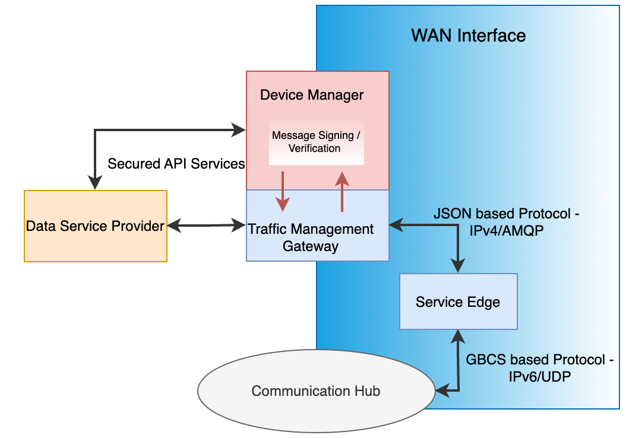

1. Communication Hub Integration

The sending of all messages to the communication hub across the WAN will be managed through the Traffic Management Gateway. The origins of commands issued to the communication hub will be either:

* the DSP (i.e. the types of commands that are currently serviced over the SMWAN link), and
* the Device Manager (DM), which will:
  + Manage device management requests from the DSP e.g., firmware, diagnostics requests
  + Schedule / issue operational device management (DMM) commands such as reboot, RTT.

In either case, the interface into the Traffic Management Gateway will be a JSON formatted request with the GBCS / DMM command as part of its payload. The Traffic Management Gateway will:

* Extract all DMM/GBCS commands from the JSON payload.
* Perform IP lookup based on communication hub GUID details.
* Issue the command to the communications hub.

Commands will be issued through Service Edge which will be responsible for supporting IPv6/UDP to IPv4/AMQP translation to support the traffic between the hub and the Traffic Management Gateway.

Telefónica will continue to utilise device management commands used to communicate and manage the variants of the communication hubs, and which are based on GBCS message constructs.

The DMM protocol has been created by our Design Authority team to provide a fully functional interface specification for communication between the device manager and the CH. This details the WAN, specific message formats, and the alerts.

The device management processes, relating to PKI, fall into three broad stages of the Communications Hub lifecycle: Manufacture, Operational (in life) and Refurbishment/Disposal.

1. SECURITY

## OVERVIEW

The solution components /layers will communicate with mutual authentication, utilise externally signed certs with TLS based encryption, trust path validation, hardened operating systems as well as endpoint protection will exist on all servers, covering antivirus, anomaly detection and threat modelling.

The SMKI and DCCKI shall be used to facilitate the manufacturing and management of Smart Metering specific PKI certificate services and infrastructure.

The solution has provision for Dedicated API Management for enhanced security and it allows to manage TLS protocols and 3DES cipher in cloud deployment. WAF is based on rules from the [OWASP (Open Web Application Security Project) core rule sets](https://www.owasp.org/index.php/Category:OWASP_ModSecurity_Core_Rule_Set_Project).

All WAN API will leverage HAProxy for authorisation and authentication. A gateway provides an extra layer of security.

Traffic Management Gateway will be developed and hosted using Microsoft Azure, where Threat modelling comes inbuilt. Furthermore, Azure cloud services platform conforms to the NIST CSF risk management practices, as defined in the Framework for Improving Critical Infrastructure Cybersecurity.

The Cloud solution hosting the Device Manager services will be supported by the HAProxy integration capability hosted within a private VNET.

In addition, the Traffic Management Gateway components are by default protected by Azure's infrastructure DDoS (Basic) Protection. The scale and capacity of the globally deployed Azure network provides defence against common network-layer attacks through always-on traffic monitoring and real-time mitigation.

The Traffic Management Gateway will use Azure Sentinel to analyse real-time event data and detecting attacks. In Telefónica system’s all services events are collected, detected, investigated, and responded to security threats and incidents. Azure Sentinel is a cloud-native security information and event manager (SIEM) platform that uses built-in AI to help analyse large volumes of data across an enterprise – fast. Azure Sentinel aggregates data from all sources, including users, applications, servers, and devices running on-premises or in any cloud, letting you reason over millions of records in a few seconds. It includes built-in connectors for easy onboarding of popular security solutions. As part of Telefónica wider Security strategy, Sentinel will feed Google Chronicle as the centralised SIEM capability for Telefónica. Telefónica will be reviewing the option of delivering a direct feed from Azure monitor into Google Chronicle. Azure Sentinel to GCP Chronicle is underpinned by IFID719.

All Service audit logs will be forwarded to Google Chronicle to capture, monitor, and correlate event activities, for analysis and onward processing. All security relevant logs generated by these systems, whether traffic related, or management/operation related, such as user logon/logoff and system status, will be transmitted to the SIEM. This will include alerts to trigger actions within the Telefónica SOC following significant events.

For Proactive monitoring, we will use Azure Monitor to help maximize the availability and performance of the applications and services. It delivers a comprehensive solution for collecting, analysing and acting on telemetry across environments. We’ll primarily use two Azure Monitor components: Application Insights and Log Analytics.

Application Insight, an extensible Application Performance Management (APM) service, will support application insights on the PaaS services used in Telefónica solution. It automatically detects performance anomalies and includes powerful analytics tools to help diagnose issues and to understand user behaviours. It's designed to help you continuously improve performance and usability.

All Traffic Management Gateway application services logs will be collected in Azure Monitor by using Log Analytics tool, to run queries on collected data and interactively analyse their results. We will use Log Analytics queries to retrieve records matching particular criteria, identify trends, analyse patterns, and provide a variety of data insights. Telefónica will also implement MITRE ATT&CK Framework and SMKI PMA logging principles.

Data in Azure Storage will be encrypted and decrypted transparently using 256-bit AES encryption, one of the strongest block ciphers available, and is FIPS 140-2 compliant.

At-rest data protection: Telefónica will use Azure Key Vault as well as FIPS140-2 Level 3 HSMs to maintain control of keys that are used by cloud applications and services to encrypt data. We will also leverage Azure Disk Encryption to encrypt VMs and Azure Storage Service Encryption to encrypt all data placed in Telefónica’s storage account.

In-transit data protection: We design network topography in-transit data protection securing data in transit internally within the Azure network and connecting to Telefónica on-premise. These include communication through Virtual Private Networks (utilizing IPsec/IKE encryption), Express Route, Transport Layer Security (TLS) 1.2 or later (via Azure components such as Application Gateway and Azure Front Door), protocols directly on the Azure virtual machines (such as Windows IPsec or SMB), and more.

Additionally, all Azure traffic travelling between Azure datacentres adopts "encryption by default" using MACsec (an IEEE standard at the data-link layer) is enabled for to ensure confidentiality and integrity of customer data. We’ll also leverage Azure Security Centre. Security Centre provides with the tools to Strengthen security posture and protect against threats.

Telefónica’s commitment to Smart Metering has been further demonstrated in the building of a Security Operations Centre (SOC) which is in appropriately secured accommodation and resourced to provide a 24/7/365 service.

Network Data Loss Prevention will enable the Smart Metering Security Operations Centre (SOC) to monitor the data traversing the network and detect DCC Data that is either inappropriately stored and attempts to remove it from the environment; determine the data usage; profile access vectors and determine the level of compliance with Telefónica security policies.

New Smart Metering SOC, Smart Metering Security Information and Event Management (SIEM) and Security Incident Management systems will be deployed that:

* Collects, protects, and stores log data from all smart metering specific components, including WAN.
* Provides summary and configurable detailed reporting for management.
* Establishes baseline levels of ‘normal activity’ – allowing Telefónica to detect unusual levels and types of activity more easily.
* Alerts if baseline activities deviate, and detects complex patterns of potentially malicious activity across multiple, disparate sources (such as firewalls and Communications Hubs)
* Supports forensic analysis for any relevant investigations; and
* Integrates with incident management processes to facilitate the correction of issues, recording activity and managing escalation.

Telefónica also has a dedicated Network Operations Centre (NOC) for the Smart Metering Service. This team will monitor dedicated Smart Metering infrastructure, such as WAN and Traffic Management Gateway. This team will work very closely with the Service Management team, Triage Team, and 2nd/3rd line technical support teams to ensure issues are detected and investigated at the earliest opportunity. They will continue to provide twice daily reports to Service Management and will be closely engaged in the Major Incident Management process to assist in determining impact and resolution.

The solution design includes measures to include early security identification, end-to-end data security, ring fenced capabilities within the communication hubs and WAN Gateway using cutting edge technologies and cloud services.

The solution is designed keeping future evolution in mind; we can use the same security framework for new devices and solutions, and it ensures flexibility with new services. The solution will leverage the following key principles that support innovation and adoption of new technologies:

* Separation of Concerns: The Traffic Management Gateway is a set of discrete, loosely coupled services that represent a specific business function
* Interoperability: The integration between internal components and external parties uses open, industry standards rather than proprietary standards that can result in tight coupling and lock in.
* Baseline for New services – Our solution is built on the principles of resiliency, global scale, agility, autoscaling, and built-in security as standard. The building blocks can be easily extended to rapidly build new services to support new use-cases.

## INTEGRATION

Security across the Traffic Management Gateway will be implemented at multiple layers, focusing on security at rest and transit level security. It should be noted that the components of the Telefónica solution will align to NSCS standards.

* Traffic Management Gateway Connectivity to the DSP (HAProxy/Web Application Firewall):
* API requests - TLS 1.2 mutually authenticated using DCCKI certificates.
* Traffic Management connectivity to Internal components of the Telefónica solution will adopt a publish and subscribe model. The PaaS service security architecture will be leveraged. The event hub, for example, enforces TLS-encrypted communications by default with TLS1.2 supported.
* Telefónica will leverage the PaaS storage services capability to ensure data is encrypted at rest. It should be noted that data is automatically encrypted when persisted to a Cloud storage solution.

The following security controls will be implemented across the Cloud and on-premise solution:

* Data Loss Prevention
* Intrusion Detection
* Malware Prevention
* Vulnerability scanning
* SQL injection and cross site scripting
* SIEM

These capabilities will be delivered leveraging the Azure native services or the third-party virtual products e.g., Fortinet Next Generation Firewall, to support a layered security approach.

To ensure that Telefónica applies appropriate controls to different classes of data, Telefónica will:

* Assign privacy markings and retention periods to all data which shall detail how it should be stored, transmitted and destroyed.
* Use no sensitive data in pre-production tests or other non-live environments

Telefónica will secure the end-to end solution with strategic placement of following:

* Intrusion prevention and detection systems
* Multiple firewalls – Big F5 and in-built Azure firewalls
* Network data loss prevention (DLP)
* Web application firewalls (WAF) and content filtering
* Secure VPN and Azure Express route for all external connections.
* Mutual / two-factor authentication

The logical security architecture for the solution is described in CSP_TEF_SD02_02_Security_Design and CSP_TEF_SD01_04_Application_Architecture.

1. MONITORING

The Cloud solution will leverage native monitoring and analytic capabilities e.g.,

* Application Insights – Detect issues across applications
* Azure Monitor – Collection, analysis and response to monitoring data from the Cloud Smart Metering environments
* Log Analytics – Collection of log data and deep dive analysis
* Azure Monitor Metrics - Data collection point for time-based analysis.

Azure Monitor will integrate with BMC Helix to support raising of alarms in Azure and tracking of incidents. The common service to support monitoring of the Azure services is described in CSP_TEF_SD11_03_OSS_Design_Specification.

The monitoring of the Traffic Management Gateway and operating model will be consistent with the support of the Strategic Data and Reporting and Device Manager solutions.

1. DESIGN QUESTIONS

|  |  |  |  |  |  |  |
| --- | --- | --- | --- | --- | --- | --- |
| No. | Capability | Area | Description | Owner | Status | Closure Notes |
| 1 | Communication Hub Traffic flows | Communication Hub IPv6 Connectivity | Traffic from the packet core will be routed to and from the Traffic Management Gateway via the Service Edge. The Service Edge will comprise of dispatcher services that will take responsibility to translate IPv6/UDP and IPv4/AMQP in both directions. The gateway will act as the single conduit between the Communication Hub and Telefónica’s downstream Smart Metering services. | Architecture | Closed | This has been agreed within Telefónica’s architecture and design teams. |
| 2 | Communication Hub function | Communication Hub | No changes will be made to the Communication Hub to support the introduction of the Traffic Management Gateway | Architecture | Closed | This has been agreed within Telefónica’s architecture and design teams. |
| 3 | Event Validation | Validation | The Traffic Management Gateway will not perform message validation. This responsibility lies with the Device Manager | Architecture | Closed | This has been agreed within Telefónica’s architecture and design teams. |
| 4 | Cell Site Management | Cell Management | The Traffic Management Gateway will perform light weight logic against cell site and Communication Hub status data. SDR will support more complex analytics that will be updated in CHSS and CSS., | Architecture | Closed | This has been agreed within Telefónica’s architecture and design teams. |

1. Design questions
2. RAID

## RISKS

The following risks have been identified as part of the development of this deliverable.

|  |  |  |  |  |  |
| --- | --- | --- | --- | --- | --- |
| No. | Description | Impact | Mitigation | Owner | Status |
| 1 | IPv6 Connectivity is yet to be proven | The CSN services will be required to support translation of IPv6 to IPv4 | Mapping IPv6 to IPv4 in the CSN. | Telefónica | Closed – the connection between the Communication Hub (IPv6) and TMG (IPv4) will be managed by edge services. |

1. Risks

## ISSUES

The following issues have been identified as part of the development of this deliverable.

|  |  |  |  |  |  |
| --- | --- | --- | --- | --- | --- |
| No. | Description | Impact | Mitigation | Owner | Status |
| 1 |  |  |  |  |  |

1. Issues

## DEPENDENCIES

The following dependencies have been identified as part of the development of this deliverable.

|  |  |  |  |
| --- | --- | --- | --- |
| No. | Description | Owner | Status |
| 1 |  |  |  |

1. Dependencies

1. APPENDIX A

This section provides additional details of the Communication Hub GBT processing extracted from the Communication Hub CHDS

## TOSHIBA

The CH fully supports the use of GBCS-defined GBT messages. This concept allows larger messages to be split into a succession of smaller messages that allow each part to be transmitted within current PDU transmission size constraints. GBT is specified in GBCS section 7.2.11.

CRT 041 (superseded by CRT045) makes the following changes to allow GBT messages to be processed by the meter without time delays.

* ZigBee message processing: Sequential   
  GBCS packets (especially GBT fragments) are submitted to the ZigBee tunnel in a sequential manner.
* GBT message retries and Buffering  
  The CH is capable of providing a recovery mechanism for GBT messages. If any missing block issue occurs, the DSP will re-submit all GBT fragments over the SMWAN. The CH will store all GBT blocks without having duplicates in the buffer. The CH will discard duplicates upon DSP retries.
* Buffering – the CH has a common buffer that stores up to 100 GBCS messages or 20 GBT series messages at a maximum. Note: If the buffer contains GBCS messages, it will not hold the maximum number of GBT messages.

The CH supports a range of buffering  interfaces. Buffering of GBT messages is performed for both CHF and GPF as well as for the GSME.  Each of these handle messages inbound from the WAN with separate buffering provided for outgoing GBT messages from CHF and GPF.

Any GBT messages inbound from the HAN are treated is the same way as non-GBT messages and buffered in the WAN out bound buffer until they can be transmitted and acknowledged by the DSP (note: TEF transport level ACK not GBT acknowledgement).  The outgoing WAN buffer is limited to typically 50 messages with new messages being silently dropped if the buffer is full at the time of a new message presenting.  This buffering is time limited and lasts for any limited retries that typical take up to approximately 6 minutes.  Incoming buffering of  CHF is limited to two GBCS messages and it does not expect any GBT commands.

The GPF limited to 5 GBT message sequences for both incoming and outgoing.

* The GSME supports 5 GBT sequences from the WAN that are only passed on to the GSME once the complete GBT sequence is received.  Incoming new GBT sequences presenting when the buffer is currently at its limit are silently dropped.

## WNC

The GBT process is designed to process fragmented messages. From the remote party side, if a message greater than 1,280 bytes is sent, the message will be parcelled and reassembled during the GBT process. If CHF or GPF transmits the message into sizes greater than 1,280 bytes, the GBT process the results from parcelling the message into many packets and then transmits them

* + 1. TRANSFER GBT MESSAGE TO ESME

The tunnelling cluster can only support 1,500 bytes for TransferData command. A message over 1,200 bytes will be identified as a GBT command. After the Communications Hub receives the GBT command from Remote Party, this message will be fragmented into some GBT blocks to be transferred to the ESME. The ESME is a non-sleepy device; therefore the Communications Hub will send GBT block data using the TransferData command in serial transfer. For example, a GBT message has been fragmented into 6 GBT blocks and the Communications Hub will send 6 GBT blocks using the TransferDataClientToServer command as described in figure 12 below.

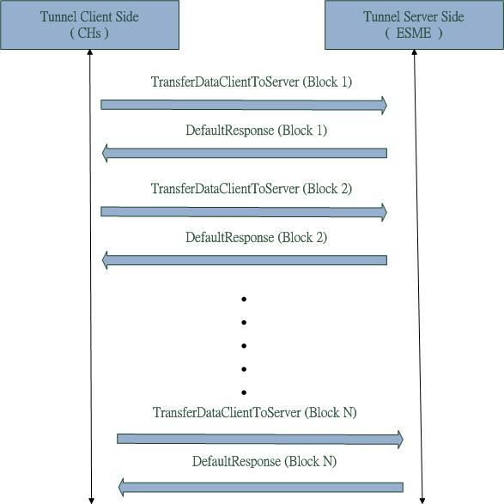

1. Send GBT Message to ESME
   * + 1. STATUS HANDLING FOR ESME

Certain cases will cause the GBT blocks data or none GBT message data cannot be transferred to the ESME; for example, package lost or get no such tunnel status. The status handling cases are listed in the following table:

| Status | Status Handling |
| --- | --- |
| Send Data succeeded using Tunneling | None |
| Send Data failed using Tunneling | Send Telefónica NACK |
| Didn’t receive ZigBee APS ACK | Send Telefónica NACK |
| Get the TransferDataError command  (No Such Tunnel) | Send Telefónica NACK |
| Didn’t get DefaultResponse | If the Communications Hub does not receive a Default Response from the ESME indicating success, the CHF will resend the Remote Party Message until it is either successfully delivered or three attempts have failed. There will be a 30 second delay between retries; and  After three re-send attempts have failed, the CHF will discard the Remote Party Message and send a new Alert to the Access Control Broker identifying the dropped Remote Party Message by its Message Identifier. Having sent such an Alert, the CHF will process any subsequent Remote Party Messages it receives for the ESME. For detailed information, refer to the CRP 428. |

1. Status Handling
   * + 1. TRANSFER OF DATA

To transfer a GBT command or a non-GBT command to the GSME, the Communications Hub will send data to the GSME using serial transfer and follows the GBCS defined GSME session to communicate with the GSME.

* + 1. TRANSFER GBT MESSAGE TO GSME

When the Communications Hub receives a GBT message for the GSME from Remote Party, this message needs to be fragmented into some GBT blocks and the Communications Hub will queue fragmented GBT blocks in HAN message buffer, waiting for the GSME to wake up to query. For example, the GBT message needs to be fragmented into 6 GBT blocks and the GSME will query the GBT block message using serial transfer way as illustrated below.

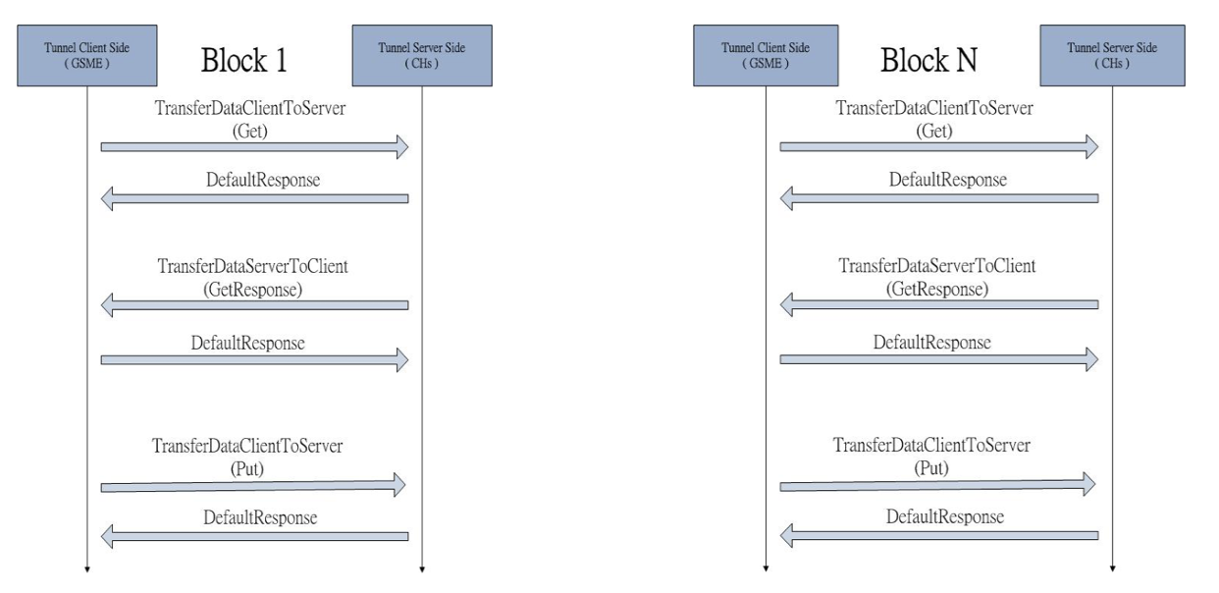

1. Seriel Transfer Data to GSME
   * + 1. STATUS HANDLING FOR GSME

Sometimes, transferring GBT Blocks or non-GBT message to the GSME might fail. The status handling of the Communications Hub for transferring data to the GSME is listed in the following table.

|  |  |
| --- | --- |
| Status | Status Handling |
| Send Data succeeded using Tunneling | De-queue Messages from HAN Message Buffer |
| Send Data failed using Tunneling | De-queue Messages from HAN Message Buffer  Send Telefónica NACK |
| Didn’t receive ZigBee APS ACK | De-queue Messages from HAN Message Buffer  Send Telefónica NACK |
| Get the TransferDataError command  ( No Such Tunnel ) | De-queue Messages from HAN Message Buffer  Send Telefónica NACK |
| Didn’t get DefaultResponse  (5 seconds) | De-queue Message from HAN Message Buffer  Send Telefónica NACK |
| Didn’t retrieve a pending message if this message is queued in HAN Message Buffer over 24 hours | De-queue this Message form HAN Message Buffer  Send Telefónica NACK |

1. ACK Packet Structure Defined in SD4.4.2

| Payload | SOUTHBOUND  (created by the DSP) | NORTHBOUND  (created by the Communications Hub |
| --- | --- | --- |
| Command (or GBT block of) | 01 | N/A |
| Response (or GBT block of) | N/A | 02 |
| Alert (or GBT block of) | N/A | 03 |
| GBT Ack/Resend | 04 | 05 |
| Telefónica Ack (see 3.2.4) | 08 | 07 |
| Telefónica Resend (see 3.2.4) | N/A | 09 |

1. Message-type definitions in SD 4.4.2

| Message | Purpose | Direction |
| --- | --- | --- |
| Command (or GBT block of) | Get/set data or request to execute operations in the Communications Hub, ESME, or GSME | DSP**è**CHF/GPF  DSPèCommunications HubèESME/GSME |
| Response (or GBT block of) | Response messages of requests/commands to DSP | CHF/GPFèDSP  ESME/GSMEèCommunications HubèDSP |
| Alert (or GBT block of) | Send outstanding events to DSP or suppliers | CHF/GPFèDSP  ESME/GSMEèCommunications HubèDSP |
| GBT Ack/Resend | GBT acknowledgement or resend packets | DSPèCHF/GPF  DSPèCommunications HubèESME/GSME  CHF/GPFèDSP  ESME/GSMEèCommunications HubèDSP |
| Telefónica Northbound Ack | The Communications Hub acknowledges to commands. | Communications HubèDSP |
| Telefónica Southbound Ack | DSP acknowledges to responses or alerts. | DSPèCommunications Hub |
| TelefónicaResend | The Communications Hub requests that DSP resend a HAN message due to a failure to deliver to ESME or GSME. | Communications HubèDSP |

1. GBCS messages can be divided generally into seven types